Tribute to Dr. Ralph D. Winter

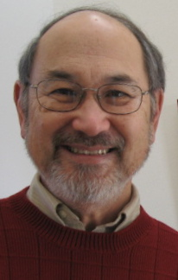

Leiton Chinn

Published in the July 2009 issue of the multi-lingual online journal www.GlobalMissiology.org

International Coordinator, Edinburgh'80: World Consultation on Frontier Missions
Past-President, Association of Christian Ministries to Internationals (ACMI)
Chair, Lausanne International Student Ministries Special Interest Committee

The expansion of God's Kingdom has been impacted by Ralph Winter's willingness to accept and entrust significant responsibilities to younger and somewhat inexperienced missionaries, sometimes unproven for the magnitude of the task assigned to them. Was it blind faith and a high tolerance for "risk"? I believe Dr. Winter had a gift for discernment that was coupled with faith as he ventured forth to delegate major pioneering mission roles to "20-30 something" who were unknowns to the veteran missions community.

I was a student in Ralph Winter's last course at Fuller Seminary's School of World Mission in 1979, when he surprisingly asked me to direct a projected 1980 global, missions executives conference, that would be fashioned after the Edinburgh 1910 World Missionary Conference. I suspended my studies at Fuller, moved to the US Center for World Mission, and under Dr. Winter's visionary mentorship, the 70th anniversary conference became the Edinburgh '80: World Consultation on Frontier Missions. The WCFM and its concurrent International Student Consultation on Frontier Missions spawned several new frontier mission agencies and endeavors and inspired the vision and slogan for the AD2000 Movement.

