TWO CRUSADES IN TWO COUNTRIES

HONG KONG, November 2007, Franklin Graham Crusade

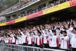
After half a year of preparation by 800 local congregations and 300 schools and para-church organizations, the “Hong Kong Franklin Graham Crusade” was held from November 29th through December 2nd. Altogether six meetings were held, including a youth rally and numerous family gatherings at satellite locations.

The total attendance was nearly 340,000, with 33,464 making decisions for Christ. Among the new converts were politicians and media stars. Extensive follow-up is in progress. Please pray that the Lord will establish His work (Ps 90:17).


PRAISE: Gospel outreach was successful and many are saved
PRAY: Follow-up is essential and intercession will be needed

HO CHI-MING CITY, December 19, 2007. Christmas Gospel Outreach.

Opportunity & Preparation

On December 19, local Christians in Ho Chi-Ming City launched their “Christmas Gospel Outreach” at the Tao Dan Stadium after years of anticipation and earnest prayers.
A permit from the government was granted 48 hours before the meeting, following a season of fasting and pray by over a thousand Christians.
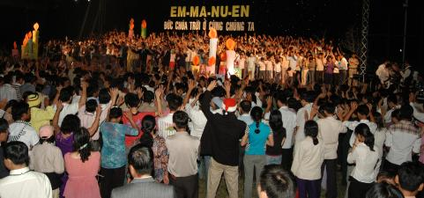
An unique aspect of this event was the fact that the sponsoring organization, called the Vietnamese Evangelical Fellowship (VEF), is made up of underground churches that are not registered and, thus, illegal.

Program & Performance
The event was attended by some 13,000 including an estimated 7,800 non-believers. About 1,500 trusted Jesus Christ at this Spirit-led gathering. The very simple program did not even feature a mass choir:
Mr. Tuan Hung, a new believer, gave an powerful testimony. He is a well-known musician working at a Hanoi TV Station, who trusted Christ only a year earlier. He is talented and rich. (It is well known that he earns some US$8,000 a day in Vietnam where most people earn less than US$30 a month.) He told the crowd that only in Jesus Christ could he find the meaning of life. “I am so very thankful that I am saved now.” After giving the testimony, he sang a song he had just written. There was a thundering applause.

Another famous musician, Khanh Tuong, played “Joy to the World” on his flute.

A tribal Christian singer performed during the alter call issued by Pastor Pham Dinh Nhan after a brief sermon of 18 minutes. He is the vice president of VEF. Then a “sea of people” rushed to the stage to accept Jesus Christ. The stage by design could only hold 600 people. Therefore people gathered in front of the stage to pray and accepted Christ as shown in the picture.
PRAISE: An unprecedented event in Vietnam, smooth operation and successful outcome.
PRAYER: Follow-up is proving a challenge due to the fact that sponsoring churches are underground congregations.

Published under “Contextualization” at www.globalmissiology.org, January 2008

