Four Decades, Four Narratives:
Political Disruption and Contemporary Mission Discourse on China
Brent Fulton
Published in Global Missiology, www.globalmissiology.org, October 2020
Abstract
This article brings China’s current clampdown on foreign Christian activity into perspective by showing how the interplay between shifting political winds and the developing internal capacity of the indigenous church have given rise to four dominant mission narratives. Viewed in broader historical context, these narratives’ inability to account for political disruption calls into question the covenantal meta-narrative that equates the Gospel’s advance with progress and political modernization. Other narratives, including those of political leaders, need to be recognized as having a place in the larger missio Dei meta-narrative.
Key Words: China, Christianization, covenantal, narrative, persecution
Introduction
Following three decades of relative openness, in 2014 the church in China began to experience increasing pressure under Communist Party General Secretary Xi Jinping’s authoritarian rule. Along with tightened restrictions on local believers came heightened scrutiny and new restrictions on foreign Christian workers as well. In early 2020 Asia Harvest reported:
In 2016, Asia Harvest was among the first to warn that a massive persecution was about to erupt across China. By the following year, house church leaders we work with were telling us things like: ‘The persecution we're experiencing is the worst since the Cultural Revolution 40 years ago!’
Meanwhile, thousands of foreign Christians who have given their lives to serve the Lord in China are feeling devastated. They've been kicked out of China and banned from returning for five years or more (Asia Harvest 2020).
The experience of foreign Christian involvement in contemporary China provides an instructive case study of the relationship between political disruption and Christian narratives about the church and mission. Christian narratives about China and its church, while reflecting an inherent unity, have evolved over time due to the interaction between changes in the political environment and changes in the capacity of the indigenous church. This interaction has shaped how foreign Christian entities perceive the situation of the church in China, what is possible in ministry, and what constitute desirable outcomes. Viewed in a broader historical context, these narratives’ inability to adequately account for political disruption suggests the need to acknowledge competing narratives when assigning meaning to political events.
Variations on a Theme
Michael W. Stroope describes narrative as “the organization of events and actors in such a manner as to convey chronology and development. Within the creases of narrative lies emplotment. As a literary device, plot arranges complex events and personalities into an accessible and comprehensible story” (Stroope 2017, 161). Psychologist Jerome Bruner uses the notion of “canonical script” to denote the normative nature of narratives, which make sense of reality in a way that is culturally acceptable (Bruner, 1991, 13). According to political scientists Molly Patterson and Kristen Renwick Monroe, narratives provide insight into how different people process information and move toward achieving their goals. Particularly relevant for the present study is the concept of meta-narratives, which provide uncritically accepted organizing concepts that shape individual and group narratives as well as the likelihood that narratives will find acceptance (Patterson and Renwick Monroe 1998, 316, 325-26).
Stroope contends that, when mission claims the role of the grand narrative, objectivity is compromised and the mission narrative seeks dominance over other narratives to justify a specific agenda (Stroope 2017, 167). Chandra Mallampalli points to the tension between two historical narratives, the incarnational, as developed in the work of Andrew Walls and Lamin Sanneh, and the covenantal. The latter, being central to early Puritan faith in America, formed the basis for the country’s commitment to democracy and rule of law, embedding in the consciousness of American Christianity a mythology that assumes the Gospel “will necessarily produce in other cultures a progression from chaos or tyranny to, ultimately, prosperity and democracy” (Mallampalli 2006, 8-9). Although this perspective appears to be incarnational in that it recognizes cultural symbols of other nations, the indigenous Christian experience is validated “only if it catalyzes movement toward political modernity” [emphasis added] (Mallampalli 2006, 10).
Nathan Faries in his work on American narratives about the church in China notes a similar theme. Outsiders, blinkered by their own nationalism, tend to miss what is distinctly “Chinese” about Chinese Christianity. Their political assumptions keep them from fully appreciating the very real cultural loyalties of the Christians whose stories they are attempting to tell (Faries 2010, 6-7). Examining secular China narratives, former Los Angeles Times Beijing bureau chief James Mann alludes to this meta-narrative of political modernization in his critique of the “soothing scenario” that came to dominate American discourse on China following normalization of relations in the late 1970s. Convinced that economic and cultural engagement would somehow bring about political transformation, US business and government elites, journalists, and academics promoted mutually reinforcing narratives that ignored the unchanging nature of China’s Leninist system (Mann 2007, 6-7). Rather than incorporating China into the Western-led rules-based international order based on free-market principles, America has instead found itself increasingly drawn into a new emerging order in which China plays a leading role (Mann 2007, 105).
The Asia Harvest quote at the beginning of this article represents the dominant China church narrative adopted by foreign Christians during the past four decades. A product of the political modernization meta-narrative, the persecuted church narrative sees the church’s challenges primarily as political, the assumption being that regime change would bring about preferable conditions for the church. The responsibility of the church outside China is thus understood, in the short term, as alleviating the suffering of believers, while the long-term goal is to promote political change, usually through a combination of advocacy, diplomatic or economic pressure, and publicizing the abuses of the regime.
While this narrative has characterized much foreign Christian discourse about the church in China and, under Xi Jinping, has reasserted its role as the dominant narrative, three other narratives have also gained currency in the post-Mao period. Each of these contains elements of the political modernization meta-narrative described above. The needy church narrative follows logically from the persecuted church narrative and sees China’s church as being in survival mode, lacking basic necessities and thus requiring practical assistance from outside in order to function properly (i.e., to modernize). The Christian China narrative focuses on the numerical growth of the church, anticipating a critical mass of believers whose influence will bring about lasting cultural and political change. Finally, the missionary church narrative invites foreign participation in equipping a new wave of cross-cultural workers being sent from China to unreached peoples beyond its borders, thus replicating the Western missionary advance of previous centuries (Fulton 2014, 100-103).
All four narratives have figured prominently in foreign Christian and missionary discourse about China since mission agencies began reengaging China in the late 1970s. The nature of this discourse has changed over time, however, with changes in the degree of political pressure on the church and in the church’s size and internal capacity. Examining the interaction between these two variables, political pressure and church capacity, helps to explain shifts in the China narratives of outside Christian entities.
For the purpose of this study political pressure is gauged in terms of relevant policies and their implementation; incidences of harassment or direct persecution; and, restrictions on Christian social engagement. Internal capacity refers to the church’s ability to provide for its material needs, whether Bibles, meeting venues, or support for Christian workers; to train its own leaders; to produce indigenous resources; and, to advance its outreach in society. As seen in Figure One, below, four possible scenarios arise from the interaction of the two variables.
Political Pressure
High Pressure/Low Capacity | High Pressure/High Capacity
Low Pressure/Low Capacity | Low Pressure/High Capacity

Church Capacity
Figure One: Interaction of political pressure and church capacity
Applying this framework to the China situation, one can see how changes in both the degree of political pressure upon the church and in the church’s internal capacity have interacted to produce each of these scenarios over time and, in the process, to color outside perceptions of the church, giving rise to the various external narratives explained below. As a kind of shorthand, the narratives have been useful in making sense of the complex, fluid, and often opaque situation in China. Although rooted in reality, each of these narratives tends to emphasize various aspects of the church and its environment over others, producing a picture of the church that is accurate yet incomplete.

The Persecuted Church: Surviving the State
Coming out of the intense persecution of the Cultural Revolution in the late 1970s, the church faced a severe shortage of trained pastors. Bibles were scarce, and the church had no legal status. Under Communist Party Document number 19, issued in 1982, China’s official approach toward religion shifted from active suppression to control. Acknowledging that religion had not disappeared despite attempts to eliminate it, the reformist government called for religion to be managed via officially sanctioned religious bodies that had been constituted in the 1950s but banned during the Cultural Revolution. Protestant religious activities were to be conducted under the auspices of the Three Self Patriotic Movement and a newly created sister organization, the China Christian Council, while Catholic worship and clerical affairs were consolidated under the Catholic Patriotic Association. House church Christians, accounting for the vast majority of both Protestant and Catholic believers, were in principle not to be prevented from meeting, but they were to be encouraged to join churches under the TSPM (Lambert 1994, 47, 54-57).
Most of China’s Christians were found in the countryside, where the church had experienced widespread revival. They continued to face threats of arbitrary fines and imprisonment for refusing to cooperate with the TSPM. Receiving Bibles or other support from outside China were forbidden, as were activities, whether in the official or unofficial churches, for children under the age of 18 (Lambert 1995, 69). Dr. Billy Graham’s highly publicized visit to China in 1988, intended as a show of China’s growing acceptance of religion, was marred by the arrest of Xu Yongze, a peasant evangelist and head of the Born Again Movement, a grassroots house church network representing millions of Christians (Aikman 2003, 167). A year later, the government’s brutal crackdown on Tiananmen Square demonstrators quashed hopes for a more democratic China and reinforced the watching world’s impression of China as a ruthless Communist dictatorship.
The title of Ma Li and Li Jin’s book, Surviving the State, Remaking the Church, suggests how China’s church came to be viewed during this opening decade of the current reform period (Ma and Li 2018). This “surviving” church drew the attention of foreign Christians who rallied to provide Bibles and other practical assistance, including basic pastoral training via shortwave radio and smuggled audio cassettes. Prayer and advocacy campaigns, often incorporating outdated Cultural Revolution images or iconic pictures of soldiers in Tiananmen Square, served to publicize the church’s plight. In the minds of many, the church in China became synonymous with persecution. Returning to the framework introduced earlier, suggests the combination of high political pressure and low church capacity gave rise to an enduring narrative of China’s Christians as innocent victims of a hostile atheistic regime or, as in the case of Xu Yongze, as tragic heroes who pay a price for standing up to authorities (see Figure Two).

Political Pressure
Figure Two: High political pressure and low church capacity give rise to persecuted church narrative.
The Needy Church: Open for Business
China began emerging from the shadows of Tiananmen in 1992 when paramount leader Deng Xiaoping made his famous southern trip to Shenzhen, a bustling special economic zone bordering Hong Kong and a symbol of Deng’s bold economic reforms. Eager for Western knowledge and technology to support its modernization effort, China welcomed exchanges with overseas educational institutions. Western businesses set up shop in China, along with traders and manufacturers from Hong Kong, Taiwan, and elsewhere in Asia. In the runup to its accession to the World Trade Organization in 2000, China’s diplomatic efforts sought to assure the world that China was indeed on the path to reform and to answer criticisms of human rights violations, including religious persecution.
Although religious policy did not change in principle, enforcement became less stringent. Growth in the official church, including the opening of nearly two dozen Bible schools and the regular printing of millions of Bibles per year by Amity Press, a foreign joint venture inaugurated in the late 1980s, eased pressure on believers and enlarged the church’s presence in society. Increased personal freedom resulting from loosened restrictions on rural migration and the opening of the economy to private enterprise also gave Christians more space in which to operate. Foreign Christians who began coming in large numbers to China could meet freely with local counterparts in educational or business settings.
Whereas the persecuted church narrative limited overseas Christian involvement in China to prayer, advocacy, and some direct aid provided surreptitiously, the needy church narrative called for large-scale engagement by sending agencies, churches, Christian colleges and universities, and parachurch organizations of all stripes, not to mention thousands of independent tentmakers. China became another pin in the world map at agency headquarters, a line item in foundation budgets, or a new section in organizational strategic plans. In addition to thousands of Christians from Western nations as well as from East Asia and Latin America who would move to major cities as teachers or business professionals, many linguistic or humanitarian workers from around the globe went to China’s southwestern provinces, home to hundreds of distinct ethnic minorities, most of them unreached. On campuses outside China, meanwhile, international student ministries flourished as waves of Chinese students arrived in the United States, Canada, Australia, the UK and elsewhere.
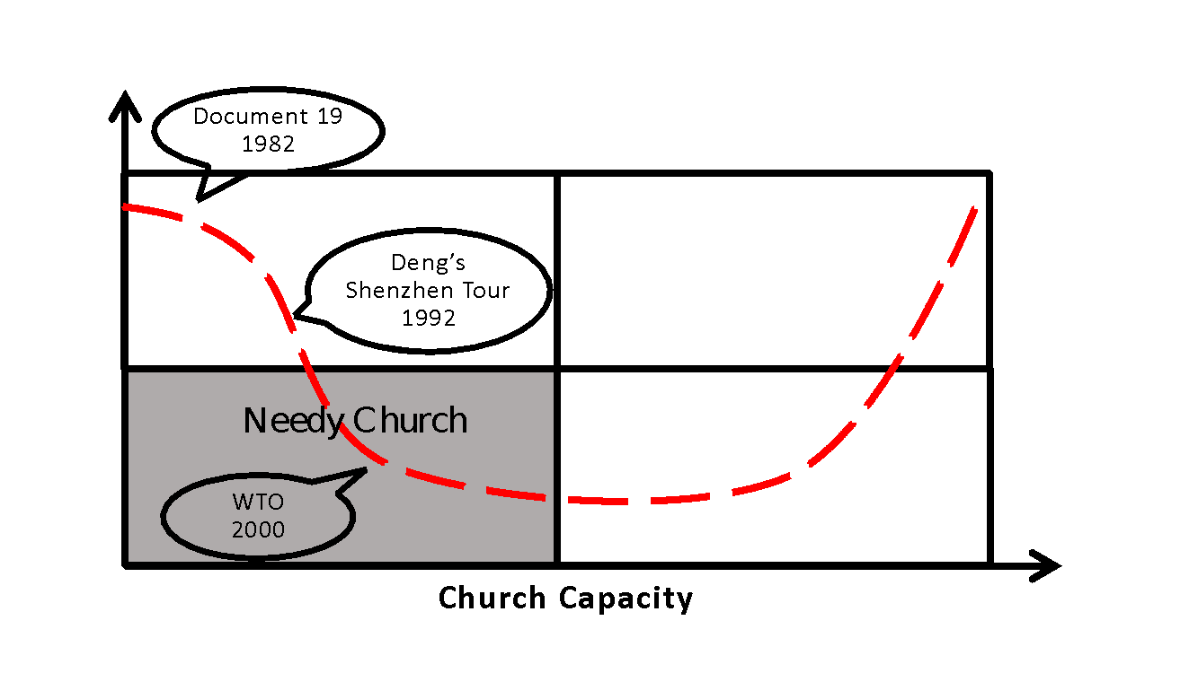
Political Pressure
Figure Three: Political pressure decreases, giving rise to the needy church narrative.
A Christian China: Cultural Transformation
The first decade of the new millennium saw China further entrenched in the international economic system, as increasingly complex global supply chains linked China’s fortunes with those of other nations. In what would become the largest human migration in history, hundreds of millions of rural Chinese began flocking to the cities to work in factories manufacturing goods for export or on massive construction projects, including the iconic “bird’s nest” stadium and other venues for the 2008 Olympic Games. At the same time, the highly competitive and increasingly unequal social environment created by China’s market reforms revealed the darker side of the Chinese miracle, with official corruption running rampant and public trust at an all-time low.
No longer the purview of uneducated peasants in rural house churches or elderly pre-Revolution believers in urban TSPM churches, the Christian faith was being adopted by a significant number of intellectuals, many of whom had been left disillusioned by the massacre in Tiananmen Square. Making their mark in society as professors, writers, artists, media professionals, and entrepreneurs, these Christians heralded the dawn of a promising new era for China’s church. Many were members of urban fellowships that would, in time, evolve into standalone unregistered congregations affiliated neither with the TSPM nor with traditional rural movements. Technically illegal, these congregations were nonetheless allowed to proliferate as long as they did not engage in overt political activity or become too large.
With the growth of China’s church receiving considerable international attention, the paradox of what was arguably the world’s fastest growing Christian movement thriving in the world’s largest Communist country begged the question of which would ultimately prevail, the church or the state? Former TIME magazine Beijing bureau chief David Aikman offered a provocative answer in his survey of China’s contemporary church, Jesus in Beijing. Subtitled How Christianity is Transforming China and Changing the Global Balance of Power, Aikman’s book predicted that a “Christianized” China would bring the emerging superpower into closer alignment with the United States, becoming a force for peace and stability in the world (Aikman 2003).
Christianity Today magazine, which had generally held to the persecuted church narrative in its China coverage, broke new ground with its May 2008 cover story profiling how emerging churches were “shaping society in untold ways” through ventures in education, community service, and business (Moll 2008). The same week this issue of Christianity Today hit the newsstands, a massive earthquake struck Sichuan Province, provoking an unprecedented nationwide response. Within days Christians from multiple cities, led by one of the pastors profiled by Christianity Today, were on their way to assist with relief and rebuilding, some staying on for years to come.
Some of the strongest expressions of the Christian China narrative have come from Reformed Christian circles. The Reformed tradition’s well-defined concept of church polity meets the immediate need for “rechurching” among congregations planted by foreign Christian English teachers or returning Chinese intellectual believers who lacked a well-developed ecclesiology (Ma and Li 2016, 59). Yet the covenantal thinking inherent in contemporary Reformed missions also includes a much broader vision, summed up in the ambitious title of a conference volume that emerged from a 2013 gathering of academics, pastors, and missionaries—China’s Reformed Churches: Mission, Polity, and Ministry in the Next Christendom. Writing in the conclusion, the editor mused:
I am mildly tempted to describe a triumphant future when China will become a global center of Reformed theology, church life, and mission. That kind of future seems quite possible today and would be very welcome. But China could take an unexpected turn at any moment, driving the house churches back underground and strangling Chinese Presbyterianism just as it is beginning to flourish (Baugus 2014, 303).
Continued loosening of political control, coupled with the church’s increased capacity not only to meet its own basic needs but also to play a redemptive role in the broader society, gave rise to this new narrative. As China’s meteoric rise as an emerging economic superpower laid bare the moral decay festering beneath the surface, foreign Christians who were engaged in China, along with a new generation of urban believers, saw an historical opportunity fundamentally to alter China’s core values and shape Chinese culture.
Figure Four: Increased church capacity supports the Christian China narrative.
The Missionary Church: Back to Jerusalem
Soon after assuming power in 2012, Party General Secretary Xi Jinping created a top-level national security commission tasked with silencing dissenting voices, blunting foreign influence efforts, and reining in groups that had strayed outside direct Party control, including religious entities (Fu and Distelhorst 2018). Externally Xi embarked on the ambitious Belt and Road Initiative (BRI), aimed at extending China’s economic, diplomatic, and military reach globally through infrastructure projects carried out by Chinese companies (Rolland 2015).
For China’s Christians, the BRI lent momentum to a nascent indigenous mission training and sending movement that had begun taking shape in the previous decade and whose roots date back to the “Back to Jerusalem” movement of the 1940s. The prospect of Chinese going across Central and Southeast Asia toward the Middle East sparked the imaginations of church leaders and foreign mission agency personnel alike, who envisioned a wave of Chinese missionaries following in the tracks of the BRI and taking the Gospel to areas where Western missionaries could not penetrate. The “Seoul Commitment,” issued by some of the 200 Chinese participants at a Lausanne young leaders conference in 2013, affirmed the Chinese church’s commitment to world missions and unveiled a vision to send out 20,000 missionaries by the year 2030 (Jin 2013).
Supporters of this vision met with a sobering reality in June of 2017, when two young Chinese missionaries were slain in Pakistan by militants apparently linked to ISIS. China’s foreign ministry quickly sought to play down the incident in order to avoid jeopardizing large-scale investment in the region (Hancock 2017). Within China, meanwhile, Xi’s national security push had resulted in new regulations aimed at foreign NGOs that effectively erased the legal gray area in which many faith-based organizations had been operating (Cheng 2017). Foreign Christian workers who had lived in China for years found it increasingly difficult to obtain visa renewals. Some left proactively after local colleagues were taken in for questioning. Several organizations were systematically targeted by security officials, resulting in a significant reduction of in-country personnel.
Faced with heightened political pressure, many foreign workers refocused on areas outside China where they anticipated working with a new generation of Chinese missionaries. While China’s leaders were well aware of the church’s missionary intentions, particularly in light of the narrowly averted diplomatic crisis in Pakistan, many Chinese believers remained optimistic about the prospects of fielding cross-cultural workers beyond China’s borders.
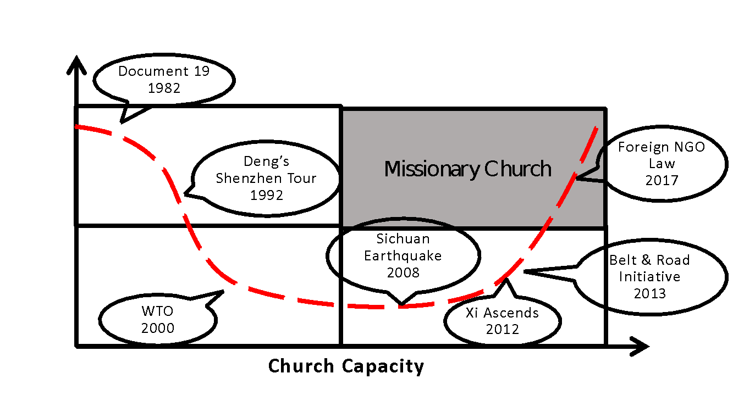
Political Pressure
Figure Five: Increased domestic political pressure causes missionaries to focus attention outside China.
Political Disruption Revisited
Developments under Xi Jinping suggested that China had indeed “taken an unexpected turn” (to paraphrase the quote earlier from the editor of China’s Reforming Churches). Following decades of progressive openness, the foreign mission community understandably viewed the imposition of Xi Jinping’s new normal as a violent disruption to what had been the status quo. Viewed within the context of the past 30 years, China’s detour away from greater religious tolerance was clearly an aberration. In the context of the past 3,000 years, however, the past three decades constituted the aberration. For most of China’s history the state has kept a strong hand on religion, and foreign involvement has not been welcome (Bays 2004). From the vantage point of Xi Jinping, the reckless reforms under Deng Xiaoping, which brought the Party to the brink of irrelevance, constituted the disruption that is only now being rectified through decisive measures to tighten the Party’s grip, including the removal of foreign religious forces.
Whether the narrator is a missionary who has had to leave China or Xi Jinping himself, that narrator makes sense of events, judging which have a rightful place in the narrative and which do not, according to his or her internal frame of reference. Amidst these competing narratives, the understanding of mission as the redemptive work of a sovereign and loving God views apparent setbacks as having a meaningful, though not immediately discernible, role in his divine plan. From this perspective political disruptions may be seen as part of God’s transforming work, both in the culture in which the Gospel is being incarnated as well as in the lives of his servants.
Conclusion
Shifting political winds and changes within the Chinese church itself have given rise to successive narratives about China and its church. Those shifts have also revealed the inadequacies of these narratives. The persecuted church narrative politicizes the church by focusing solely on its relationship to the state. The needy church narrative overlooks the growing capacity of the indigenous church (not to mention the possibility that China’s church may actually have a contribution to make to the global church). By assuming a linear relationship between church growth and political change, the Christian China narrative ignores deep-seated cultural barriers—including within the church—to personal and societal transformation. The missionary church narrative is likewise overly simplistic in its assumptions about the Chinese church sending out cross-cultural workers.
The inability of these narratives adequately to account for political disruption calls into question the covenantal meta-narrative of inevitable progress and political modernization. Yet, as the long history of the Gospel in China has shown, what appears to be disruption often serves to advance the cause of Christ in unexpected ways. Hence the need to recognize other narratives, including those of political actors, as having a place within the larger meta-narrative of the missio Dei.

References
Aikman, David (2003). Jesus in Beijing: How Christianity is Transforming China and Changing the Global Balance of Power. Washington, DC: Regnery Publishing, Inc.
Asia Harvest (2020). “Trouble in China - The Brutal Persecution of the Chinese Church” Asia Harvest website, https://asiaharvest.org/trouble-in-china-the-brutal-persecution-of-the-chinese-church/ (this and all other websites accessed September 14, 2020).
Baugus, Bruce P. (2014). "The Future of Presbyterianism in China," in Bruce P. Baugus, ed., China's Reforming Churches: Mission, Polity, and Ministry in the Next Christendom. Grand Rapids, MI: Reformation Heritage Books, 303-307.
Bays, Daniel H. (2004). "A Tradition of State Dominance," in J. Kindopp and C. Hamrin, eds., God and Caesar in China: Policy Implications of Church-State Tensions. Washington, DC: The Brookings Institution, 25-39.
Bruner, Jerome (1991). "The Narrative Construction of Reality" Critical Inquiry 18:1-21.
Cheng, June (2017). Taking Prisoners” World Magazine website, https://world.wng.org/2017/04/taking_prisoners.
China Partnership (2020). “About China Partnership” China Partnership website, https://www.chinapartnership.org/about-cp#why-china
Distelhorst, Greg and Fu, Diana (2018). "Grassroots Participation and Repression under Hu and Xi" The China Journal January 79:100-122.
Faries, Nathan (2010). The "Inscutiably Chinese" Church: How Narratives and Nationalism Continue to Divide Christianity. Lanham, MD: Lexington Books.
Fulton, Brent (2014) "In Their Own Words: Perceived Challenges of Christians in China" in B. Baugus, ed., China's Reforming Churches. Grand Rapids: Reformed Heritage Books, 100-117.
Hancock, Tom (2017, August 10). “Chinese missionaries seek converts along the Belt and Road” Financial Times website, https://www.ft.com/content/69a41f7e-6b96-11e7-bfeb-33fe0c5b7eaa.
Jin, Ezra (2013). "A Landmark Encounter: The significance of the ACLF for the church in China" Lausanne Global Analysis November, 2(5). Available online at https://www.lausanne.org/content/lga/2013-11/a-landmark-encounter-the-significance-of-the-aclf-for-the-church-in-china.
Lambert, Tony (1994). The Resurrection of the Chinese Church. Wheaton, IL: Harold Shaw Publishers.
Ma, Li and Li, Jin (2018). Surviving the State, Remaking the Church: A Sociological Portrait of Christians in Mainland China. Eugene, OR: Pickwick Publications.
Mallampalli, Chandra (2006). "World Christianity and ‘Protestant America’: Historical Narratives and the Limits of Christian Pluralism" International Bulletin of Missionary Research January, 30(1):8-13.
Mann, James (2007). The China Fantasy: How our Leaders Explain Away Chinese Repression. New York: Viking.
Moll, Rob (2008). "Great Leap Forward" Christianity Today May:22-33.
Patterson, Molly and Renwick Monroe, Kelly (199). “Narrative in Political Science” Annual Review of Political Science, June, 1:315-331.
Rolland, Nadége (2015). “China's New Silk Road” The National Bureau of Asian Research website, https://www.nbr.org/publication/chinas-new-silk-road/.
Stroope, Michael W. (2017). Transcending Mission: The Eclipse of a Modern Tradition. Downers Grove, IL: InterVarsity Press.

