God’s Plan for the Fullness of Time:
Overhauling Ralph Winter’s “Ten Epochs” and “Three Eras” Models (Part I)
J. Nelson Jennings
Published in Global Missiology, www.globalmissiology.org, January 2021
Abstract
Over the past half-century, Dr. Ralph Winter (1924-2009) shaped the framework, goals, and strategies of evangelical missions more than any other single missiologist. Winter’s monumental presentation at the 1974 Lausanne Congress on World Evangelization, entitled “The Highest Priority: Cross-Cultural Evangelism,” steered the focus of evangelical missions away from converting individuals and their countries to reaching people groups. Winter argued persuasively that distances missionaries needed to traverse were cultural more than geographical. The concept of two ongoing structures he termed sodalities and modalities, along with his identification of modern missions’ “closure” trait, are only two of many other seminal insights that reinforced Winter’s expansive influence.
Related were Winter’s two historical models that have influenced evangelical missiology. His “Three Eras of the Modern Missions Movement” has especially shaped Evangelicals’ historical sensibilities; Winter’s broader “Ten Epochs of Redemptive History” links with and supports the “Three Eras” model. Both of these models substantiate Evangelicals’ expectation that today is both the final missions era and the age of Jesus’s return. As such, Winter’s “Three Eras” has provided evangelical missiologists and missions mobilizers a useful historical framework for inspiring fellow Christians to become involved in today’s missions movement.
These “Eras” and “Epochs” models have undoubtedly galvanized evangelical missions with easily understandable historical metanarratives necessary to sustain any movement. They convey a passion and spirit to be cultivated and treasured. Even so, the models seemingly de-emphasize important biblical-theological themes. Moreover, due to contextual changes the models appear to have inadequate capacity for current historical sensibilities as well as the kind of theocentric and worldwide-collaborative character required for future mission movements.
Divided into three parts, this study conducts an overhaul of the two models to see what repairs and enhancements might be needed. Part I introduces the models, including their general context and basic components. Important influences on the models’ formations are noted in Part II, leading into an analysis of the models’ contextual moorings, traits, and limitations for wider use. Part III then considers viable courses of action, including commending features of more adequate historical models for Evangelicals to consider for moving forward. Recognition of the inherent limitations of all human constructs for explaining God’s “plan for the fullness of time” (Ephesians 1:10) concludes the study.
Key Words: context, iterations, limitations, mobilization
Introduction
Any consideration of the past, present, and future of evangelical missions must include - extensively or minimally, explicitly or implicitly - the influence of Dr. Ralph D. Winter. The crystallized idea of Unreached People Groups (UPG), which has played the single most central role for evangelical missions over the last half century, came directly from Winter’s presentation, entitled “The Highest Priority: Cross-Cultural Evangelism” (Winter 1974a), to the inaugural 1974 Lausanne Congress on World Evangelization. Even when missiologists today discuss needed revisions to UPG thinking or even question the continuing validity of the UPG construct for today’s globalized world of megacities (Datema 2016:45), the monumental importance of the UPG concept testifies to Dr. Winters’ central and enduring influence for evangelical missions research, strategizing, and practice. As his biographer Harold Fickett put it, Winter was “a genius for God” who “dared to shake up world missions” (Fickett 2012).
Another framework formulated by Winter is arguably as widely influential as that of UPGs, namely the “Three Eras of the Modern Missions Movement” model. The model has been updated and modified by both Winter himself and others, but its validity has not been questioned to the degree that UPG thinking has. An adjoining historical scheme of Winter’s may not be cited as much but, like the “Three Eras” model, remains unchallenged: “The Ten Epochs of Redemptive History.” Simple and memorable diagrams of each model are etched in many Evangelicals’ minds, further solidifying and broadening the models’ steadfast and ongoing influence.
Dr. Ralph D. Winter was gifted at communicating through clear diagrams the main emphases of any number of complex ideas. However, Winter’s gift of clear communication should not cloud the challenge of analyzing the intricacies of Winter’s wide-ranging and ever-growing thought that undergird his simple and memorable diagrams. That analytical challenge becomes all the more daunting when a necessarily brief examination such as this one seeks to do justice to the two influential models under consideration here.
Analyzing the “Ten Epochs” and “Three Eras” models, including how they developed, is complicated by the difficulty of sifting through their voluminous and varied source materials. Winter’s own published versions first came out in 1979 and 1981, but almost from the very beginning his essays appear in different publications and even under different titles - particularly the “Three Eras” essay. Furthermore, Winter’s ever-developing understanding of a constellation of themes, their interrelationships, and their effect on Christian missions meant that his writings and publications - including about the “Ten Epochs” and “Three Eras” models - were always being refined, revised, and updated. In Winter’s own words late in life, “both charts and thoughts keep recurring as I attempt each time to give a clearer explanation” (Winter 2008b:viii). Various collections of Winter’s writings are helpful (Snodderly 2018), but identifying and locating pertinent materials are not straightforward processes.
As referenced below, the various editions of the Perspectives course reader and several issues of the Mission Frontiers (MF) and International Journal of Frontier Missions (IJFM) journals have been the main (but not the only) outlets for Winter’s own compositions. Identifying and locating all relevant versions of Winter’s works about or related to the models are not simple tasks. Furthermore, others’ writings and presentations use various versions of the models’ essays and graphics - with differing degrees and styles of referencing whichever version is being employed. Simply identifying how and where the models have been presented, then subsequently used, takes one on an adventurous and uncharted journey.
Such complications notwithstanding, this study dares to give an appreciative and thorough inspection of both models, both to understand them better and to determine how improvements might be made, i.e., to give the models an “overhaul.” The study first introduces the models, including their general context and basic components. Important influences on the models’ formations are noted next, leading into an analysis of the models’ contextual moorings, traits, and limitations for wider use. In light of its findings, the study then considers viable courses of action, including commending features of more adequate historical models for Evangelicals to consider for moving forward. Recognition of the inherent limitations of all human constructs for explaining God’s “plan for the fullness of time” (Ephesians 1:10) concludes the study.
Before proceeding, it should be noted that this study was not prompted by Ralph Winter’s new concerns later in life, which did affect his presentation of the two historical models. Rather, the study’s impetus was what and how the models communicate in today’s different context of world missions compared to four decades ago, when the models were first published. Of course, what and how the models communicate, as well as why it is helpful to overhaul the two models to see what repairs and enhancements might be needed, should emerge through what follows.
Additionally, this study believes that close examination of the effects on the models by Winter’s late-in-life change in focus reveals more continuity among the models’ several iterations than discontinuity. As seen further below, Winter sought to add to his models more than to alter their fundamental structures. Much more than Winter’s change in focus, it is today’s different context that calls for a careful and constructive overhaul of the “Ten Epochs” and “Three Eras” models.
The Models and Their Iterations
Taken together, Winter’s two models are interdependent - but not completely. They are almost always presented independently, each as a stand-alone scheme. They differ in their historical spans: 4,000 years and 200 years. Also, the degrees of details explained vary, particularly with regard to the models’ respective diagrams. Where the models link content-wise is how the “Three Eras” essentially comprise “the latter half” of the final 400-year “Epoch.” Winter expressly makes that connection in his lone essay in which both models appear together, albeit in succession rather than integrated by theme or topic per se (Winter 1989). As for other analysts, John Piper most explicitly links the two models where he concludes his article entitled “Overview of the History of Missions” - which is expressly based on Winter’s “Ten Epochs” model - with “See the three eras of modern missions” (Piper 1981). Winter himself makes a similar reference within a later version of his “Kingdom Strikes Back” essay (Winter 1999a:212).
At a conceptual level, interconnections are evident in Winter’s Fuller School of World Mission course outline on “The Historical Development of the Christian Movement” (Winter 1974b:6). In particular, from their earliest publications the models are tied together by Winter’s conviction that, throughout redemptive history (including modern missions history), Old Covenant Israel and subsequently “nations which have been singularly blessed by God [have had an] obligation to be a blessing to other nations.” Winter thus exhorts his fellow U.S.-Americans, “As individuals and as a nation we are responsible ‘to be a blessing to all the families of the earth’,” pointing to God’s promise and charge to Abraham in Genesis 12:1-3. Winter adds Jesus’s sobering warning, “Unto whomsoever much is given, of him shall much be required” (Winter 1981e:139; Winter 1981d:168). This conviction about national responsibility will be explored further below. So will another vitally important link between the two models, namely their intended goals of mobilization for frontier missions.
“Ten Epochs” Model
Winter’s lesser known framework, “Ten Epochs of Redemptive History,” shapes the overall historical backdrop against which he formulated and presented many of his missiological ideas. The model is most systematically laid out in Winter’s article, “The Kingdom Strikes Back: Ten Epochs of Redemptive History,” first published in 1981 (Winter 1981e). The important place in Winter’s mind of the “Ten Epochs” model is demonstrated by the “Kingdom Strikes Back” article being placed first in the historical section of all four editions, ranging across almost three decades from 1981 to 2009, of the Perspectives on the World Christian Movement: A Reader (Winter and Hawthorne 1981, 1992, 1999, 2009). The article also is positioned first in the earliest editions of the Foundations of the World Christian Movement: A Larger Perspective reader, designed for the course of the same name offered by the Institute of International Studies at Pasadena’s U.S. Center for World Mission (USCWM) (Winter and Snodderly 2008, 2009). A version for children was also published under the same title in 2008 (Winter 2008a).
With its title inspired by the previous year’s blockbuster movie “The Empire Strikes Back” (Star Wars Episode V), the essay sets forth redemption as a divine counter-attack against Satan’s attempted coup to unseat God’s rightful rule over his world. Winter’s model labels ten equal-length, historical periods or “epochs” linked by “the grace of God intervening” and “contesting an enemy … so that the nations will praise God’s name” (Winter 2009a:8). Winter notes more than once that each of the epochs lasts “roughly” 400 years (Winter 2009a:8-9), but the graphics and the overall essay convey a start-to-finish history evenly divided into well-defined periods.
More specifically, Winter’s model casts the overall sweep of redemptive history as consisting of 4,000 years: 2,000 years before Christ and 2,000 years after:
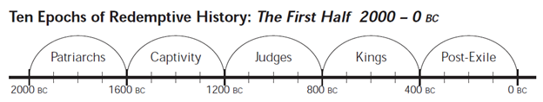
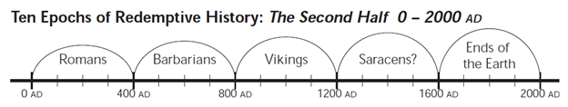
(Winter 2009b:211-212; Bible and Knowledge 2015). God’s redemptive work begins - that is, the Kingdom initially “strikes back” at Satan’s doomed occupation of God’s rightful domain - through Abraham. This initial redemptive initiative takes place around 2000 B.C. The five subsequent Old Testament periods are focused on:
- Patriarchs - Abraham, Isaac, Jacob, and Joseph
- Captivity in Egypt
- Judges
- Kings
- Post-Exile - The Babylonian Exile and Dispersion
Throughout these five B.C. 400-year epochs, even though “the promised blessing and the expected mission (to extend God’s rule to all the nations of the world) all but disappear from sight,” there continues “the active concern of God to forward His mission” (emphases original; Winter 2009a:9).
Jesus Christ marks the central dividing point of redemptive history. Winter strikingly asserts that “Jesus did not come to give the Great Commission but to take it away” from “the chosen missionary nation,” Israel. In turn, God then “makes sure that the other nations are both blessed and similarly called ‘to be a blessing to all families of the earth’” (emphases original; Winter 2009a:9).
The five subsequent periods that comprise “The Second Half of the Story” (Winter 2009a:9) are marked by various foci of Christian mission:
- Romans
- Barbarians
- Vikings
- “Saracens?” (later “Muslims?”)
- Ends of the Earth
Winter introduces his extensive descriptions of these periods by noting, “Those nations that are blessed do not seem terribly eager to share” the blessing of Christ’s kingdom with other peoples (Winter 2009a:9-10). Even so, throughout both the first half of the story and the five A.D. 400-year epochs, “God has not changed His plan in the last 4,000 years…. ‘This Gospel of the Kingdom must be preached in the whole world as a testimony to all peoples, and then shall the end come’ (Matt 24:14).” Other nations were blessed beyond the “agony of Rome” and the “agony of the Barbarians,” and that same expectation holds for what lies beyond the likely upcoming “very dark period for the Western world,” including even the uncertain “survival of our own country” (Winter 2009a:23).
Even if not as explicitly influential as his “Three Eras” model, Winter’s “Ten Epochs” scheme serves to correct some Protestants’ mistaken notion that the entirety of Christian missions history consists only of the last two hundred years. Moreover, looking at 4,000 years of redemptive history has supported many evangelical leaders’ corrective emphasis that Christian missions did not begin with “The Great Commission” of Matthew 28:18-20. Represented by Kaiser’s Mission in the Old Testament (Kaiser 2012), along with Winter these leaders have pointed Evangelicals to Genesis 12 and God’s promise (and command) to Abraham that “all nations will be blessed through you” (Genesis 12:3). Christian missions thus becomes more than simply obeying Jesus’s final, and supposedly isolated, command: God’s long-ranging Kingdom redemption of all peoples throughout the earth, the divine invasion of Satan’s usurped and illegitimate reign, becomes the larger framework for missions.
For the purposes of this study’s analysis, it is constructive to note some of the revisions to the “Ten Epochs” model (or at least to the model’s presentation) that have been made over its almost 40-year lifespan. Among what might be considered smaller revisions, in the first 1981 version and second 1992 version the only graphic is of the “Second Half,” whereas later versions include both halves plus expanded explanations of the “First Half” (Winter 1981e:138, 140; Winter 1992a:B—4-5, B—7; Winter 1999a:196-198; Winter 2009b:210-212). There is an inexplicable omission of the question mark after “Saracens” in the graphic of the revised (second) edition only (Winter 1992a:B—7); and, there is a curious dropping of the arcs in the 2009 Foundations course version’s graphics (Winter 2009a:8-9). Another subtle change is the 2009 fourth edition’s use of “Muslims” instead of the previous versions’ “Saracens” (Winter 1981e:140, 141, 150; Winter 1992a:B—7, B—16; Winter 1999a:198, 199, 208; Winter 2009b:212, 213, 221). Epoch headings in later versions, in the text if not in the graphics, have the added beginning “Period #” (Winter 1981e:141; Winter 1992a:B—7; Winter 1999a:200; Winter 2009b:213), perhaps reflecting early questions Winter had received (and to which Winter had made adjustments elsewhere) regarding “Whether [time periods should be] considered ‘epochs’, ‘cycles’, or ‘eras’” (Mission Frontiers 1979; Winter 1989).
A set of three revisions in the same later versions seemingly reflect a change in the model’s commitment to the finality or completion of the 4,000-year redemptive history around A.D. 2000. First, later versions drop the initial “The” in the 1981 and 1992 editions’ article subtitle, “The Ten Epochs of Redemptive History.” Second, whereas the earlier versions state that Jesus came in the middle “of the 4000-year period we are now ending,” the reworded versions shift the emphasis backward: “... of the 4000-year period beginning in 2000 B.C.” Third, after the earlier iterations’ concluding words of Matthew 24:14 (The gospel must be preached throughout the world to all peoples, “and then shall the end come”), the later versions add two sentences: “God can raise up others if we falter. Indeed, the rest of this book [the Perspectives reader] indicates that is already happening” (Winter 1981e:137, 138, 155; Winter 1999a:195, 196, 213).
Each essay’s iteration progressively includes more content, explanations, details, and changes. Even the second, revised 1992 version - otherwise identical to the first 1981 essay - adds a brief paragraph to highlight “the four different ‘mission mechanisms’ at work [throughout the first half of redemptive history] whereby other peoples could be blessed,” namely going and coming both voluntarily and involuntarily (Winter 1992a:B—5; emphasis original). One substantial revision is later versions’ inclusion (early in the essay) of Winter’s later-year emphasis on wider “Kingdom” themes, including battling germs and disease. For example, later versions have added references to “disease germs,” “‘The Son of God appeared for this purpose, that He might destroy the works of the devil’ (1 Jn 3:6),” and how Satan “distorts even DNA sequences, perhaps authors suffering and all destruction of God’s good creation,” and devises “virulent germs” (Winter 2009a:7-8; Winter 2009b:209-210 [includes correction to 1 Jn 3:8]). A subtle, corresponding change is made in the wording of Matthew 24:14: earlier versions read, “This gospel must be preached in the whole world as a testimony to all people groups, and then shall the end come”; in later versions there are two changes: “This Gospel of the Kingdom must be preached in the whole world as a testimony to all peoples, and then shall the end come” (Winter 1981e:155; Winter 1999a:213; emphases mine).
A particularly significant addition in later versions (starting in 1999) is a greatly expanded “Period II: Winning the Barbarians, A.D. 400-800,” including sections on monastic orders and Charlemagne (Winter 2009a:13-16). Yet another major addition, as part of the expanded “Period V: To the Ends of the Earth, A.D. 1600-2000” section (and introduced earlier in the essay), is a full-page chart entitled “Pulses in Western Civilization,” directly correlating Latourette’s “Resurgences” in his A History of Christianity with “Renaissance in Five Epochs,” i.e., over the course of two millennia of Western history and, through modern missions, “Global Coastlands” and “Ends of the Earth” (Winter 2009a:11, 21):
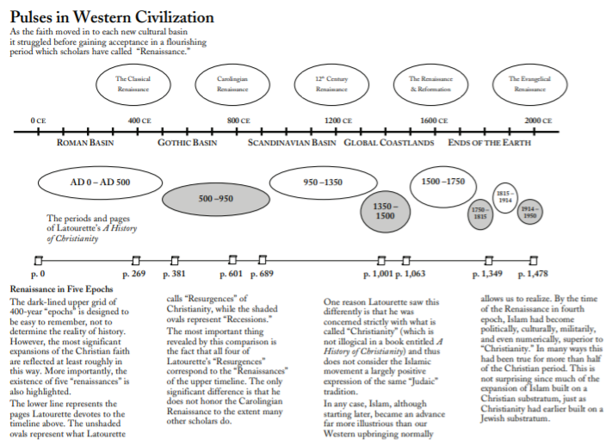
The significance of these various adjustments will be pursued later.
“Three Eras” Model
Winter’s “Three Eras of the Modern Missions Movement” model has captivated many Evangelicals, including other renowned missiologists and students of the “Perspectives” course. The model has been a refreshing revelation to many who have discovered it, as many blogs and teachings have testified. The widely read John Piper, for example, published an “essay of gratitude” for Daniel Fuller of Fuller Seminary entitled “A Vision of God for the Final Era of Frontier Missions.” Piper composed the essay in 1985, four years after his aforementioned missions history article and only eight years prior to the first edition of his widely influential Let the Nations Be Glad! (Piper 1993). Just as Piper’s earlier article follows Winter’s larger historical outline, this 1985 essay expressly utilizes “the insights of Ralph Winter, who has identified three major eras in Protestant missions history” (Piper 1985).
The many other authors, teachers, students, and other Christians who have referenced Winter’s models of redemptive and missions history, all approvingly, have done so in a variety of ways. Some have considered the models only “very rough approximations” and “a memory device” (Culbertson n.d.). Others have incorporated them into their own outlines (John 2014). The Frontiers Mission Movement has understood its own historically particular location and role coming out of the “Three Eras” scheme (Johnson 2001). Several analysts have sought to build on the “Three Eras” progression to suggest a “Fourth Era” for contemporary missions (Chismon 2020; Davis 2017; Shadrach 2018). Countless others have been gripped by the models’ urgency for service in missions’ “final” era (Smith 2014).
The vast majority of those who have referenced the models have reckoned them as authoritative and accurate historical depictions. It is worth noting as well that The Gospel Coalition website, while recently publishing articles questioning certain aspects of the Unreached People Group construct (Akin 2019; Carlson and Clark 2019), has never conveyed an essay critical of either of Winter’s historical models.
The following diagram from 1999 is the most mature visual presentation of Winter’s original “Three Eras” scheme:
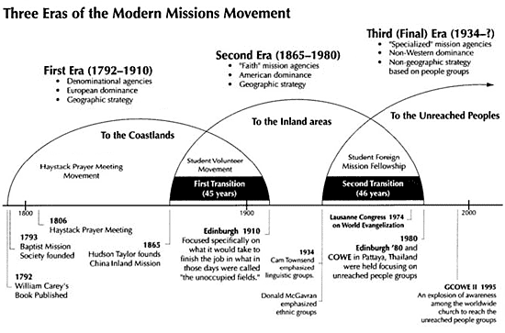
(Winter 1999b:259; Gospel Revival Ministries 2017). As was the case with the “Ten Epochs” model, Winter’s “Three Eras” scheme appeared in the first edition of the Perspectives reader (Winter 1981d). Interestingly, however, the familiar graphic above - which is from the third edition of the Perspectives reader - was not the first graphic that Winter used. The basic idea of “Kodachrome slides on the same screen” (Winter 1981c) was there from early on, but the first diagram, which appeared in slightly variant forms in two different 1981 publications (with one again in 1992), was styled differently. More substantially, along with stating the focus of the “Third (Final) Era” as “Bypassed, ‘Hidden People’,” the 1981 and 1992 graphics were labeled with a different heading than the later and more familiar “Three Eras” title, namely “The Two Transitions”:
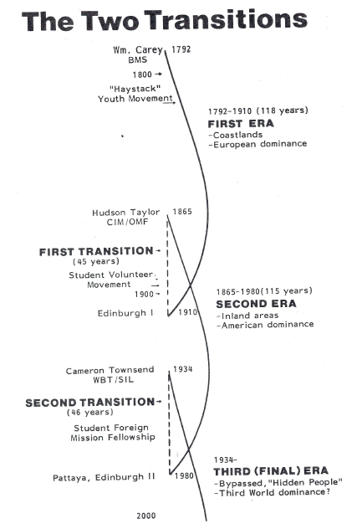
(Winter 1981b);
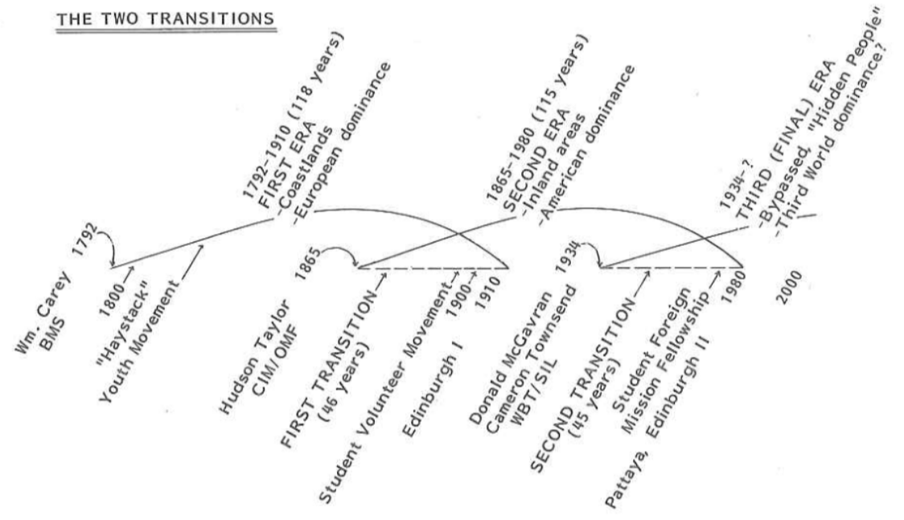
(Winter 1981d:173; Winter 1992b:B—39). Both graphic headings were incorporated in the title of both the 1992 and 1999 (but not final) revised versions of Winter’s essay: “Four Men, Three Eras, Two Transitions: Modern Missions” (Winter 1992:B—33; Winter 1999a:253). The importance of the titles and headings will emerge further below.
As suggested earlier, there were hints of the emerging model in Winter’s 1974 Fuller School of World Mission “Historical Development of the Christian Movement” course syllabus (Winter 1974b:6). The “Three Eras” scheme first appeared publically (not yet with an accompanying graphic) in 1979. That brief article, entitled “The Hidden Peoples: the last frontiers,” was published halfway through the first year of the new journal Mission Frontiers (Winter 1979). The USCWM and William Carey University had just been established a few years earlier (Frontier Ventures 2020), plans for the long-awaited Edinburgh 1980 conference were taking concrete shape (Winter 1980), and Winter thus issued his clarion call about “THE THIRD ERA--Today!” The article stirringly concludes,
These forgotten people will be receptive to the Gospel if the means and strategies are developed to reach them. The new U.S. Center for World Mission in Pasadena is small in comparison to the immensity of the task, but it is the largest single property in the world today dedicated exclusively to reaching the hidden people. What has been launched in Pasadena must alert us, as did that first satellite [launched in 1961, cited at the article’s beginning], that we have entered a new age, and nothing short of a total effort will conquer this last frontier (Winter 1979:5; emphasis original).
Ralph Winter was passionately marshalling all conceivable “means and strategies” to equip evangelical Christians to complete the task and the final era of Christian missions.
The basic thrust of the model comes from the three, overlapping arcs that identify modern missions’ three eras and their transitions, culminating in the new (as of the late 1970s and early 1980s) final era of reaching unreached peoples. Starting with William Carey and his 1792 Enquiry, missions first went to the coastlands of Africa and Asia. Before this coastal trend concluded, Hudson Taylor spearheaded missions initiatives into Africa’s and Asia’s “inland” regions. In the 1930s, the third (final) era starts to coalesce with Cam Townsend’s identification of the importance of reaching different linguistic groups in Latin America simultaneously with Donald McGavran identifying groups of people coming to faith in India. The notion of people groups emerges, along with the exegetical insight that these groups are actually the “nations” or ethne of Scripture, preeminently Matthew 24:14 and 28:19, “all nations” or panta ta ethne. Whereas the first and second eras involved “geographic strategies,” the third era’s focus on unreached peoples is “non-geographic.” This “three era” model has helped contemporary Evangelicals locate themselves at the culminating point of missions (and redemptive) history.
In the model’s earliest versions, Winter repeatedly stressed the challenge of transitioning between eras - most pointedly from the second era into the new and final third missions era: “The bombshell confrontation for our time is not quite the same as Carey’s (the ‘heathens’ can and must be reached) or Taylor’s (we’ve forgotten the inland peoples) but rather, what about the 4 out of 5 non-Christians who are still beyond invisible cultural frontiers?” (Winter 1979:5; emphasis original). Winter sensed that a “potent new mood was developing all through mission circles with regard to the final frontiers-the final cultural and social barriers to the penetration of the gospel” (Winter 1981c). At the same time, Winter perceived “the contrast between this new concern for frontiers, and the still strong concern for nationalization and withdrawal, that is, the predictable tension between two overlapping eras” (Winter 1981b:1; emphasis original). The three eras and their overlapping transitions constitute the model’s message.
After the initial almost-two years of presenting his overlapping-eras framework for modern missions (Winter 1979; Winter 1981a), Winter added “an alliterative sequences of stages” of mission activity to the model - both verbally and graphically:
Stage 1. A Pioneer stage - first contact with a people group.
Stage 2. A Paternal stage - expatriates train national leadership.
Stage 3. A Partnership stage - national leaders work as equals with expatriates.
Stage 4. A Participation stage - expatriates are no longer equal partners, but only participate by invitation” (Winter 1981d:170-171; Winter 1981b:2; Winter 1981c).
At first glance, this addition may seem arbitrary and out of place. Moreover, the situational nature of Winter’s essays, along with his continual revision of what he had published earlier, can make the exact reasons for adding these four stages difficult to determine. However, Winter was confronting evangelical Christians, especially mission executives, with the question, “Is it not possible for one field to be in one stage while another field is in another stage?” Historically speaking, “Today the Protestant tradition is in a slow, massive, agonizing transition between a Second Era and a Third (and final) Era, and ... like two Kodachrome slides on the same screen, the partnership and participation stages of the Second Era confusingly overlap and tend to obscure the logic of the pioneer and paternal stages of the emerging Third Era” (Winter 1981c). Different fields require different activities, Winter explained. Partnering with newer and maturing churches is important to be sure, but pioneering missions efforts are desperately needed in today’s third and final era to reach the heretofore unrecognized, vast number of hidden, unreached peoples.
Other important revisions that Winter made to his model in 1981 were, first, adding “another young man … Cameron Townsend” (following Carey and Taylor) as “the early prophet of the Third Era” (Winter 1981a; Winter 1981b:7; Winter 1981c) and, second, adding Donald McGavran alongside Townsend as having begun the third era (Winter 1981d:174-175). Winter differentiates Townsend and McGavran as having identified “linguistic barriers” and “social barriers,” respectively, that must be overcome by frontier missions efforts for unreached people groups (Winter 1981b:174; Winter 1997).
In the 1992 version, Winter’s essay adds strong criticism of interpreting Old Testament missions as centripetal versus centrifugal New Testament missions: “The fact is, both patterns operated in both periods,” Winter retorts (Winter 1992b:B—34). Winter also changes earlier versions’ use of “Hidden Peoples” to “Unreached Peoples” (Winter 1992b:B—42-43), reflecting intense discussions in which he had been involved in the late 1970s and early 1980s (Datema 2016:51-54). Winter also appreciatively mentions the AD2000 Movement’s added phrase, “the gospel for every person…” (Winter 1992b:B—43). Winter’s late 1990s iterations include bits of updated information, a more visually pleasing “Mission-Church Relations: Four Stages of Development” graphic, and the more detailed, mature “Three Eras” graphic displayed earlier (Winter 1997; Winter 1999b:256, 259).
It was during Winter’s later years that his “intriguing thoughts on science and theology and their importance for our understanding of disease,” a pursuit concerning which some may “wince” or be “uncomfortable” (Fickett 2012:151; Huckaby 2013), significantly affected his presentation of the “Three Eras” scheme. One “huge intellectual task” Winter attempted was to combine “the Christian dynamics” and “the secular events” of the nineteenth and twentieth centuries (Winter 2009c:263). The result appears in the latest, fourth edition of the Perspectives reader and puts “Kingdom Mission Recovery” alongside the third era’s task of crossing the frontiers of unreached people groups:
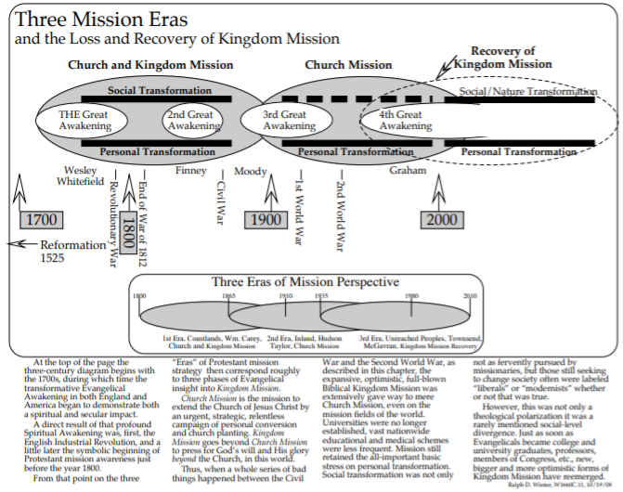
(Winter 2009c:265). In this revised scheme, a three-century interplay between Church Mission and Kingdom Mission is set atop the original two-century, coastal-inland-unreached three-era progression. Pivotal events of wider U.S.-American (and European) history are given more visibility than before. Prominent U.S-American evangelists take center stage.
Earlier versions of Winter’s “Three Eras” essay conclude with a section entitled “Can We Do It?” - ending with a stirring call to finish the task of world evangelization: “We have potentially a worldwide network of churches that can be aroused to their central mission. Best of all, nothing can obscure the fact that this could and should be the final era…. God has not asked us to reach every nation, tribe and tongue without intending it to be done. No generation has less excuse than ours if we do not do as He asks” (Winter 1981d:176; Winter 1992b:B—43; Winter 1999b:261; emphasis original). This later iteration now ends with two subsections entitled “How Far Have We Come?” and “How Far to Go?” - ending with a more comprehensive and less urgent tone: “The Third Mission Era, in so far as it recognizes both Unreached Peoples and a recovering Kingdom Mission, reveals significant demands, unfailing inspiration and incredible promise” (Winter 2009c:277-278). One appreciative interpreter seeks to retain the feel of both versions, asserting that with Winter’s updated model Christians can “aggressively and effectively collaborate to advance his Kingdom and His Church and to complete the missionary task in our day” (Butler 2008; emphasis mine).
An alternative later version of the “Three Eras” model - tweaked by Winter’s mentees in his honor - retains the single emphasis of Winter’s original version. The three-arc graphic is almost identical to the 1999 mature version. The sole addition is Ralph Winter himself as one of the “Pioneers Leading the Way in the Final Era”:
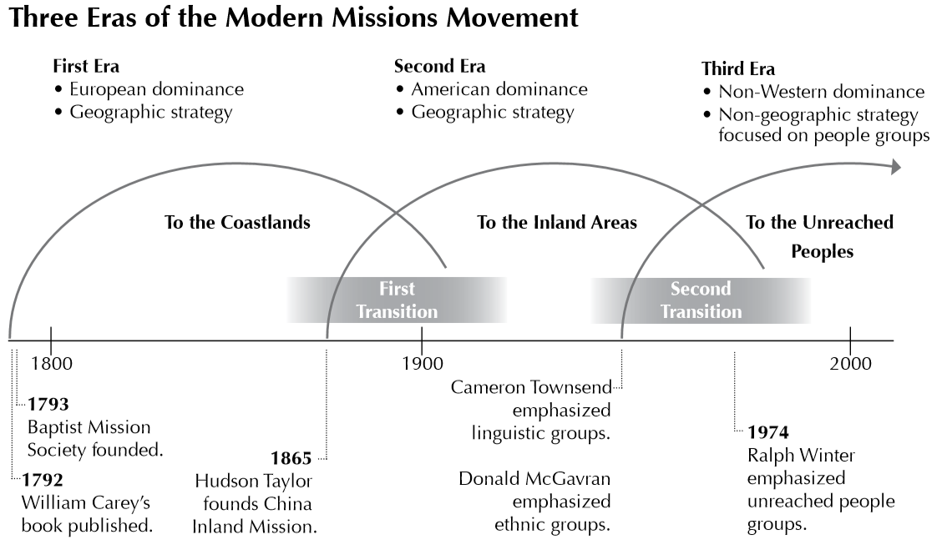
(Honeycutt 2009:377, 378). This simplified iteration notes that “Winter popularized the concept of unreached people groups” at Lausanne 1974; then, “the Winter-promoted Edinburgh 1980 conference made the phrase ‘a church for every people’ common among mission movements all over the world” (Honeycutt 2009:379-380). The original “Three Eras” call to finish the task of reaching the unreached remains the primary focus.
Winter’s other later, integrated version burst the “three-eras” wineskin into what he renamed, “Seven Men, Four Eras” (Winter 2008b:308-316). The “Fourth Era” Winter calls the “Kingdom Era,” in which Christians are to focus on “how reconciled man working with God can together destroy the Kingdom of Darkness, putting away both human evil and natural evil (disease).” The three added men are “three key Evangelicals,” all professors and authors: Carl F. Henry, Timothy Smith, and David O. Moberg. Because of three books these three men composed, they “can reasonably be considered the pioneers of the growing Kingdom Era for American Evangelicals in the 20th and 21st centuries” (Winter 2008b:314-315). The essay concludes with the familiar challenge of “Can We Do It?” - ending with the Kingdom Era theme interwoven with the same, previous versions’ clarion call to action in missions’ final era(s): “The Unreached Peoples Era and the Kingdom Era could well be the final eras…. God has not asked us to assist in the expansion of the Kingdom of God into every nation, tribe and tongue without intending it to be done. No generation has less excuse than ours if we do not do as He asks” (Winter 2008b:315-316; emphasis original).
References
Akin, Paul (2019). “There’s More to Missions Than Unreached People Groups” The Gospel Coalition website, https://www.thegospelcoalition.org/article/missions-unreached-people-groups/ (accessed March 3, 2020).
Bible and Knowledge (2015). “Ten Epochs of Redemptive History.” Available online at https://bsmilal2.tistory.com/entry/Ten-Epochs-of-Redemptive-History (accessed January 28, 2020).
Butler, Bobby (2008). “New Insight From the Three Eras of Mission History” Mission Frontiers November-December. Available online at https://www.missionfrontiers.org/issue/article/new-insight-from-the-three-eras-of-mission-history (accessed April 13, 2020).
Carlson, Darren and Clark, Elliot (2019). “The 3 Words That Changed Missions Strategy - and Why We Might Be Wrong” The Gospel Coalition website, https://www.thegospelcoalition.org/article/misleading-words-missions-strategy-unreached-people-groups/ (accessed March 3, 2020).
Chismon, Max W. (2020). “Does the World Christian Movement Need a Fourth Era?” Simply Mobilizing website, https://simplymobilizing.com/does-the-world-christian-movement-need-a-fourth-era/ (accessed April 24, 2020).
Culbertson, Howard (n.d.). “Lecture 2: History” Southern Nazarene University website, http://home.snu.edu/~hculbert/history.htm (accessed April 24, 2020).
Datema, Dave (2016). “Defining ‘Unreached’: A Short History” International Journal of Frontier Missions Summer, 33, 2:45-71. Available online at https://www.ijfm.org/PDFs_IJFM/33_2_PDFs/IJFM_33_2-Datema.pdf (accessed April 15, 2020).
Davis, D. Ray (2017). “Missions History: We are entering a ‘Fourth Era’ of modern missions” God Reports website, http://godreports.com/2017/09/missions-history-we-are-entering-a-fourth-era-of-modern-missions/ (accessed April 24, 2020).
Fickett, Harold (2012). The Ralph D Winter Story: How One Man Dared to Shake Up World Missions. Pasadena, CA: William Carey Library.
Frontier Ventures (2020). “History” Frontier Ventures website, https://www.frontierventures.org/about/history (accessed April 10, 2020).
Gospel Revival Ministries (2017). “The Peoples Movement: 3 Eras of Modern Missions.” Available online at https://gogoodnews.org/who-is-grm/why-native-pastors/peoples-movement/ (accessed January 28, 2020).
Honeycutt, Yvonne Wood (2009). “New Pioneers Leading the Way in the Final Era,” in Ralph D. Winter and Steven C. Hawthorne, eds., Perspectives on the World Christian Movement: A Reader. Fourth Edition. Pasadena, CA: William Carey Library, 377-381.
Huckaby, Chuck (2013). “How One Man Dared To Shake Up World Missions: The Ralph D. Winter Story” Mission Frontiers July-August. Available online at https://www.missionfrontiers.org/issue/article/how-one-man-dared-to-shake-up-world-missions.
John, Joshva Raja (2014). “4 history of missions” SlideShare website, https://www.slideshare.net/joshvajohn/4-history-of-missions (accessed April 24, 2020).
Johnson, Alan (2001). “Analyzing the Frontier Mission Movement and Unreached People Group Thinking, Part I: The Frontier Mission Movement’s Understanding of the Modern Mission Era” International Journal of Frontier Missions Summer, 18, 2:81-88. Available online at https://www.ijfm.org/PDFs_IJFM/18_2_PDFs/AJFrontier.pdf (accessed April 24, 2020).
Kaiser, Walter C., Jr. (2012). Mission in the Old Testament: Israel as a Light to the Nations. Second ed. Grand Rapids, MI: BakerAcademic.
Mission Frontiers (1979). “EFMA Confronts ‘Third Era’” Mission Frontiers December. Available online at https://www.missionfrontiers.org/issue/article/efma-confronts-third-era (accessed April 11, 2020).
Piper, John (1981). “An Overview of the History of Missions” desiringGod website, https://www.desiringgod.org/articles/an-overview-of-the-history-of-missions (accessed March 4, 2020).
_____ (1985). “A Vision of God for the Final Era of Frontier Missions” International Journal of Frontier Missions 2, 2, available online at http://ijfm.org/PDFs_IJFM/02_2_PDFs/2_2%20Piper%20A%20Vision%20of%20God%20fixed1.pdf (accessed March 3, 2020).
_____ (1993). Let the Nations Be Glad! The Supremacy of God in Missions. Grand Rapids, MI: BakerAcademic.
Shadrach, Steve (2018). “Mobilization: The Fourth (and Final?) Era of the Modern Mission Movement” EMQ July-September, 54, 3:8-13. Available online at https://s3.amazonaws.com/missio-emq/EMQ-Volume-54-Issue-3.pdf (accessed April 24, 2020).
Smith, Steve (2014). “The Final Assault: Hastening” Mission Frontiers March-April. Available online at http://www.missionfrontiers.org/issue/article/the-final-assault-hastening (accessed April 24, 2020).
Snodderly, Beth (2018). “Collections of Ralph Winter Writings” Roberta Winter Institute website, https://www.rdwresearchcenter.org/post/2018/12/05/ijfm-articles-and-editorials-by-ralph-d-winter (accessed April 15, 2020).
Winter, Ralph D. (1974a). "The Highest Priority: Cross-Cultural Evangelism." Available online at https://www.lausanne.org/content/the-highest-priority-cross-cultural-evangelism (accessed January 7, 2020).
_____ (1974b). "The Historical Development of the Christian Movement.” Fuller School of World Mission, SWM 651 Syllabus.
_____ (1979). "What is this all about? The Hidden Peoples: the last frontiers" Mission Frontiers July/August, 1, 5:4-5.
_____ (1980). “1980: Year of Three Missions Congresses” Missio Nexus website, https://missionexus.org/1980-year-of-three-missions-congresses/ (accessed April 10, 2020).
_____ (1981a). “Three Men, Three Eras: The Flow of Missions History” Missions Frontiers February. Available online at http://www.missionfrontiers.org/issue/article/three-men-three-eras (accessed April 17, 2020).
_____ (1981b). “The Concept of a Third Era.” Courtesy of the Ralph D. Winter Archives and Research Center, Pasadena, California.
_____ (1981c). “The Concept of a Third Era in Missions” Missio Nexus website, https://missionexus.org/the-concept-of-a-third-era-in-missions/ (accessed April 16, 2020).
_____ (1981d). “The Long Look: Eras of Mission History,” in Ralph D. Winter and Steven C. Hawthorne, eds., Perspectives on the World Christian Movement: A Reader. Pasadena, CA: William Carey Library, 167-177.
_____ (1981e). “The Kingdom Strikes Back: The Ten Epochs of Redemptive History,” in Ralph D. Winter and Steven C. Hawthorne, eds., Perspectives on the World Christian Movement: A Reader. Pasadena, CA: William Carey Library, 137-155.
_____ (1989). “Seeing the Big Picture, Part I: Lessons from the Past” Mission Frontiers October. Available online at http://www.missionfrontiers.org/issue/article/seeing-the-big-picture1 (accessed April 17, 2020).
_____ (1992a). “The Kingdom Strikes Back: Ten Epochs of Redemptive History,” in Ralph D. Winter and Steven C. Hawthorne, eds. Perspectives on the World Christian Movement: A Reader. Revised Edition. Pasadena, CA: William Carey Library, B—3-B—21.
_____ (1992b). “Four Men, Three Eras, Two Transitions: Modern Missions,” in Ralph D. Winter and Steven C. Hawthorne, eds. Perspectives on the World Christian Movement: A Reader. Revised Edition. Pasadena, CA: William Carey Library, B—33-B—44.
_____ (1997). “Four Men, Three Eras” Mission Frontiers September-October. Available online at http://www.missionfrontiers.org/issue/article/four-men-three-eras (accessed April 13, 2020).
_____ (1999a). “The Kingdom Strikes Back: Ten Epochs of Redemptive History,” in Ralph D. Winter and Steven C. Hawthorne, eds. Perspectives on the World Christian Movement: A Reader. Third Edition. Pasadena, CA: William Carey Library, 195-213.
_____ (1999b). “Four Men, Three Eras, Two Transitions: Modern Missions,” in Ralph D. Winter and Steven C. Hawthorne, eds. Perspectives on the World Christian Movement: A Reader. Third Edition. Pasadena, CA: William Carey Library, 253-261.
Winter, Ralph (2008a). The Kingdom Strikes Back. Retold by John Holzmann. Littleton, CO: Sonlight Curriculum, Ltd.
Winter, Ralph D. (2008b). Frontiers In Mission: Discovering and Surmounting Barriers to the Missio Dei. Fourth Edition. Pasadena, California: William Carey International University Press. Available online at https://static1.squarespace.com/static/5b3157f3b40b9d21a8096625/t/5be3338f21c67c84dfc1b9f1/1541616554604/Frontiers_in_Mission+4th+ed+copy.pdf (accessed April 17, 2020).
_____ (2009a). “The Kingdom Strikes Back: Ten Epochs of Redemptive History,” in Ralph D. Winter, gen. ed. and Beth Snodderly, assoc. ed., Foundations of the World Christian Movement: A Larger Perspective. Second ed. Pasadena, CA: Institute of International Studies, 7-23. Available online at http://www.foundationscourse.org/uploads/documents/reader/1_kingdom_strikes_back.pdf (accessed April 17, 2020).
_____ (2009b). “The Kingdom Strikes Back: Ten Epochs of Redemptive History,” in Ralph D. Winter and Steven C. Hawthorne, eds., Perspectives on the World Christian Movement: A Reader. Fourth Edition. Pasadena, CA: William Carey Library, 209-227.
_____ (2009c). “Three Mission Eras and the Loss and Recovery of Kingdom Mission, 1800-2000” in Ralph D. Winter and Steven C. Hawthorne, eds., Perspectives on the World Christian Movement: A Reader. Fourth Edition. Pasadena, CA: William Carey Library, 263-278.
Winter, Ralph D. and Hawthorne, Steven C., eds. (1981, 1992, 1999, 2009). Perspectives on the World Christian Movement: A Reader. First, Second (Revised), Third, and Fourth eds. Pasadena, CA: William Carey Library.
Winter, Ralph D., gen. ed. Snodderly, Beth, assoc. ed. (2008, 2009). Foundations of the World Christian Movement: A Larger Perspective. First and Second eds. Pasadena, CA: Institute of International Studies. Second ed. available online at http://www.foundationscourse.org/uploads/documents/Foundations_Reader.pdf (accessed January 22, 2020).

