Obituary

The Rev. Dr. Paul G. Hiebert, missiologist and missionary to India, has died of cancer on March 11, 2007 at the age of 74. After six years of service as a missionary under the Mennonite Brethren Board of Missions, Hiebert earned a doctoral degree in cultural anthropology, and taught for some years in secular universities. Subsequently, he taught missions and anthropology at Fuller Seminary in Pasadena, California (1977-1990) and at Trinity Evangelical Divinity School in Highland Park, Illinois (1990-2007).
A prolific writer, Hiebert has published more than 150 articles and 10 books. His colleagues will remember him for his efforts to bring the insights and skills of anthropology to the theory and practice of Christian mission, and for his contribution to the critical realist approach to epistemology. His students will remember him for his generosity, and for his care and concern for them as people.
Hiebert was a loving husband, father and grandfather. His wife, Frances Flaming Hiebert, died in 1999. His parents, also missionaries to India, were John Nicholas Christian Hiebert and Anna Jungas Hiebert. He is survived by his sisters, Phyllis Martens, Elizabeth Dahl, Gwendolyn Schroth, JoAnne Sorensen, Margaret Hiebert, and Loey Knapp; his three children and their spouses, Eloise and Michael Meneses, Barbara and Bryan Rowe, and John and Jane Hiebert-White; and by his grandchildren, Bria Hiebert-Crape and Dan Aulisio, Holly and David Metzler, Andrew Meneses, Mary and Nicholas Hiebert-White.
His family will remember him for the following things among many others: playing rough and tumble with kids, enjoying family camping, celebrating all events at Chinese restaurants, happily eating hot curry till dripping with sweat, traveling so much he could hardly be found (‘Where’s Dad?’), doodling on Styrofoam cups, being an honorary member of his sisters’ Red Hat Society, and faithfully having family devotions.

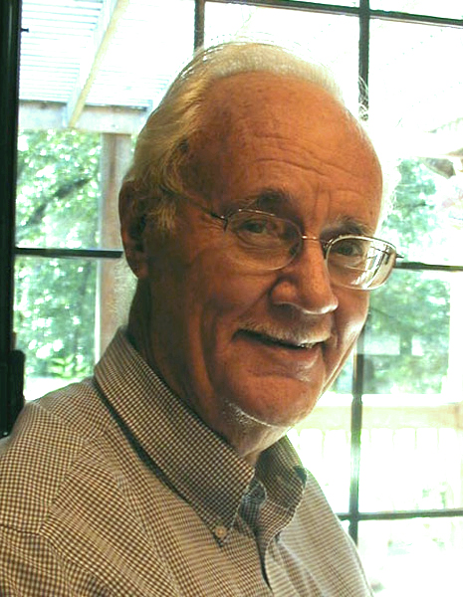

In Loving Memory
Paul G. Hiebert

