TRIBUTES TO PAUL IN E-MAIL FORMAT
(Compiled by Enoch Wan)

NOTE:
For privacy purpose, all e-mail addresses and references of personal nature – removed.

From: Georgia R. Grimes
Sent: Friday, March 16, 2007 11:04 PM
To: Enoch Wan
Subject: RE: may I have your "okay" and clear instruction of what is public and private
You have permission to send whatever I have forwarded on to you. EMS had a meeting here today and I hear did a wonderful tribute to Dr. Hiebert, and read his “Shorts and …” article

Attached is the photo of Dr. Hiebert from 1981 at Fuller.
Thanks Enoch, by the way can anyone get the article coming out April 1st?? I’d like to send the link to friends. (…personal notes deleted)

Georgia R. Grimes Shaw
(Paul & Fran Hiebert at Fuller Theological Seminary, 1981)
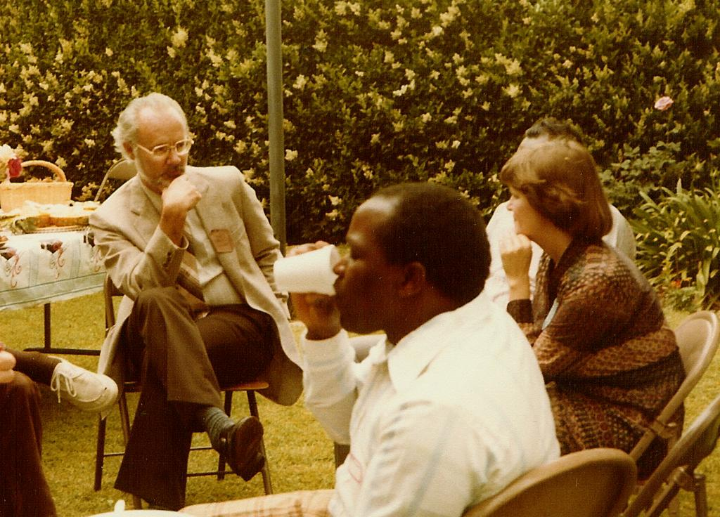
Roger Greenway wrote:
Date: Mon, 11 Dec 2006 20:22:04 -0500
From: "Roger Greenway"
To: <enochwan@yahoo.com>
Subject: Re: our mutual friend Paul Hiebert
Dear Enoch,
Thank you so much for the update on Paul Hiebert. He is a dear brother,
America's foremost anthropologist and one from whom all of us have learned a great deal.
I would like to write him. Could you send me an email or mailing address so that I can
write him? (…personal notes deleted)
A Blessed Christmas to you and yours,
Roger Greenway

From: Mike Pocock
Sent: Tuesday, March 13, 2007 10:35 PM
To: EMS-board
Subject: RE: [EMS-board] Paul Hiebert's home going & EMS-NW

Dear Enoch.
Thanks for sharing this news. I am in India as I write, the very place Paul served and I thank God for his life and ministry and impact on so many of our lives. I praise God he went peacefully and in triumph to his Lord.
God bless you Enoch. Warmly in Christ. Mike Pocock

From: Gailyn Van Rheenen
Sent: Wed 3/14/2007 6:51 PM
To: Enoch Wan
Subject: Re: [UNVERIFIED SENDER] THEME - A Memoriam of Paul G. Hiebert at www.globalmissiology.org
Enoch,
I wish I could find time to give honor to Paul Hiebert in this way. I cannot, however, add anything more to my schedule in the near term.
I feel the loss of this great mentor! (…personal notes deleted)
Blessings,
Gailyn

From: John_Newman
Sent: Tuesday, March 13, 2007 7:00 AM
To: Enoch Wan
Subject: Re: PAUL HIEBERT'S HOME GOING
Dear Enoch,
Thank you for sharing this news with us. It's wonderful you had so many good visits with Paul over these last few weeks. May you know His peace, comfort and hope at this time. Blessings in your ministry in equipping those who will carry Paul's torch/vision into the next generation - perhaps the completion generation! John Newman

From: Georgia R. Grimes
Sent: Fri 3/16/2007 5:43 PM
To: Enoch Wan
Subject: RE: Tribute to Paul Hiebert
Thank you so much for your immediate encouraging response, Enoch. The photo of Paul that was in Dan Shaw’s tribute was one I took in 1981 when I first met the Hieberts. Paul and Fran used one of my Folk Religion course papers for their book Case Studies for Missionaries and I was thrilled (to say the least). I also had the privilege of organizing the Hiebert farewell from Fuller, with numerous dishes from Indian students and Indian foods.

I refer to Paul as a “gentle giant”. Dan and I arrive in Ellicott City this Sunday evening for a week speaking with the Perspectives course – we had so hoped to visit with Dr. Hiebert, but it was not to be.
(…personal notes deleted)

Georgia R. Grimes Shaw

From: Sam Larsen
Sent: Monday, March 12, 2007 7:02 PM
To: Enoch Wan
Subject: RE: PAUL HIEBERT'S HOME GOING
Thank you, Enoch! I am grateful for your sharing Paul's cell phone number, as I was able to speak with him a week ago. Even then, he was ever the encourager! - Sam Larsen

From: Bill Thomas
Sent: Monday, March 12, 2007 2:02 PM
To: Enoch Wan
Subject: Re: PAUL HIEBERT'S HOME GOING
Thanks, Enoch for the message. Paul has left a great legacy.. (…personal notes deleted)

-----Original Message-----
From: Eunice Irwin
Sent: Monday, March 12, 2007 1:37 PM
To: Enoch Wan
Subject: Re: PAUL HIEBERT'S HOME GOING

Enoch,

Although it is difficult to say goodbye to such a wonderful colleague and example, I rejoice with family and friends, as well as all of his mission friends, for his victorious entry into heaven. May we be found faithful and follow him when our turn comes!

Thank you for keep us posted.

Blessings on you, his dear friend.

Eunice

From: J Samuel Escobar
Sent: Saturday, January 27, 2007 7:58 PM
To: Enoch Wan
Subject: Re: update on our mutual friend - Paul G. Hiebert

Thanks dear Enoch for this update. It is refreshing to hear about the courage and sense of commitment of Paul in spite of the trials through which he is going. We will pray for him.

(…personal notes deleted)

Peace,

Samuel Escobar

From: Mok Chan Wing
Sent: Wednesday, March 14, 2007 7:50 PM
To: Enoch Wan
Subject: RE: THEME - A Memoriam of Paul G. Hiebert at www.globalmissiology.org

Dear Enoch,

I don’t think I’m in a position to write because I have only read 2 books by him and know very little about him as a person.

Last month I sent you two papers written by my students as group projects on urban mission. Have you received them?

Wingyan

From: Richard Stellway
Sent: Saturday, February 24, 2007 10:34 AM
To: Enoch Wan
Subject: RE: Update on our mutual friend Paul Hiebert- in weakening state but welcomes phone call from you

Thanks, Enoch, for keeping us informed. It's such a blessing to rest in the memory of a full and fulfilling life and in the knowledge of a bright future with our Lord.
--Dick

Dick Stellway, Ph.D.
Facilitator, Viva Network AIDS Forum
www.viva.org/aids

Published in the special issue “A Memoriam of Paul G. Hiebert”
www.globalmissiology.org April 1, 2007

