REVELATION CONFRONTS CULTURE
Paul E. Grant (Brisbane, Australia)
(Paul began Pentecostal ministry in 1947 and continues in regular part-time lecturing - )
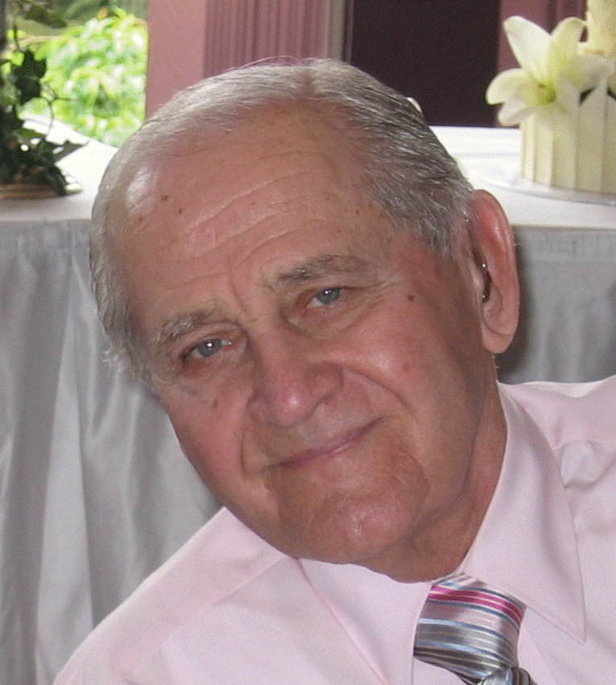

PROLOGUE

Malachi lived not long before the period of Greek (Hellenistic) culture. Within a little more than 100 years Alexander the Great would conquer the Persians and rule over the Middle East from Egypt to places close to India. Its language would become the medium for the New Testament writings. Egypt was under Greek rule. Alexandria was a university city of world renown. From there the Old Testament was translated into Greek – the Septuagint. In the third century before Christ three great philosophers emerged as men who would influence world thought for centuries from then until now : Socrates, Plato, and Aristotle.

Exiled Jews had returned to Jerusalem and Israel and rebuilt the Temple. They faced many difficulties and in many ways compromised their faith. Their failures occasioned the stern correction, and later, promise of ultimate blessing that would come through Christ.

Paul the apostle knew Greek worldview and language. He would have known the famous philosophers and their ways of thinking. He wrote : In the wisdom of God the world through its wisdom did not know him (1 Cor. 1:21). But he also said : … you are in Christ Jesus who has become for us wisdom from God (1 Cor. 1:30).

It intrigues me to think that before the time of the apex of Greek power, God raised up a prophet who would foretell the coming of John the Baptist and then Jesus. Then, later, he raised up Paul to show us that as great as Greek culture was (and other cultures too), it was deficient in that key area of bringing to people, universally, the true knowledge of God. Yet God would use the Greek language (not Hebrew) to spread the Gospel, orally, and by print (parchments).

This poem is an attempt to underscore the fact that cultural worldviews by themselves are simply unable to present to us an adequate knowledge of God. That their forms need the transformative power of the Gospel and the revelation of the Holy Spirit if they are to function for their destined effectiveness. And finally, that in the general sense, all thinking capabilities must be made obedient to Christ (2 Cor- inthians 10:5). That it is the Holy Spirit, who, if given entry, becomes the divinely designed “operating system” for our thinking mechanisms.

Finally, I am intrigued that God, who knows all things and pre-planned the world’s history and its climax, should show us that in himself, as the Triune God, there is the one and only way so perfectly expressed in Jesus’ own claim : I am the way, and the truth, and the life. No one comes to the Father except through me (John 14:6).

REVELATION CONFRONTS CULTURE

PART 1 (Revised 23.03.2007)

Intelligence and the power to reason
Come from our great Creator,
Whose original intent holds true
To be our navigator

As software is to the computer
So Word and Spirit to thinking,
They both enlighten and enliven
To bring a special discerning

Socrates, Plato, and Aristotle
Proposed, reasoned, and questioned,
Initiating new ways of conceiving
And knowledge that excelled

Their philosophies established
A foundation for Western thought,
And over these two milleniums
On this basis we have been taught

The question and answer method,
Analysis and definitions,
Concepts, logic, and debate,
And critical disputations

Inquiring minds probed ever further
Learning must have no end,
Why we are here and who we are
Challenged humans to comprehend

Yet this wisdom was frustrated.
In its avid search for meaning,
Intelligence alone was just unable
To discover the secret of living

Four hundred years after their time
Jesus brought a new dimension,
The apostle Paul showed that Christ had come
To set up our redemption

This unique redemption package
At its core brought wisdom,
No cultural heritage could match,
Its insights uniquely awesome

PART 2

If wisdom seeks to make a claim
To show itself superior
It must align with revelation
From the biblical criteria

Socrates’ role in teaching
Encouraged his pupils to question,
To find wisdom within themselves
By means of introspection

He challenged people to rigorous thought
An eminent facilitator,
The Bible however makes it plain
True wisdom is from the Creator

Paul refers to the wisdom of the wise
And the intelligence of the clever,
But for grasping the knowledge of God
Their mechanisms failed to deliver

Reason needed something else,
A mysterious Spirit power
To possess its potentiality
If God’s knowledge was to flower

Paul spoke of a wisdom that was hidden
The wisdom of Holy Spirit,
When the mind consents to his Lordship
This wisdom we inherit

Paul goes further when he says
The mind of Christ directs us,
Human thinking is thus transformed
And wisdom comes to its fullness

God’s revelations transcend reason
Yet reason under God’s rule,
Animated and enlightened,
Becomes irresistible

In a merger that only God could create
Spirit and reason participate,
Reason submits and communicates
A knowledge that authenticates

Authenticity is in more than the words
Of cultural imagination,
The authentic mind of God is conveyed
By the Spirit’s illumination

Revelation must descend into reason
And reason becomes its carrier,
Reason delights in the Spirit’s possession
To display God’s own insignia

PART 3

So I am intrigued that the finest thinking
When surrendered to God, its admission
Becomes so wonderfully transformed,
Its cultural destiny reaches fruition

Greek thinking needed a cleansing,
Then following, a conversion as well,
Its riches free of sin’s baggage
Would be fitted for the Gospel to tell

Greek thought, Greek words, Greek notions
Became instruments of the Divine,
Becoming free of self-serving interests
They gained a celestial shine

Cultural worldviews need conversion
Thinking and language are gifts from God,
When these are saved and sanctified
They pass the test of his measuring rod

First Corinthians Chapters One and Two
Stress the importance of revelation,
Thinking and words when so possessed
Exceed all human invention

Why? They are words taught by the Spirit
No eye has seen, no ear has heard
No mind has conceived these things,
Carried along by the Spirit-driven Word

When culture gate-keepers of our lands
Yield to the Spirit’s revelation
The mind of God will be known to all,
The focus on Christ’s exaltation

PART 4

Paul the eminent teacher and revelator
Grew up in Greek societies,
In Roman and other ethnic groups
He saw his opportunities

Cultural and religious pluralism
Describe that significant era,
Paul saw it as an opportunity,
For Gospel display, an arena

Called as an apostle to the Gentiles
He was under obligation
To penetrate and identify
With every race and nation

Ethnic and cultural barriers
Brought suspicions and divisions,
Jesus came to bring oneness
Dissolving these partitions

Cultural and ethnic differences
In Christ are reconciled,
In God’s own astonishing way
All believers are domiciled

Made one in a new global family
While retaining their distinctives,
People of every ethnicity
Become a new collective

The identity now is “sons of God”
Cultural status is superseded,
Gender and social categories
In Christ are now transmuted

Christ becomes the defining centre
Of this new community,
The diverse cultures of this world
Surrender their wisdom to Eternity

Cultural transformation will reach its goal
When people from every nation
Will stand before the Lamb and the Throne
Singing the song of salvation

Published in the special issue “A Memoriam of Paul G. Hiebert”, Poetry and Missions,
www.globalmissiology.org April 1, 2007

1 Corinthians 1:19
1 Corinthians 2:7
1 Corinthians 2:16
1 Corinthians 2:13
1 Corinthians 2:9
Romans 1:5
Romans 1:14
Ephesians 2:14-18
Galatians 3:26-28
Revelation 7:9-10

