Can Muslims be Reached with the Gospel?

Findings from Three Research Studies
Gordon Scott Bonham
Published in Global Missiology, www.globalmissiology.org, October 2023
Abstract
Three research studies provide information on gospel broadcasts to the Muslim world, prayer promotion for Muslims in the Middle East and North Africa (MENA), and involvement with disciple making movements. Together they offer insights on reaching Muslims with the gospel. The studies are from research One Challenge (OC International) has conducted in the past 12 years in cooperation with mission organizations focused on reaching Muslims for Christ. They each relate to Jesus’ statement about a plentiful harvest and instruction to pray to the Lord of the harvest to send workers.
Key Words: broadcast, MENA, movements, Muslim, prayer
Introduction
Aware of some research I had conducted, a group of Chinese church leaders asked me a few years ago for a presentation on ministering with Muslims. I decided that I could provide them with important findings by limiting details about the ministries, the sources of information, and the locations. I also conjectured that other ministries might also benefit from such a presentation.
This article comes out of that requested presentation and presents key findings from three research projects. The projects focus on ministries with Muslims in the Middle East and North Africa (MENA), and they represent three phases of the instructions Jesus gave his disciples in Matthew 9:37-38: “Then he said to his disciples, (1) ‘The harvest is plentiful, but the workers are few. (2) Ask the Lord of the harvest, therefore, to (3) send out workers into his harvest field.’”

Phase 1: “The Harvest is Plentiful”—Muslim Response to Gospel Broadcasts
The Global Response Management System (GRMS) included 17 ministries with evangelistic websites, radio broadcasts, television programs, and other electronic media between 2008 and 2013. It recorded responses to evangelistic presentations of the gospel directed to Muslims and other non-Christians in the Middle East and North Africa (MENA). Upon hearing that the GRMS was ending, One Challenge (OC International, henceforth OC) inquired if any analysis had been made of the data it had collected. None had been made and the GRMS data were transferred to OC. The GRMS contained three types of datafiles: Inquirer, Conversation, and Local Follow-up.
- The Inquirer file established a record with a unique inquirer identification number (ID) for each person who contacted the GRMS system in response to a gospel presentation.
- The Conversation file contained a record for each interchange between a ministry representative and an inquirer.
- The Local Follow-up file contained a record of each inquirer assigned to a local believer for follow-up.
The analysis linked records within and between the three files using the unique person ID. This resulted in a final response code for each contact grouped into three categories: 1) outcome of a contact that did not result in a conversation, 2) outcome of the last conversation that did not result in a local contact request, and 3) outcome of the local contact request.
A total of 33,395 people contacted the GRMS in response to a gospel broadcast during the six years of the system (see Table 1). The information in the system was too incomplete for some people to identify an outcome. For those where an outcome could be identified, 54% contacted the system only to leave a comment, and 14% left no contact information for follow-up. All other contacts were automatically forwarded to a representative of the appropriate ministry for a response. The representative’s response appeared sufficient for 17% of these, as they made no further contact with the system. Another 6% of these initial contacts with the system had a recorded outcome of waiting for representative, closed, or waiting for inquirer with no second contact by the inquirer. The gospel broadcasts engaged 9% of the people in multiple conversations: 3% who did not request a local contact and 6% who did. By the time the GRMS ended, 3% of the people who had responded to a broadcast of the gospel had either become part of a local fellowship of believers or were still interacting with a local contact.
Table 1. Outcomes of initial response
 |  | Number |  | Percent determined
Total |  | 33,595
Outcome not determined |  | 2,020
Outcome determined |  | 31,575 |  | 100%
 | One inquirer response | 28,561 |  | 90%
1 | Inquirer left no contact information |  | 4,287 |  | 14%
2 | Comment only, no ministry replies |  | 17,125 |  | 54%
3 | Ministry reply, no additional conversation |  | 5,239 |  | 17%
4 | Other |  | 1,910 |  | 6%
 | Last of multiple inquirer responses | 1,034 |  | 3%
5 | Inquirer left no contact information |  | 104 |  | <1%
6 | No ministry reply reported |  | 479 |  | 2%
7 | Ministry reply, no additional conversation |  | 448 |  | 1%
8 | Other |  | 3 |  | <1%
 | Local contact requested | 1,980 |  | 6%
9 | Contact requested; disposition unknown |  | 64 |  | <1%
10 | Local contact declined |  | 1,135 |  | 4%
11 | Local contact in process |  | 520 |  | 2%
12 | Local integration of inquirer in fellowship |  | 261 |  | 1%
The GRMS system requested people who contacted the systems to provide their age, sex, country, and a statement about their faith in addition to their contact information. People from 185 countries responded to the broadcasts with 80% living in the 17 countries of the MENA region. The largest numbers came from Egypt (8,646) and Tunisia (4,701). Those from Egypt represent 10 per 100,000 population, while those from Tunisia represent 44 per 100,000 population. One-third of the inquirers were 18-25 years of age, and an additional third were 26-35 years of age. Three-fourths were male and one-fourth female. On average, males were three years older than females.
Based on their faith statement and reason for contacting the broadcaster:
- 40% had non-Christian backgrounds and wanted to make a comment.
- 21% had non-Christian backgrounds and wanted to learn about Jesus.
- 18% had non-Christian backgrounds and wanted to become a follower of Jesus or wanted to know more about the faith they had already chosen.
- 21% had Christian backgrounds and wanted to recommit to, or grow in, the faith into which they were born.
Age affected the reason people responded to the broadcast. Among children younger than 14 years of age, 53% had non-Christian backgrounds and wanted to make a comment, 32% had non-Christian backgrounds and wanted to learn about Jesus or become a follower, and 15% had Christian backgrounds. Almost half (47%) of those 26-35 years of age had non-Christian backgrounds and wanted to learn about or follow Jesus. Adults 60 years of age or older were the least likely to want to make a comment, 22% had a non-Christian background and wanted to learn about or follow Jesus, and 42% had a Christian background and wanted to recommit and grow in the faith.
Geography also affected their religious background and reason for responding to the broadcast. The majority from Libya and Saudi Arabia were non-Christians and wanted to make a comment. The majority from Morocco, Yemen, Tunisia, and Algeria had non-Christian backgrounds and were interested in learning about or following Jesus. Lebanon and Egypt had the largest percentages with Christian backgrounds who wanted to grow in the faith.
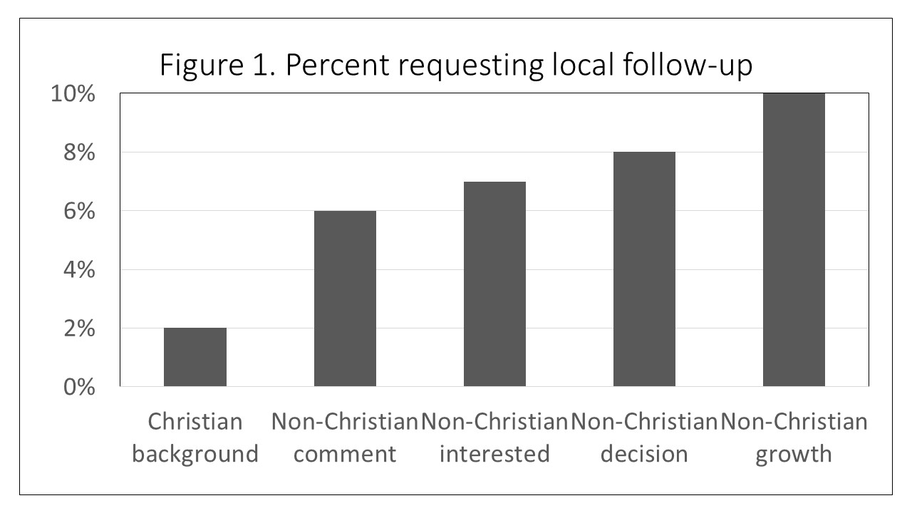
People’s religious backgrounds and reasons for calling affected, but did not determine, the final outcomes (see Figure 1). Very few (2%) of the people with Christian backgrounds requested local follow-up. Among those with non-Christian backgrounds who initially said they only wanted to make a comment, 6% became engaged with the ministry representative and subsequently expressed a desire to talk with a local representative. This figure increased to 10% when those with non-Christian backgrounds initially said they wanted to grow in faith in Jesus.
The GRMS data shows that the Lord has people in the Muslim world open to evangelistic presentations of the gospel through impersonal electronic and broadcast media. Some who encounter the good news this way will respond, particularly young adult men. Some of these may say they only want to comment, but interacting virtually with a Christian can lead to 6% requesting follow-up from a local Muslim background believer. In a Muslim environment, however, confidentiality and security are prominent issues. Connecting an inquirer with a local Muslim background believer must be pursued carefully, and only when the person is ready. However, a local contact is key for integrating Muslim inquirers into local Muslim-background fellowships. These GRMS findings are from a period just prior to the “Arab Spring” and may not reflect the current situation. However, the use and availability of technology has expanded since then, and many workers are being trained by the MTM (media to movements) Training Coalition (Preston and Bonham, 2021).

Phase 2: “Ask the Lord of the harvest”—MENA Prayer Promotion
The prayer promotion research was sponsored by a Christian networking organization in 2016 to discover and document the state of prayer promotion focused on the Middle East and North Africa (MENA). The objective was to identify ways that might increase prayer for the region. It sought to learn more about those who were leading and engaging in MENA-focused prayer and identify effective prayer approaches. The research identified 157 prayer network initiatives that included website home pages, focus pages within websites, social media accounts, and distribution lists. These initiatives focused on 40 topics such as specific countries, regions, or issues. They were produced or managed by 53 organizations and individuals. This project had three phases: Website Abstraction, Organization Survey, and Intercessor Survey.
The Website Abstraction phase showed that 61% of the sites offer the visitor two or more ways to get prayer information: 1) visiting the website or social media account (Facebook, Twitter, or YouTube) and 2) directly receiving the material (email, postal mail, text messages, and apps). The others offered prayer information only through the website (16%) or Facebook (23%). Two-thirds had a single focus on the MENA region. Of 69 websites, English was the only language that appeared available on 55 of them, Arabic was the only language on two, and Portuguese on one. The other 11 websites offered material in English and up to 100 other languages. Half of the websites updated prayer requests on their websites daily or weekly, and one-sixth sent out requests daily or weekly. The others updated them less frequently. Many of the websites also profiled countries, peoples, religions, or issues. Many also provided prayer guides. Half of the websites gave intercessors free access to prayer requests with no option for registration. Most of the others offered free access to prayer requests on the website and sent prayer requests to those who registered for them. A few sites (8) required registration prior to both viewing and receiving prayer requests. Most sites make no effort to report results of prayer or to indicate when they update their websites.
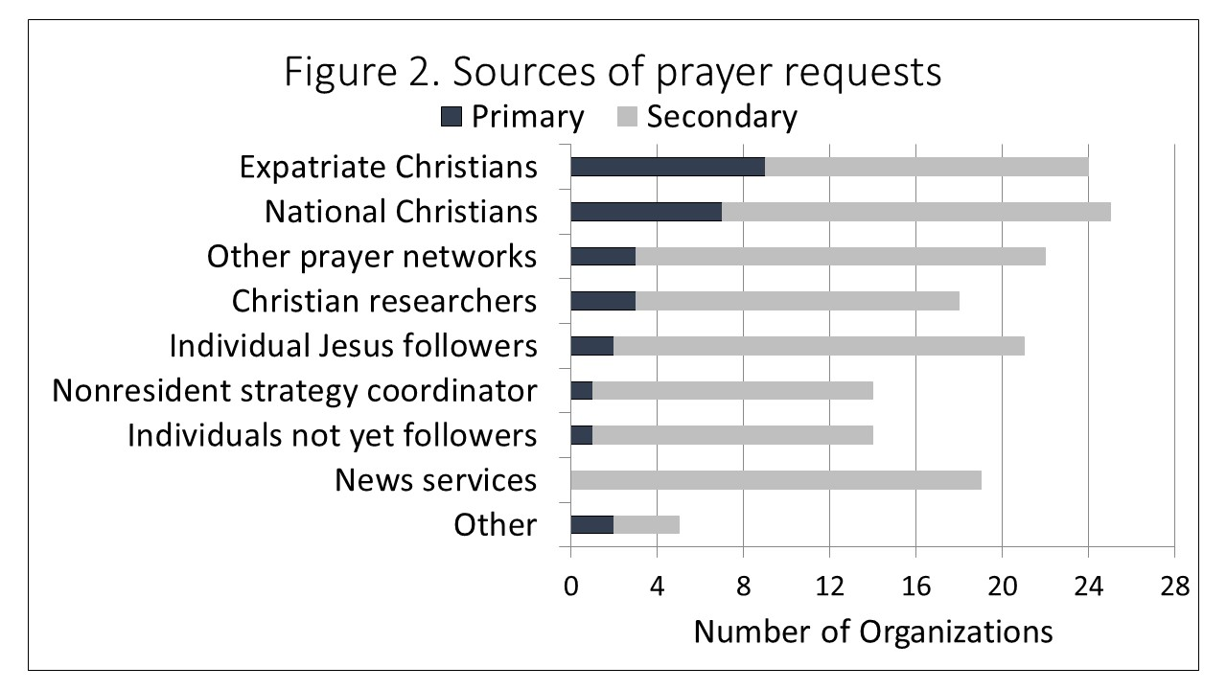
The Organization Survey included the distribution of a survey to 53 organizations, receiving responses from 33 of them. The survey collected information about the organizations and their MENA prayer initiatives not available on the websites. Most of the responders agreed that their organizations mobilized prayer (91%) and worked with other prayer initiatives (81%). They were less likely to agree that they had a dedicated staff person coordinating prayer requests (52%) or had adequate financial resources (43%). They indicated that distributing prayer requests through social media and email was the most effective method to mobilize prayer. Expatriate Christians were the primary source for nine organizations and a secondary source for 15 more (see Figure 2). National Christians were the primary source for seven organizations and the secondary source for 18 more. Three organizations relied primarily on other prayer networks and three on Christian researchers for prayer requests. Nineteen organizations developed prayer requests from news services, but none used them as their primary source.
The reach of prayer networks varied among organizations and by methods of distributing prayer requests (see Table 2). Five of the 33 organizations reported sending out an average of 620,940 prayer alerts each month. This number of alerts was more than ten times the average number of monthly visits to prayer websites that seven organizations reported. Over half of the organizations email prayer requests that averaged 2,931 messages in a month. Nine organizations distributed prayer requests through Twitter and nine through Facebook, with about five times as many Twitter followers as active Facebook users in a month. Six organizations reported conference calls to distribute prayer requests with an average of 37 participants on each call.
Table 2. Reach of prayer networks
Media format | Number reporting | Monthly distribution
Prayer alerts | 5 | 620,940
Website visits | 7 | 54,999
Website unique visitors | 8 | 25,291
Email messages sent | 18 | 2,931
Twitter followers | 9 | 2,344
Facebook users | 9 | 533
Conference call participants | 6 | 37

The Intercessor Survey phase requested help from the organizations to identify recipients of their prayer requests. Six organizations either provided email addresses or placed a link to the web survey on their website. Fifty people responded, many of whom were from a single organization. It is not possible to know how representative these 50 were, but they provide some insights. Most lived in the United States and Canada and were 45 years of age or older. Half were men and half women. One-third had obtained prayer requests from the website for three or more years. One-fifth were paid church staff. About half had financial involvement in the MENA region, and about half had personal experience (ministry, travel, or planning a ministry) in the MENA region. They varied in the frequency with which they got prayer requests: 18% at least weekly, 35% several times a month, and 47% less than monthly. Half of the intercessors got prayer requests from more than one website. Receiving a new request from the website reminded 53% of them to pray and was the only trigger for prayers for 16% of them (see Figure 3). Fewer (33%) said that visiting the website and finding new requests triggered their prayers, although this was the only method for about half of them (14%). Many intercessors also used a prayer list or calendar to help trigger their prayers, but few said it was the only triggering event. When they pray, 62% pray for two or three requests at a time, 26% pray for only one request at a time, and 12% pray for four or more requests at a time.
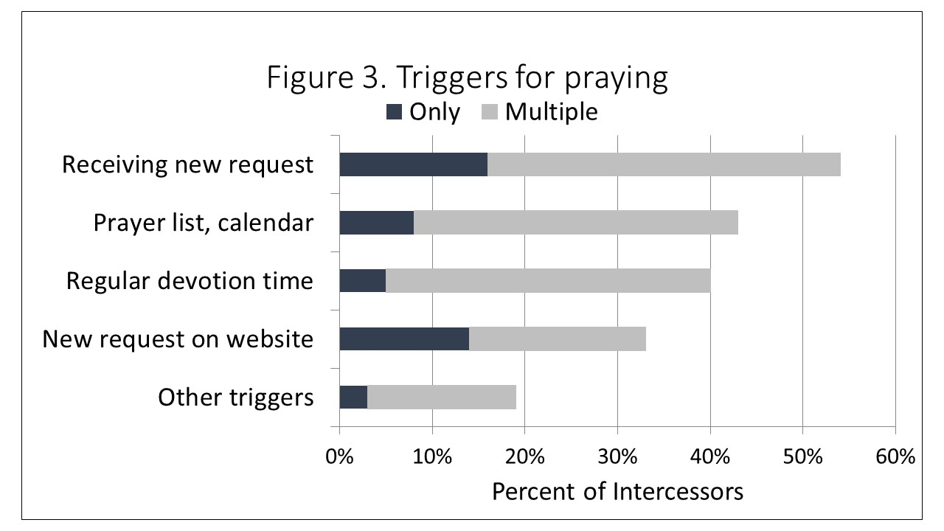
So how can prayer for MENA be encouraged? The frequent sending out of two or three prayer requests to committed intercessors appears to trigger the most prayers by them. It also increases the likelihood that they share the prayer requests with others. Praying is also encouraged by experience and by financial commitments in the region. Stories, testimonies, and relaying answers to specific prayers also encourages prayer, as does having a regular devotional time.

Phase 3: “Send out workers into his harvest field”—Disciple Making Community of Practice Survey
This survey about experience with disciple making movements included 44 expatriate Christians and 12 local Christians working with one of the expatriates. Most respondents ministered in Muslim communities. The questions covered:
- Involvement and interest in advancing disciple making movements.
- Familiarity with specific methodologies.
- Challenges they see in advancing disciple making movements.
- Interaction with co-workers and ministry partners.
- What would help them in the future.
Invitations to complete the English-language web survey were sent to 62 members of an international alliance in 2014; 44 responded. An expatriate in Southeast Asia translated the survey into the local language and reported the responses of 12 collaborating national Christians. Among the 56 combined responses, 28% were from nationals in Southeast Asia, 30% from people in or sent from the United States and Canada, 30% from those in or sent from Brazil, Guatemala, Philippines, Taiwan, and the United Kingdom, and 18% with origin and location unknown.
Respondents were interested in disciple making movements for several reasons. More than one-fourth were learning about them as a productive way to follow the Lord’s commission. About the same proportion had been trained in the methods but were not currently involved with a movement. About the same proportion were currently involved training others about movements and were involved with them. The remainder were involved with a movement only. Respondents used words like “effective evangelism,” “transformation,” “productive,” and “fruitful” when asked about the method.
“Disciple making” was the undefined general term used in this 2014 survey. Different terms were used at the time to describe different strategies. This survey presented respondents with a list of six names and asked them to choose the one which “most closely represents your disciple making strategy.” The three most frequently chosen names were the same as discussed in an article by Smith and Parks a year later (Smith and Parks, 2015):
- Thirty chose DMM, short for “Disciple Making Movements.” This number includes 17 English survey respondents who selected the initials, and all 12 non-English speakers when the English translator identified this term as what they were doing. One respondent wrote in “Discovery Bible Study.” According to Smith and Parks, DMM is one of the two major approaches to CPM as widely taught by David Watson, with Discovery Bible Study (or DBS) as its primary method.
- Seven selected CPM, short for “Church-Planting Movements,” which Smith and Parks identify as the original term for disciple making movements from which the two major adaptations have resulted.
- Six selected T4T, short for “Training for Trainers” developed by Ying Kai, which is the other of the two major approaches to CPM.
- Three selected the term Storying.
- Two selected the term Train and Multiply.
- Two selected multiple methods.
- Three wrote in other terms for their method: Dynamic Churches Intl, Ubabalo, and Urban DMM.
- Three did not respond to the question.
Disciple making movements are frequently discussed in terms of “generations.” A generation is a group of unbelievers who regularly read, listen, and discuss the Bible together. Those in the “first generation” are often led directly by a Christian trainer from a different culture. Those in the “second generation” are then led by those in the first generation, with indirect guidance by the Christian trainer. Those in the “third generation” are led by those in the second generation, etc. Close to half (44%) of the survey respondents had relationships with first generation groups, 40% had relationships with second generation groups, 26% had relationships with third generation groups, and 17% were involved with fourth or later generations. David Garrison defined a “movement” as “a rapid multiplication of indigenous churches, planting churches that sweeps through a people group or population segment” (Garrison, 1999, 7, emphasis original). Sometimes the “rapid multiplication” is measured by 500 or 1000 new believers baptized within a specified time such as one-to-three years (DMMs Frontier Missions, n.d.).
There appears to be a relationship between the method which respondents selected and the highest generational level of their involvement:
- 92% of the 13-person team that selected DMM (12 national Christians and the expatriate Christian who translated the survey for them) were involved with a fourth generation or beyond. The other person was involved with a first generation.
- 25% of the others who identified with DMM were involved with a fourth generation or beyond and none with a third generation.
- 17% of those who identified with T4T were involved with a fourth generation or beyond, and 50 % with a third generation.
- 14% of those who identified with CPM, were involved with a fourth generation or beyond, and none with a third generation.
- None of those identifying with other methods were involved with a fourth generation or beyond although 15% were involved with a third generation.
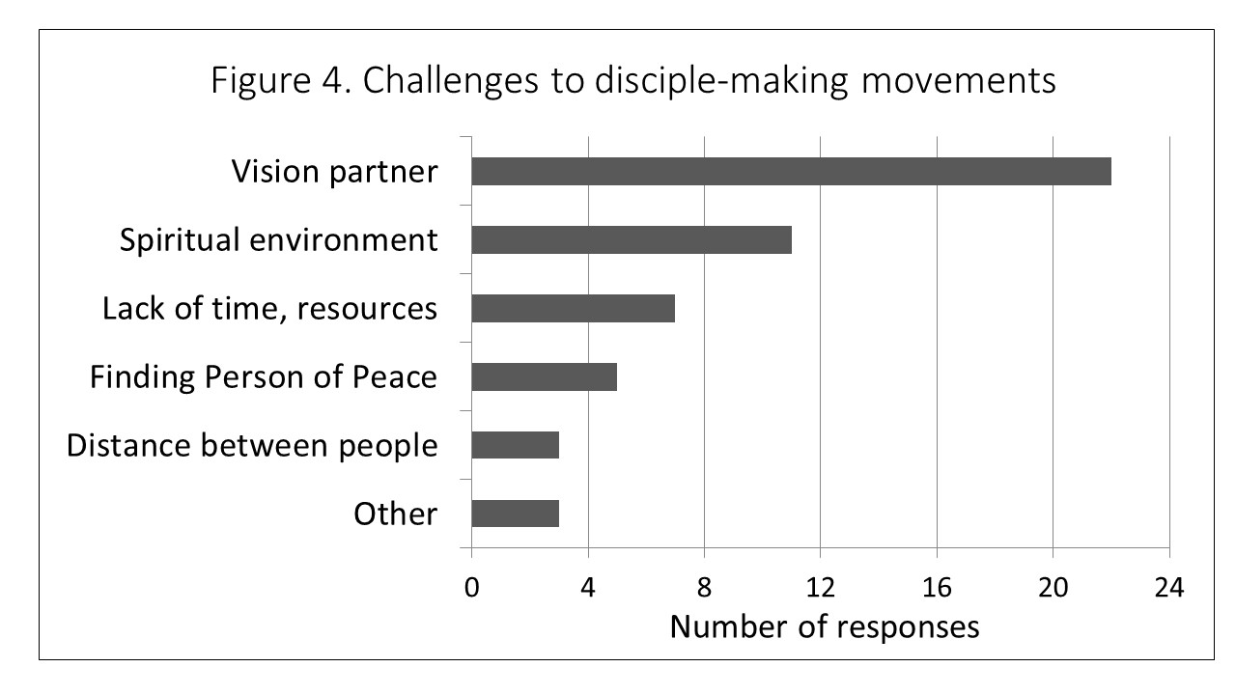
Respondents were asked about the specific challenges they see as they work to advance disciple making movements. The responses were classified into six groups (see Figure 4). The most frequent group of reasons (22 respondents) involved having partners with the same vision for disciple making. Example statements are:
- I’m lacking partners and a ministry platform….people are pretty satisfied with how things are.
- “Already believers”…just want to be fed and not reach out.
- The groups inclined to meet with Christians and not with unbelievers.
- It is hard for us to get national {church} leaders to embrace this method or receive specialists to mentor them.
- Getting pastors and denominations to cooperate.
- Leaders have mixed DMM up with cell churches.
The spiritual environment was mentioned next most frequently (11 respondents) but only half as frequently as vision partners. The spiritual theme included statements like:
- Most people in … are practicing Christianity by their cultural definitions.
- Blasphemy law, political unrest, belonging to a minority group.
- Infidelity in the community.
Seven mentioned a lack of time and resources, five the challenge of finding a Person of Peace, and two the challenges of the distance between people for communication and follow-up.
The survey identified people in all regions of the world who were interested in learning about and assisting disciple making movements. They expressed at the end of the survey that having a community of disciple making practitioners with whom they could pray, share, and learn together would increase their ability to advance disciple making movements. The main purpose of the survey was to build community among English-speaking workers, but such a community would be most valuable if it could involve local practitioners who communicate best in languages other than English. The survey found the greatest experience with disciple making movements was among one team in Southeast Asia for whom an expatriate Christian translated the English survey so they could participate. This finding probably indicates the importance of translation capacity to learn best about movements. Alternatively, it could mean that this team, or Southeast Asia in general, has some special experience with movements which could be instructive to others.

Summary and Discussion of the Three Projects
The first research project included in this article partnered with a ministry that was ending. This article is the first place where the findings have been publicly available. The partners on the other two projects have made the findings available to those they think are interested in them, but this article makes the key findings more widely available. The main commonality among the three projects is that they relate to Jesus’s instructions to look at the harvest field in the Muslim world and pray to the Lord of the harvest to send out workers. A second commonality is that the author conducted all three projects and can provide more detail within constraints of confidentiality. A third commonality is that these projects have shown me:
- The Lord has prepared the Muslim harvest field. Some Muslims are ready to receive the gospel and follow Jesus, and some of them can be reached through hearing an evangelistic message broadcast through electronic media. However, it is important for them to have ways to get more information and connect with others who can help them understand and grow in faith.
- Young Muslim adults are the most likely to respond to the gospel message as they transition from childhood to adulthood. Muslim men appear more likely than Muslim women to respond to an impersonal broadcast message.
- Disciple making movements expand as believers with Muslim backgrounds share what they are learning with their Muslim friends and relatives as they themselves grow. These often develop into a fellowship of Muslim background believers.
- Existing Christian churches may not meet the needs of Muslims within their community. Many focus on worship and caring for current members and do not have a vision of sharing the gospel with Muslims.
- When churches and individuals have a vision, Scripture says the prayer of the righteous is powerful and effective (James 5: 16). Prayer can be promoted through websites, messages, and social media. The most effective prayer promotion is to frequently send two or three detailed prayer requests to people committed to being intercessors. Sharing answers to prayer whenever possible appears to encourage praying, as does personal involvement with the mission field.
These project findings may or may not be representative of the broader knowledge of sharing the gospel in the Muslim world. The projects had specific purposes for specific ministries at a specific time and have helped the author learn about the Muslim harvest field and the workers the Lord has sent. The intent of this article is to help others learn more about, and to help them reach, Muslims for Christ.
References
DMMS Frontier Missions (n.d.). “Pursuing Disciple Making Movements in the Frontiers.” https: //www.dmmsfrontiermissions.com/disciple-making-movement-what-defined/
Garrison, D. (1999). Church Planting Movements. Richmond, Virginia: Office of Overseas Operations, International Mission Board of the Southern Baptist Convention.
Preston, F. and Bonham, G. (2021). 2021 Media to Movements Training Coalition Research Report. https: //www.mediatomovements.org/articles/global-survey-of-media-to-movements-report-2021)
Smith, S. and Parks, S. (2015). “T4T or DMM (DBS)? – Only God Can Start a Church-Planting Movement (Part 1 of 2)” Mission Frontiers (January-February). https: //www.missionfrontiers.org/issue/article/t4t-or-dmm-dbs-only-god-can-start-a-church-planting-movement-part-1-of-2)

