Shen, Xiao Feng with Dr. David Hunt. No Limitations: Brother Shen Xiao Feng – his story and writings. WorldServe Publishing, 2006. ISBN 1 894685 52-0. Hardback. 159 pages.

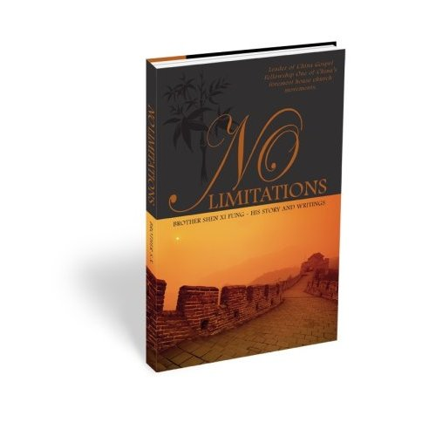

Reviewed by Wright Doyle - Director of China Institute, a ministry to Chinese in North America, Taiwan, and England (www.chinainstitute.org.tw). He and his wife live in Charlottesville, Virginia.

Of all the books on the house churches in China, this is surely one of the best. Indeed, it stands toward the top of any list I would make of Christian books, period.

The author, a leader in one of the large house church networks, displays remarkable balance, insight, depth, knowledge, humility, and charity– not to mention the courage and zeal we have grown to expect from house church Christians in China. This is an eminently sane book, with a mixture of the spiritual and the practical that is sometimes lacking in such accounts.

David Hunt, President of WorldServe, pens a Foreward that draws attention to a major lesson to be gleaned from No Limitations: “The Lord doesn’t need your strength. He needs your weakness, your dependence upon Him. He needs a vessel through which He can work with relentless power and ‘show that this all-surpassing power is from God.’”

“Part One – Revisiting the Past” takes us from Shen’s childhood through his release from captivity by the Eastern Lightning cult. Most of us would have been broken by the sufferings that he has endured, and sidelined by the rheumatoid arthritis that requires him to use crutches to get around, but he believes that God has used these to temper his soul, toughen his body, and tie him to God in humble reliance upon divine strength.

He writes of persecution by the government for notjoining the Three Self Patriotic Movement; constant itineration to evangelize unreached villages; miracles of healing, guidance, and protection. How different from ours were his “most common sermon topics”: “Self-denial, Suffering, Carrying Your Cross, and Evangelizing”! No wonder the Chinese church has grown exponentially, while those in the West languish amidst the cares of this world.

In “No House, No Money, Sick and Persecuted – ‘Will You Marry Me?’” he tells the story of his “courtship” and marriage. The hardships and trials endured by his wife are enough to make one weep, and yet she was willing to accept these as part of her vocation as his companion and helper.

Other chapter and section headings give the flavor of the book: “Torture and Forced Labor – A Normal Life”; “Emissaries Sent Throughout China”; “The Spirit’s Fire Ignites the Church”; “Jesus – Our Help and strength.”

A central section of color photographs depicting the life of house church Christians is followed by Part Two: “Envisioning the Future.” Here Brother Shen presents his reflections on church life in the era of reforms; “the Battle for Unity”; “Migratory Missions”; “Great Poverty Provides Great Opportunity to Share”; “Parasitic Dependence Versus Self-Sustenance of Church Workers.”

Shen introduces to us a house church leadership marked by organizational ability; utter insistence upon fidelity to the Bible; a hunger for unity; awareness of the challenges resulting from urbanization and globalization; eagerness to upgrade theological training for leaders; bold plans for missions.

These people will not surrender what they consider to be the truth in order to affiliate with the Three Self Patriotic Movement. Though Shen admits that there are believers within the TSPM, he states that its continued persecution of house churches, subservience to the government, and promotion of non-biblical theology (at the top; most at the local level are orthodox) make widespread close cooperation with house churches impossible.

Indeed, one of Shen’s purposes in writing No Limitations is to inform Christians outside of China of the true conditions facing believers in unregistered churches. They are “deeply hurt” by reports of full religious freedom in China and the donations of millions of dollars to an organization they consider to be compromised and corrupt.

Not that house churches have no serious flaws. Far from it. Shen faces these candidly, and frankly discusses improvements which must be made. Still, the growing unity, cooperation, toleration, and mutual trust among leaders of large networks – and especially the adoption of a common statement of faith in 1998 – attest to a “coming of age” that evidences real humility, maturity and sagacity.

Shen packs a great deal of material into a brief compass, often using lists to outline major categories. One gets the impression that he could write long chapters on each of the topics listed, such as (in a list of reasons why foreign giving has dropped off recently) “5. God wishes for the churches in China to mature amidst these trials.”

Which brings me to a theme increasingly prominent towards the close of the book: The financial needs of the house church and the merits and demerits of foreign aid. Shen voices ambivalence about receiving funds from abroad, but still utters a request for help, at least for a while.

Frankly, this part – and the strong plea for funds in the Conclusion by WorldServe President Hunt – bothered me a bit. When I considered Paul’s passion for helping the Christians in Jerusalem, however, I thought that perhaps Western believers should do something to help Chinese Christians who have lost all their possessions through persecution or who want to send teams of missionaries to people of other cultures (mostly Muslims) in China, but lack the means.

Another question raised by the book for me was: How effective is the leadership training it describes in the photo section, featuring non-stop, intensive lecturing for weeks on end? But I have heard that house churches are re-evaluating their training methods recently.

It’s hard to say what struck me most in this remarkable work by a man of obvious spiritual stature, but I must not omit the bold, and very practical, plans he and his colleagues have for sending experienced married couples on “migratory missions” – that is, long-term missions with the goal of settling among a people whose language and culture one must learn. Inspired by Western missionaries of an earlier time, Chinese house church Christians are overcoming their natural ethno-centrism to carry the Gospel to unreached peoples.

Though he describes the Back to Jerusalem Movement as “more a slogan than a movement,” Shen implies that he, too, shares the goal of “completing the circle” of evangelism (as Chinese believers see missions history).

When I first saw this slim volume, I wondered why the publishers had spent so much money on its hard cover and glossy paper. Now I think I know: A small gem that will be treasured for years to come, it is worth repeated, prayerful readings. I recommend that it be a required text for all those in the Western church who are, or aspire to be, leaders.

Whether we should give money to house churches is a hotly-debated subject. Any gifts should come with provisions for measuring accountability, but without control by outsiders. Many people believe that foreign money carries the potential for great disruption; the author himself expresses such doubts.

Therefore, though I highly recommend this book, I do not presume to judge whether it should result in donations to any Western organization, including WorldServe. It is simply too complex a question, and I do not have adequate information or wisdom.

Published in the special issue “A Memoriam of Paul G. Hiebert”, Review and Preview,
www.globalmissiology.org April 1, 2007

