QUINTESENTIAL GLOBAL SOUL

Charles A. Cook
Professor of Intercultural Studies and Mission (CTS)
Chair, Global Mission Roundtable (EFC)

A voice mail this month informed me that my good friend and mentor Dr. Paul G. Hiebert had finally succumbed to his battle with cancer. After hearing the news I slipped into my study and pulled down a number of his books and browsed their pages. I was again reminded of Paul’s great insight and wisdom which he shared so capably and humbly. In my mind, Paul was the exemplary Christian scholar! He had a remarkable ability to generate theory, articulate it in writing and engage his students in its application. But it was his manner of being, that was even more attractive! Paul was indeed a godly gentleman and a scholar! On both accounts he showed the way to those of us who were privileged to study under him or live with him.

So how does one recapture Paul Hiebert’s life? Well, the truth is no one really recaptures him for another … since each of us was touched by him in unique and personal ways. All of us who knew him have our own personal “Paul Hiebert memories.” Yet as I leaf through the last two decades where my life entwined with his, there are common themes, remarkable aspects to Paul’s life that I suspect all who knew him would affirm to be true.

HEART FOR GOD:
During a lectureship in 2003 held in Dr. Hiebert’s honor, a colleague and contemporary at Trinity, Dr. Ted Ward described Paul as “…a man of gracious integrity, brilliant in his capacity for reasoning, careful authorship and a man of humble spirit reflecting the Lord Jesus Christ.” It’s this last aspect that overwhelmingly defined Paul!

The late Stephen Olford, lamenting our proclivity to religious celebrity, noted that over the course of his life he had received his share of honors, but acknowledged that when he, or for that matter any follower of Christ dies, “… if my family [or friends] don’t say, ‘There is something of God in the man I will have failed.’”

Paul had the “signature of Jesus” stamped all over his life and will long be remembered for his love for God, creative careful insightful reflection and love for the centrality of Christ in the lives of people around the globe. A humble man, Paul shunned celebrity living out the truth that, “…we have this treasure in earthen vessels, that the excellence of the power may be of God and not of us” (2 Corinthians 4:7, NKJV). Paul finished well enabling us to confidently say that he was indeed a study of what God can do through a man totally committed to Him!

HIEBERT ASHRAM:
Paul was not only gifted teacher, author and scholar, but a man who embodied what he believed! In the years that followed Fran’s death (1999), Paul opened his home to many students, birthing what he affectionately called the Hiebert Ashram (Pronounced "aashram"…derived from Sanskrit meaning protection). The Hiebert Ashram was a clear connection to Paul’s Indian heritage where Hindu sages live together engaging in spiritual, educational and physical exercise.

The Hiebert Ashram was organized around two central themes: fellowship and scholarship! Paul appreciated the fellowship, and enjoyed the interaction! We, of course, appreciated his kindness and valued his insight and willingness to speak into our lives! The Ashram was a busy place, occasionally hosting up to eight people at a time. While our days were busy with reading, writing and research. It was the times of fellowship that we grew to appreciate! Conversation over early morning coffee set the tone for the day! Paul would park himself in his large easy chair with a mug of coffee and anyone who wanted could join him and talk about whatever was on our minds before heading out in various directions.
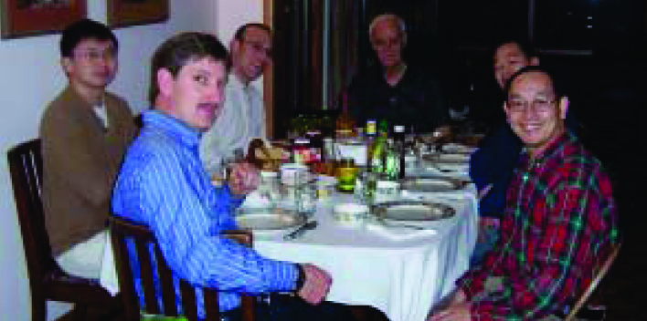

The evening meal often became another
focal point at the Ashram. We made many
interesting concoctions; the meal being a fascinating
study in collaboration, which often called forth
an interesting array of male culinary skills!
The global makeup of the Ashram guaranteed
an eclectic diet. Then, of course, there was Paul’s love of ice cream which spawned a delightful evening tradition, where after several hours of study and prior to bed, anyone who wanted, could gather in the family room over a bowl of ice cream and reflect on the day.
By and large the Hiebert Ashram was characterized by a collaborative spirit that infused every aspect of life together. A semblance of order at the Ashram was maintained through the ritual work bee on Saturday mornings followed by the regular requisite shopping expedition that included a stop at Trader Joe’s!

Paul’s generosity expressed in the development of the Hiebert Ashram added a significant component to the learning experience and gave new meaning to the concept of the community of learners! Those who shared in the Ashram experience have been forever shaped by the spirit of a man who loved learning, enjoyed people and wanted to tangibly assist in the preparation of leaders for the global church. It is one thing to observe Paul “from a distance” and appreciate his spirit and scholarship. It was quite another to watch him “up close and personal” and see the consistency of his life!

GLOBAL SOUL:
Paul was the quintessential global soul! He seemed to be at home in every corner of the world. Once he “retired” he enjoyed heading off on a more regular basis to some part of the world to help out with lectureship or module courses
—often at his own expense!
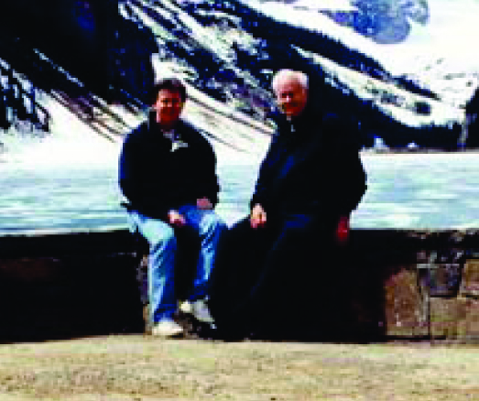
Paul enjoyed traveling and learning! His bi-cultural
skills, anthropological training and missionary kid heritage
likely contributed to his ability to be at home and enjoy
whatever cultural context he found himself in.
Paul enjoyed a quote about birds in flight that I thought
captured his spirit of a global soul: “Birds in flight,” wrote architect Vicenzo Volentieri, “are never really between places because they carry their places with them! They never really concern themselves with where they will live or what they will do, for “birds are at home in the sky, in flight. Flight is their way of being in the world!” Paul was in my estimation a classic global soul!

CONSUMMATE TEACHER:
Paul was also a consummate teacher! Now there is one thing about Dr. Hiebert that his family, students and colleagues know well! And that is that he couldn’t teach or explain an issue without generating some kind of sketch or drawing. On a delightful visit of the Banff/Lake Louise area of the Canadian Rockies we explored talked and enjoyed the wonder of the area.

One day as we wandered around Lake Louise he began to explain the theory behind something and the reason it was so critical to missiology. It suddenly dawned on that the sketch he was carving in the dirt with a stick would be difficult for me to pick up and keep. I scavenged some paper and there on the shores of Lake Louise in the majestic Rocky Mountains, Paul sketched out what he had been talking about! And as I followed his diagrams, I was suddenly overcome by the humor of the moment. For there before my eyes was the venerable Dr. Hiebert sketching some missiological construct on a scavenged piece of paper in the Canadian wilderness. Well we laughed and joked about the fact that he was willing to do almost anything in order to provide a significant teaching and learning experience!

GRACIOUS ENCOURAGER:
Paul was also a gracious encourager; I don’t recall him ever verbalizing an unkind word about anyone. He would often have “concerns” about choices people would make but he never expressed anything about them in a negative way. In debates or discussions with others he would often use his acumen and wisdom to employ what I called the straight stick principle. Ever the gentleman, Paul rarely forthrightly told you were wrong. Rather, if he perceived that there was another way of looking at an issue, he would express his thoughts on the subject by simply laying down a “straight stick” beside your “crooked stick.” As you compared your idea with his, it would often became self evident that maybe your approach was not necessarily all that well developed and that there was the possibility of understanding the issue from another perspective!
SCHOLAR AND LIFELONG LEARNER:
Few people I know could wed such broad knowledge with deep insight. Yet Paul had the ability to do so! He was certainly one of the few encyclopedics that I know! His knowledge on numerous subjects reached beyond his particular specialties of anthropology and missiology to a broad array of disciplines. One night as we sat reading in the family room he turned to me and said … “this is fascinating Charlie” …and proceeded to explain the intricacies of quantum physics and the importance understanding quarks and strings. Paul realized, with a rare perceptiveness, that for Christians to grow as intelligent followers of Jesus, intelligence itself must grow in them! He model that for me.

Paul had a curiosity for life and was always working at developing greater understanding! One night after an absence of a few months, I returned to the Ashram. Paul had recently turned 72 so we celebrated birthday over Chinese food and a bowl of ice-cream. I asked him what he had been up to and he informed me that he had just finished “brushing up” on his calculus and physics! “My calculus and physics was getting rusty,” he told me with his characteristic little grin, “so I ordered video courses and just completed them.” Paul was one of those great original thinkers. Over the years that I was around him I observed that one could often learn more from watching him think, than from just simply listening to him teach or from studying the content of his thought! Good as those elements were!

Paul also believed in the importance of writing. One of his often repeated statements was that “we don’t know a whole lot about the Apostle Paul’s ability to preach or even plant churches other than what we know from what he wrote down. So write, Charlie, write!” And write he did! A prolific writer, Paul generated over 150 articles and wrote ten books. Furthermore, down through the years Paul developed a passion for helping his students catch a vision for becoming scholars! Scholars who would serve God with both their hearts and minds! Paul Hiebert did an apt job of modeling both for us!

FINAL THOUGHT:
Well, much more could be said about Paul, and undoubtedly there will be! But I must close for now with those oft heard words of Paul during the writing of my dissertation; “Charlie, remember, you never really finish writing, you just quit!” So I will quit on this note!
Paul left the kind of legacy many would aspire to and I am thankful to be one of literally thousands whose life was touched by his! While we can no longer tell him how significant he is to us, we can honor him by imitating his character, honoring his convictions and heeding his counsel! I pray that his legacy of faith in God and his desire for excellence in scholarship will prevail in the lives of his students and those that read him! (Adapted from Heart in Hand #48, 2007-03).

Published in the special issue “A Memoriam of Paul G. Hiebert”
www.globalmissiology.org April 1, 2007

