Pioneering Precision and Transparency in Mission Work
Dwight Martin
Published in Global Missiology, www.globalmissiology.org, January 2024
Abstract
In the realm of mission work, the challenge of acquiring precise data is a constant struggle. This difficulty often leads to a profusion of figures being disseminated, which may lack specificity and clarity. Such ambiguity can result in stakeholders viewing the data with skepticism, a situation that could damage the mission organization’s reputation. Therefore, data accuracy and transparency are paramount for effective mission work and for maintaining the integrity of our faith-based endeavors.
The Harvest Church Database and KapTrack are innovative tools designed to enhance the accuracy and clarity of mission work data. Harvest provides a clear snapshot of the Body of Christ’s status across various geographical and church organizational structures. On the other hand, KapTrack is a multifaceted tool proficient in gathering data for diverse applications, such as tracking metrics on believers and churches, conducting surveys, monitoring resource usage, facilitating research, and tracking progress towards ministry goals. It also enables the creation of custom report dashboards, offering a more intuitive understanding and visualization of this data.
These tools are committed to preserving the integrity of faith-based endeavors by ensuring data accuracy and transparency. They serve as a beacon of trust and reliability in the mission field, illuminating the path towards a more informed and effective outreach.
Key Words: AFT, churches, dashboard, data accuracy, Harvest Database, integrity, KapTrack, software
Introduction
In 2002 I, Dwight Martin, software entrepreneur and son of a missionary, received a call from God to return to my native Thailand. I sold my business and, with my wife, journeyed back to Thailand from the U.S. in 2006. Certain Thai church leaders, remembering my parents’ significant contributions as Christian literature suppliers in the 60s and 70s, quickly recognized who I was.
The church leaders, recognizing my technical skills, requested my help to be the Research Coordinator for the Thai Church. These leaders wanted crucial data about the Christian community in Thailand, including the number of churches, the Christian population size, and their geographical distribution. As a result, I developed the eSTAR Foundation for the update and management of all the data (eSTAR Foundation n.d.a.) and the Harvest Church Database (Global Harvest n.d.).
Over a decade later, I identified a need for ministries to securely capture, retrieve, and visualize their mission data in near “real time.” To address this need, I developed “KapTrack” (Kaptrack n.d.). This tool allows users to create custom “capture” forms for remotely collecting many types of data. Each form is tailored to the ministry’s specific needs. KapTrack also features “intelligent” dashboards, making data visualization and understanding straightforward and accessible.
Both KapTrack and Harvest are secure web-based software applications, making them accessible worldwide. KapTrack is also mobile-friendly, with an app compatible for both iPhone and Android smartphones. These tools have significantly advanced data collection and visualization in mission work.
Harvest
Upon my arrival in Thailand, I was quickly recognized by the members of the Thailand Evangelism and Church Planting Committee. This committee was composed of top Thai Christian leaders from all the major church affiliations (Dahlfred 2009). Their goal was ambitious yet straightforward: to reach the nation for Christ. However, they faced a significant challenge. They lacked crucial data about the Christian community in Thailand, including the total number of churches, the size of the Christian population, and their geographical distribution. This lack of data was a significant roadblock to their mission.
With dual Thai and US citizenship, I have extensive cultural and language knowledge of Thailand. Recognizing these capacities, along with my technical expertise and deep understanding of software systems, the Thai leaders asked me to serve as their Research Coordinator for the Thai Church. The Thai leaders believed that I could help them overcome their data challenges and gain a better understanding of the status of the Thai Church.
Leveraging my business acumen and technical skills, I agreed to take on the challenge. We assembled a research team, and we embarked on the task of collecting data on all the churches in Thailand. The cooperation of all the major church affiliations made the data gathering process relatively smooth. The next challenge lay in developing a tool to visualize the data and make it accessible to the Body of Christ in Thailand.
To meet this challenge the team developed the aforementioned Harvest Church Database. This comprehensive digital database provides a detailed directory of churches, a visual map of Christian presence, and a locator for churches. The Harvest Database is more than just a collection of data; it is a tool for believers seeking to understand the state of Christianity in their particular country. For those interested in the Thai Church, for example, Harvest offers a platform to conduct comprehensive research from multiple perspectives, enabling a thorough understanding of the Church’s landscape (Church Cloud Solutions 2021a).
Maintaining an extensive database like Harvest comes with its unique challenges, especially considering the dynamic nature of churches. Churches are not static entities; they open, close, grow, shrink—and in Thailand relocate constantly. When questioned about the accuracy of the Harvest database, I offer the following thought-provoking perspective: “The data is 100% wrong, but there is nothing more right.” This statement reflects the inherent challenges of maintaining a dynamic database. Certainly, only God has the complete picture, but the database’s aim is to “think God’s thoughts after him.” The advantage of Harvest being an online platform, unlike a printed book, is its capacity for daily updates, ensuring the data remains as current as possible.
The Harvest Database's influence extends beyond Thailand. Christian leaders and organizations worldwide have expressed interest in developing a Harvest Church Database for their respective nations or organizations. Currently, Harvest is utilized in both “open” and “closed” countries. “Open” countries, where information is publicly available online, include not only Thailand but also Japan, Cambodia, the Philippines, and the Netherlands. Additionally, various ministries use Harvest as their private church database, demonstrating its global impact and versatility. Figure 1 below shows the home page of the Philippines implementation of the Harvest Database (Church Cloud Solutions 2021b):

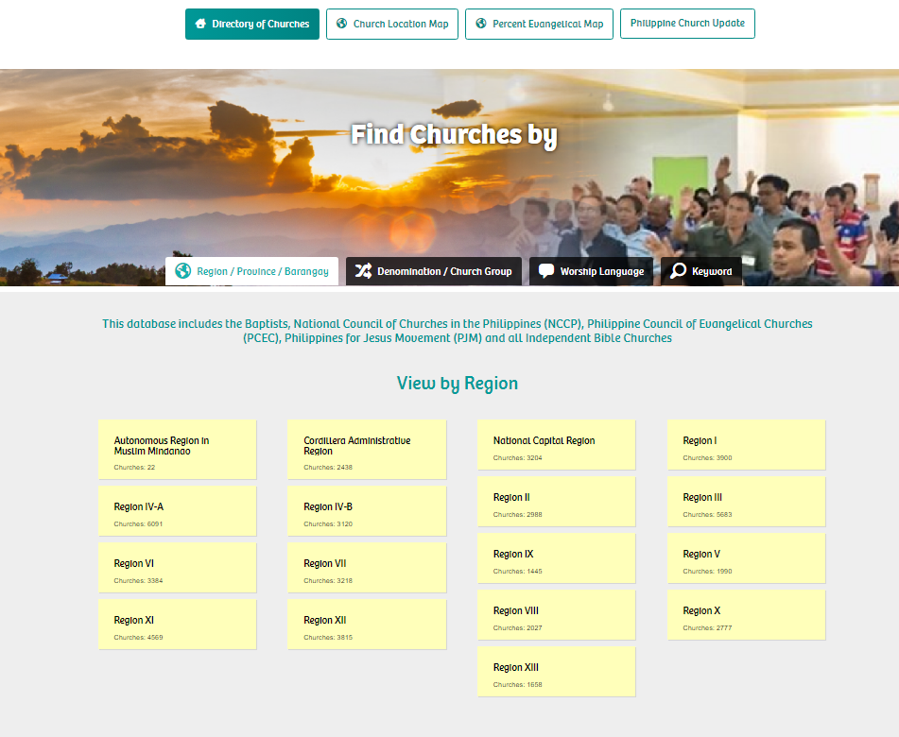
Figure 1. Philippine Church Update home page
The Harvest Church Database is a comprehensive repository of churches that serves as a tool for missionaries and Christians to help locate churches and educate themselves on the status of the Body of Christ in a nation. This database can also reveal fascinating insights about the distribution of the Christians in a country.
For instance, in Thailand the database reveals that the northern three provinces, which account for a mere 5% of Thailand’s total population, are home to a staggering 50% of the country’s Christian population and churches. These provinces are predominantly inhabited by various tribal groups, all identified in people group databases as an “unreached people group.”
While missionaries have made significant inroads into these “unreached people groups,” the data suggests that the largest segment of the population outside these groups remains largely untouched. In other words, while the focus has been on reaching the “people groups,” the individual “people” have been somewhat neglected. This intriguing fact, hidden until now, was brought to light by the Harvest database, underscoring its value in guiding mission strategies.
In 2016, after examining the data and feeling disappointment with the slow spread of the gospel in Thailand, I came across Jesus’s words in Mark 1:38, which sparked a change in my perspective: “Let us go somewhere else—to the nearby villages—so I can preach there also. That is why I have come.” I had a profound realization that Jesus’s mission was intended for the villages of the world rather than “people groups.” This insight inspired a deeper exploration of the Harvest Database, extending the data analysis to include the village level, going beyond just provinces, districts, and sub-districts.
What I discovered was startling and moved me to tears. Despite 200 years of Christian influence, with my own family being involved for 76 of those years, only 5% of the villages in Thailand had a Christian presence or churches. The corollary was that a staggering 95% of Thai villages lacked any Christian presence. I was left questioning the effectiveness of previous missionary efforts and wondering, “What in the world have we been doing?” Figure 2 below shows very clearly the data for all of Thailand as of April 2023:
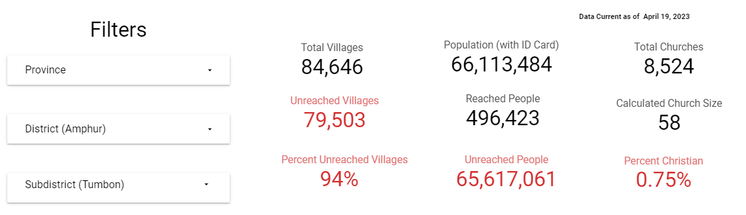
Figure 2: Thai Christian Data (eSTAR Foundation n.d.b.)
This revelation highlighted the enormous task ahead and the need for a renewed focus on the needed mission work. That need raised the question as to whether or not there was a national group in Thailand specifically targeting the villages. Indeed, there was! Around the same time, a country pastor named Somsak felt a divine calling to establish 1,000 churches and welcome 10,000 new believers by 2020.
Despite the enormity of this task, Somsak stepped out in faith and began establishing house churches. As the research coordinator with all the data, in 2017 I joined forces with Somsak and dozens of church planters. Somsak and the team worked relentlessly, and by the end of 2020 the Association of Free Churches (AFT, also known as the Free in Jesus Christ Church Association, or FJCCA) had established 1,087 house churches and welcomed 10,412 new members. This achievement marked a significant milestone in their mission work. The AFT revival became well-known and was featured on the cover of the April 2019 issue of Christianity Today (Shellnutt 2019).
At the end of 2020, after succeeding on their 2016 vision, the leaders of AFT established a new vision for the year 2021. This new vision was to establish 800 more house churches. Using the data at my fingertips I suggested a way for the AFT church planters to be strategic, rather than random, and do something that had never been done before: to completely reach every village in one Thai province with the gospel.
Having data on all the churches in Thailand, I knew that Phichit Province had over 800 villages without any Christian presence. I suggested establishing those 800 churches strategically by reaching every village in Phichit Province with the gospel. Once a house church had been formed in every village, the AFT would establish a district church in every district to continue mentoring and growing the village house churches. So that is what the AFT leaders decided to do.
KapTrack
Before the use of KapTrack, leaders of the AFT would manually record the names of those who responded to the gospel on paper, later transferring this data into a simple database. Recognizing the limitations of this method, I developed another application to streamline this process. Instead of writing down information, leaders enter data directly into a smartphone. This process includes taking a picture of the individual and capturing the GPS location where they first heard about Jesus.
However, KapTrack was designed to do more than just that. It was built with flexibility in mind, allowing the creation of custom forms to capture any type of remote data. Moreover, since the mobile version of KapTrack does not require an internet connection, users can collect as much data as they need throughout the day and upload it later when they have internet access. This innovation significantly improved the data collection process, making it more efficient and comprehensive.
When AFT church planters venture into a new village, they traverse every road and lane in search of “persons of peace” (Luke 10). Once found, the church planters capture pertinent information about each new believer, enabling effectively returning to disciple them in their homes. As the church planters return, the house church grows organically from the original believer. Knowing where these individuals live and being able to track their discipleship growth ensures that no one is left behind due to a lack of information.
Imagine a map, teeming with dots (see Figure 3 below), each representing a person who has responded to the gospel message. Such a map is what you will see on the KapTrack dashboard. The dots are a testament to faith, showing the location of each new believer. This map is freely accessible (eSTAR Foundation n.d.c.). and provides a visual representation of more than 64,000 persons who have responded to the Gospel. Each dot represents the GPS coordinates where that person was found.
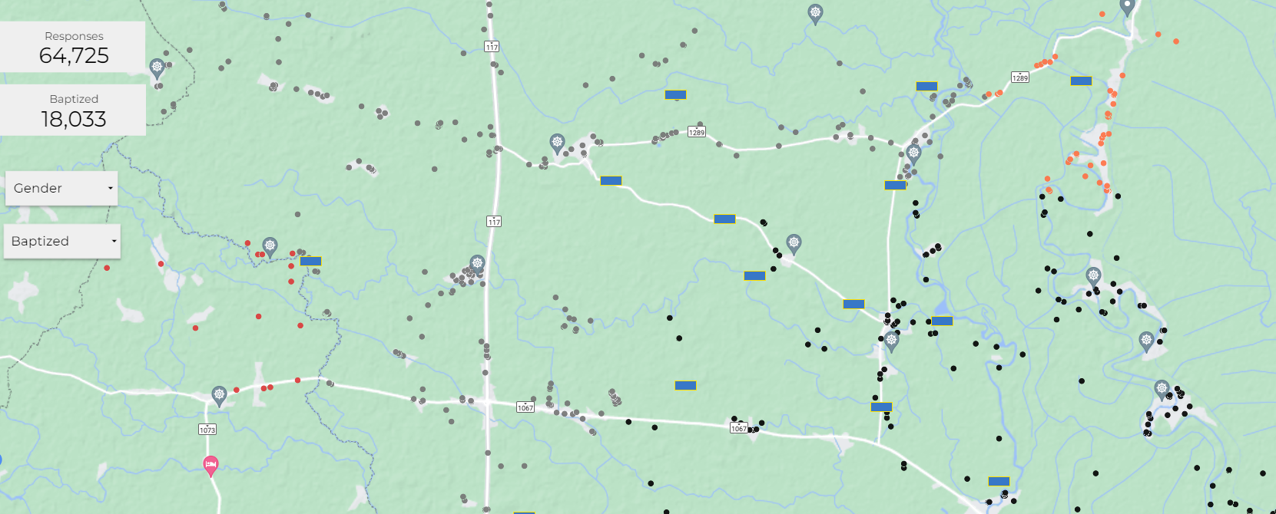
Figure 3: KapTrack Map (eSTAR Foundation n.d.c.)
AFT church planters make repeated visits to the villages, discipling the new believers and as a result many choose to be baptized. Once a house where people are being discipled has at least three baptized members, a different KapTrack form is used to mark that location as a new house church. Relevant information about this new Body of Christ is then recorded, marking another milestone in their mission work (eSTAR Foundation n.d.d.).
KapTrack is more than just a tool for tracking individuals or churches: it is also a vital asset for managing the data. It enables the creation of clear, comprehensive dashboards or “insights” that are updated daily with captured data. For example, Figure 4 below gives baptism data. These dashboards empower KapTrack administrators to generate reports on the captured information. For example, if an AFT KapTrack administrator requires information on unbaptized members, they can access this data with just a few clicks of a button. They can then view a list of unbaptized individuals who need follow-up to assess their willingness and readiness to be baptized.
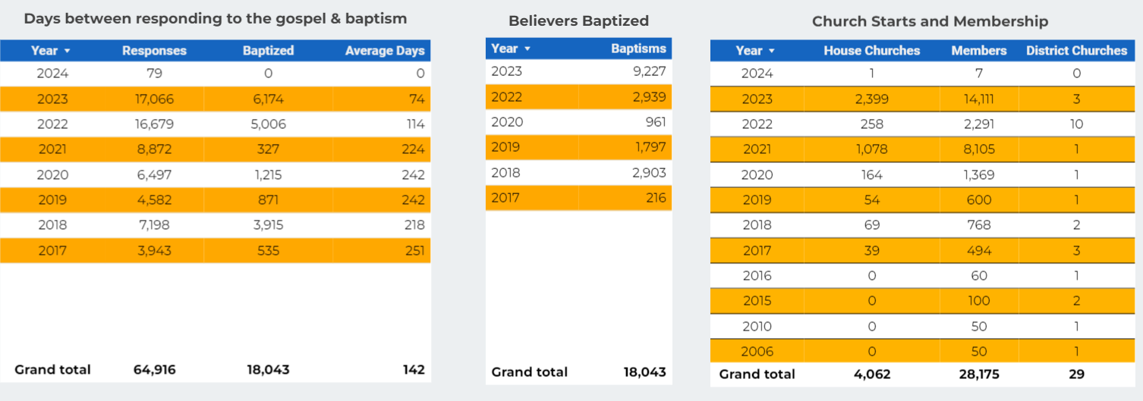
Figure 4: KapTrack Baptism Data (eSTAR Foundation n.d.c.)
KapTrack also serves as a significant source of encouragement. It not only identifies the “gaps” or areas that still need outreach but also allows AFT church planters to track their progress and the areas they have covered. The dashboards offer a deeper understanding of their members’ demographics, such as age and gender. Users can delve into these visual representations and conduct thorough research on the data. This feature facilitates effective management of the AFT revival, solidifying KapTrack’s role as an indispensable tool in the AFT’s mission work.
How KapTrack Helped Transform a Province
Phichit Province has been steeped in Christian mission history as “hard soil,” symbolizing the immense challenges faced in spreading the gospel there. However, the AFT church planters discovered an unexpected truth: the people of Phichit were not resistant to the gospel but in fact they yearned for it. This revelation ignited a determination within the AFT to transform Phichit’s “hard soil” into fertile ground for faith.
To accomplish this transformation, the AFT deployed around 40 church planting teams. Each team consisted of about four members and was assigned to share the gospel in 20 villages, returning weekly for over half a year to nurture and disciple the new believers until they were firm in their faith. These volunteer teams formed the backbone of the AFT mission.
However, just as the AFT church planters set out on their journey, they encountered an unforeseen obstacle: the COVID-19 pandemic. This global crisis threatened to halt their progress and cast a shadow of uncertainty over their efforts. Yet, fortified by their faith, these leaders were undeterred. They turned to prayer, seeking God’s guidance amidst adversity. In response to their steadfast faith, God showed them an opportunity. They decided to distribute masks and hand sanitizers while sharing the gospel, transforming their mission into a beacon of hope during a time of fear and uncertainty. This act of service allowed them to connect with the community on a deeper level, fostering meaningful conversations about faith and demonstrating God’s love and care in these challenging times. Thus, COVID-19 became an opening to reach the entire province.
Their journey involved traversing every road and lane, seeking “persons of peace” and to share Jesus with them. Their mission was not just to spread the word but also to establish house churches, following the Apostle Paul’s approach in the book of Acts. They faithfully recorded the fruit of their efforts into KapTrack.
Over two transformative years, the AFT church planters’ efforts bore fruit. House churches sprouted in every village, and district churches were established in all 12 districts of Phichit Province. The transformation was astounding. Phichit Province, once the seventieth least reached province (out of 77 provinces) with only 477 believers, rose to become the fourth most reached province in Thailand with over 20,000 people responding to the gospel.
Having successfully established house churches in every village of Phichit Province, complete with twelve newly established district churches and designated leadership, the AFT mission turned its attention to the next province—Phetchabun. In 2023, leveraging data from Harvest and KapTrack, the AFT managed to form one or more house churches in each of Phetchabun’s 1,562 villages and establish district churches in all 11 districts.
Looking ahead, the AFT has charted an ambitious plan. In 2024, they aim to reach every corner of Nakorn Sawan Province, followed by Khon Kaen Province in 2025, and both Chaiypum and Phitsanulok Provinces in 2026. After 2026 they will seek God’s guidance where to go next.
The two electronic data-gathering tools described above, Harvest and KapTrack, have been instrumental in guiding and recording the results of the AFT mission. Without these two platforms, accomplishing the monumental evangelistic and church-planting task just sketched would have been significantly more challenging, if not impossible. The journey of faith continues, one province at a time.
Conclusion
KapTrack, as illustrated in the Phichit example, has been instrumental in discipling a multitude of believers and initiating thousands of house churches. However, its capabilities extend far beyond this use case. KapTrack is a versatile tool that can be employed in any scenario where data, whether remote or paper-based, needs to be collected into a form, custom-built for each use case.
But KapTrack is more than just a data capture tool. It includes data “tracking” or database lookup with extensive search capabilities, and ultimately KapTrack boasts a powerful reporting feature that can create custom dashboards. These dashboards, filled with maps, graphs, tables, and more, bring the data to life, making it easier to understand and interpret the information.
KapTrack empowers ministries by providing an efficient way to manage their data. Furthermore, the end user, or church planter, benefits immensely from seeing the fruits of their labor. This visibility not only motivates the church planters to strive for more and do better, but it also allows everyone to witness the transformative power of their work. In essence, KapTrack is a testament to the remarkable results that can be achieved when technology and faith come together.
Finally, KapTrack serves as a communication tool for ministry donors. It enables the ministry to demonstrate how donations are being effectively utilized to further the mission. This transparency fosters trust and encourages continued support from the donor, making KapTrack an essential fund-raising tool.
KapTrack and Harvest are innovative tools that play distinct yet complementary roles in the realm of missions. KapTrack offers a detailed perspective, tailored to cater to diverse data needs. On the other hand, Harvest provides a broader view of the Body of Christ at various levels—national, provincial, or even denominational across multiple nations.
Harvest empowers national leaders, mission leaders, and denominations to devise comprehensive church planting strategies. But its benefits extend beyond strategy formulation. It facilitates communication among churches and ministries and provides extensive research capabilities to truly understand the “Status of the Church.”
At their core, KapTrack and Harvest are more than just data management tools. They are catalysts for understanding, communication, and strategic planning within the mission and donor community. They serve as bridges, connecting individuals, communities, leaders, and donors in the shared journey of spreading Jesus’s love and helping complete the Great Commission.
These tools transcend the realm of technology. They embody a commitment to fostering understanding, nurturing growth, and building trust. They serve as conduits, linking individuals and communities, and facilitating the sharing of faith and love. In essence, they are not just tools but companions in the mission of faith.
For those interested in learning more, I encourage you to visit https://kaptrack.com to learn more about KapTrack and http://globalharvestmap.com to learn about the Harvest Church Database These platforms offer a wealth of information and insights, serving as invaluable resources in the journey of faith.
References
Church Cloud Situations (2021a). Find Churches by…. Tuthai. https://thaichurches.org/directory/area/
_____ (2021b). Find churches by…. Philippine Church Update. https://philippinechurches.org
Dahlfred, Karl (2009). Evangelical Unity in Thailand. Gleanings from the Field. https://www.dahlfred.com/index.php/blogs/gleanings-from-the-field/76-evangelical-unity-in-thailand
eSTAR Foundation (n.d.a.). History of eSTAR. eSTAR Foundation. https://estar.ws/History.html
_____ (n.d.b.) Where Churches are Needed. eSTAR Foundation. https://estar.ws/
_____ (n.d.c.). The power of faith in action. eSTAR Foundation. https://estar.ws/AFT.html
_____ (n.d.d.). AFT Church. eSTAR Foundation. https://estar.ws/AFT-Churches.html.
Global Harvest (n.d.). View the Word as Jesus sees it. Global Harvest. http://globalharvestmap.com/
Kaptrack (n.d.). Kaptrack. http://kaptrack.com
Shellnutt, Kate (2019). Making Missions Count: How a Major Database Tracked Thailand’s Church-Planting Revival | Christianity Today. Christianity Today. March 15. https://www.christianitytoday.com/ct/2019/april/missions-data-thai-church-fjcca-reach-village.html

In this article, “the Thai Church” refers to what traditionally many have called “Protestant” churches.

