Transforming Thailand:
The Vision, Mission, and Impact of
The Association of Free Churches in Thailand
Dwight Martin
Published in Global Missiology, www.globalmissiology.org, July 2024
Abstract
Within the spiritual landscape of Thailand, Protestantism, despite being introduced in the nineteenth century, has yet to establish a strong foothold. In contrast to its Southeast Asian neighbors, Thailand's adoption of Christianity has been more limited. However, the Association of Free Churches in Thailand (AFT), an indigenous organization, is leading a spiritual revival. Through AFT efforts, God is revitalizing the spiritual lives of the Thai people and ushering in a new era of faith through the transformative power of the gospel. This article describes the AFT’s efforts and the accompanying, remarkable growth in followers of Jesus that is taking place.
Key Words: church planting, culture, discipleship, indigenous, Thailand
Background
Despite a 200-year presence of Christianity, it remains conspicuously absent in the majority of Thai villages. According to statistics from eSTAR Foundation in Thailand, an overwhelming 94% of these villages lack a Christian community (eSTAR Foundation, n.d.-a).
This absence has tangible repercussions for the dissemination of Christian beliefs; a significant portion of the Thai populace remains uninformed about the teachings of Jesus Christ. The reason for Thai people not knowing about Jesus is straightforward: the absence of Christians in their immediate vicinity.
Dwight Martin, a dual citizen of Thailand and the United States, has a unique bi-cultural heritage, having been born and raised in Thailand by missionary parents. His formative years in Thailand, coupled with his familial missionary background, have endowed him with a profound connection to the country and its religious landscape. Upon completing his high school education in 1974 Martin departed from Thailand, only to return in 2006, heeding what he describes as a divine summons.
Upon his return to Thailand, Martin assumed a pivotal role entrusted by the leaders of the Thai Protestant Church. These leaders expressed a pressing need for clarity regarding the Christian demography of Thailand, acknowledging a lack of comprehensive data on the number and distribution of churches across the nation. In response to this call, Martin took on the position of Research Coordinator, with the specific task of illuminating the obscured contours of the Thai Protestant community.
To address this informational deficit, Martin initiated the creation of the Harvest Thai Church Database (TUTHAI, n.d.). This digital repository was meticulously designed to collate and disseminate data related to the presence and geographical location of Protestant churches throughout Thailand. The establishment of this database represents a significant stride toward equipping church leaders with empirical insights essential for navigating and nurturing the Christian faith within a predominantly Buddhist society.

A New Hope
In 2016, upon reviewing the sparse presence of churches and Christians in Thailand—a scenario persisting for two millennia—Martin faced an acute existential crisis. This crisis was precipitated by his decade-long, personal and meticulous observation of the Thai Church's stagnation. Confronted with the glacial pace of church growth, he was compelled to question the future prospects of Christianity's influence within the nation. It was during this period of skepticism that Martin encountered a seminal moment: the discovery of a scriptural passage that would invigorate his mission with newfound resolve and strategic focus.
The passage in question, Luke 4:43, encapsulated Jesus’s purpose: “I must preach the good news of the kingdom of God to the other towns as well; for I was sent for this purpose” (ESV; emphasis added). Martin saw a connection between Jesus’s preaching approach during his life on earth and the mandated town-to-town evangelistic method of Christ’s body, the Church. Inspired by this divine mandate, Martin turned to the Harvest Thai Church Database, a repository of church-related data. His research extended beyond conventional statistics; he delved into the granular details, reaching down to the village level. Martin sought to discern whether the Christians in Thailand were in sync with Christ’s purpose—to spread the good news of the Kingdom of God across every town and village.
His findings were staggering: approximately 95% of Thai villages remained untouched by the gospel message. This revelation became the catalyst for Martin’s investigative odyssey. He sought to determine whether any organizations within Thailand were genuinely committed to bridging this outreach gap—to spreading the gospel across every town and village.
In the course of his inquiry, Martin’s path intersected with that of Pastor Somsak, a fellow visionary. They shared a common goal: nationwide evangelism. Their collaboration would prove instrumental in reshaping much of the spiritual landscape of Thailand, transcending barriers and kindling a new hope. Martin’s data-driven approach, fueled by Somsak’s unwavering faith, exemplified the power of persistence and collective vision in reshaping the spiritual fabric of a nation.
During the same year, 2016, a powerful vision came to Pastor Somsak to significantly expand the footprint of the Free in Jesus Christ Church Association (FJCCA) footprint. Pastor Somsak is the leader of the FJCCA, a member organization under the Association of Free Churches in Thailand. Pastor Somsak’s goal was ambitious: to establish 1,000 new churches and welcome 10,000 new believers by the year 2020. His vision caught the attention of Dwight Martin. Moved by the goals and the potential impact, Martin joined Pastor Somsak. Together, they embarked on a mission to bring the Kingdom of God into every village in Thailand, aiming to achieve the vision's bold targets. Their partnership became a key chapter in the AFT's story, significantly enhancing its mission to reach out and grow its community across the nation.
Planting Seeds of Faith in Thailand’s “Hard Soil”
In 2021, after successfully completing their 2016 vision, the Association of Free Churches in Thailand embarked on another mission, aiming to establish 800 more house churches by the year 2022. Leveraging the data available in the Harvest Thai Church Database, Martin realized that approximately 800 villages in the province of Phichit (approximately 300 km north of Bangkok, in east-central Thailand) lacked any gospel presence. Inspired by this alignment of numbers, Martin proposed an unprecedented initiative: to reach every village in Phichit Province and establish a house church within each one.
The strategic approach involved a systematic progression which the AFT leaders and church planters readily adopted. As AFT church planters brought the message of Jesus and the Kingdom of God to each village, they diligently formed house churches, fostering spiritual growth and community engagement. However, their mission extended beyond the village level. Once all the villages within a district were reached, the establishment of a district church followed suit. These district churches served as hubs for continued discipleship, ensuring that the seeds of faith sown in the house churches flourished and bore fruit.
Over the years Phichit Province had earned a reputation as “hard soil” for the receptivity of the gospel. Skepticism prevailed, and the prevailing assumption was that the local populace would resist the Christian message. However, the AFT church planters encountered a profound revelation: as long as the gospel was presented in a way that Thai people could understand, the people of Phichit were not resistant; in fact, they were hungry for the good news of Jesus. Their hearts longed for the transformative message of Christ. This realization infused the AFT mission with renewed vigor and unwavering determination.
By the close of 2022, the Association of Free Churches in Thailand achieved a remarkable milestone: the formation of a house church in every village and the creation of a district church in each district within Phichit Province. This concerted effort led to a profound spiritual metamorphosis, propelling Phichit from its former status as the 70th least-reached province for gospel presence in Thailand to an impressive rank as the fourth most reached.
The quantitative impact of this transformation is equally striking. In 2016 Phichit Province harbored a mere 477 church members. However, by April 2024 this number had surged exponentially, reaching a staggering 7,073 church members attending 1,010 house churches and 12 district churches. The legacy of this endeavor reverberates beyond mere statistics. Since then, the AFT has extended its reach to encompass every village in Phetchabun Province (adjacent to Phichit to the east), further solidifying their commitment to nationwide evangelism. Looking ahead, by this year's end, Nakorn Sawan Province (bordering Phichit to the south) is poised to witness the establishment of a house church in every village—a testament to persistence, collective vision, and the indomitable spirit shaping the spiritual fabric of a region (eSTAR Foundation, n,d.-b).
Evangelism
The Thai cultural perspective is intrinsically intertwined with Buddhism, encapsulated in the axiom, “To be Thai is to be Buddhist.” This statement reflects the profound integration of religion within Thai national identity. The Thai worldview is a syncretism of Buddhism, animism, and Hinduism, together which frame life as a cyclical journey of karma and suffering. In their quest for existential answers, Thais perceive the pantheon of deities they serve as insufficient in providing an ultimate resolution. Many are in pursuit of a singular, true deity. From a Christian standpoint, we know Jesus fulfills this role.
Immersed in this rich tapestry of Thai culture, Somsak's worldview was intrinsically shaped by the enduring traditions and beliefs of his homeland. At the age of 24, Somsak and his wife found themselves in dire need of money. With three children to raise, they decided to seek financial assistance from Somsak's mother-in-law, who lived more than 120 kilometers away. When they arrived, they discovered that she was attending an evangelistic outreach meeting. So they decided to patiently wait until the service concluded to speak with her.
During this waiting period, they listened to the Thai pastor's message. The gospel message they heard was so compelling that they both made a conscious choice to follow Jesus. They received a real sense of peace and joy after they believed in Jesus, to the point that they forgot to ask for the money! Once they returned to their home they were acutely aware that there were no other Christians within a 120-kilometer radius of their home. Their only option was to begin a journey of self-guided study and direct application of God’s Word.
Their decision marked the beginning of a transformative journey. This direct and unfiltered engagement with the Bible fostered in Somsak a worldview that is “Biblical” in essence, rather than one that might be termed “Christian” in the conventional sense. The latter term often implies an accumulation of interpretations and practices that have crystallized over the course of 2,000 years of Christian history. In contrast, Somsak's stance is characterized by an immediate and personal interaction with Scripture, free from the layers of historical and cultural accretion that have traditionally shaped Christian thought and practice.
This mode of learning and spiritual growth had a distinct advantage: it allowed Somsak to interpret and practice his new faith without the overlay of Western ideological influences. This culturally congruent approach to Christianity is now a cornerstone of the AFT's strategy. The organization employs native methods of evangelism and discipleship that are both biblical and harmonious with the Thai populace's worldview.
The predominant evangelistic practices imported to Thailand emphasize a doctrine that one should “Believe in Jesus, have your sins forgiven, and go to heaven” formula. This approach does not resonate within the Thai conceptual framework, where “sin” is perceived as an action that exacerbates one's karma rather than an affront to a Creator God (Venerable K. Sri Dhammananda Maha Thera, n.d.). Moreover, the concept of heaven, while acknowledged as a desirable realm, is not viewed as a permanent destination in Thai belief systems (Barre Center for Buddhist Studies, 2005). Instead, the ultimate aspiration is Nirvana—a state beyond the transient pleasures of heaven (Lopez, n.d.). This divergence in eschatological understanding necessitates a tailored approach to evangelism that aligns with the Thai worldview.
Beyond these ultimate questions to life, Thais are searching for contentment and tranquility in this life. As a result, they often turn to material and temporal solutions such as wealth (despite widespread financial indebtedness), gambling, transactional rituals with supernatural deities, and the fleeting pleasures of sex and alcohol. These pursuits, however, do not provide lasting fulfillment. In contrast, the gospel message offers liberation from these dependencies, presenting Jesus as the source of true and enduring joy and peace.
In the process of making disciples, church planters from the Association of Free Churches in Thailand, rather than using traditional Christian or imported evangelism methods, recount their personal life stories. They describe how their faith in Jesus has provided a peace and joy they never experienced before and provided a pathway beyond the cycle of karma. They proclaim Jesus as the supreme deity, the embodiment of absolute truth, and the only divine figure who can liberate individuals from the endless cycle of sin and rebirth, thereby granting salvation. After they present their personal story, they invite others to believe in Jesus.
Upon an individual's initial encounter with Jesus and their subsequent invitation to believe, the inaugural phase of discipleship commences with an invitation to prayer. At this juncture, the individual's acquaintance with Jesus is nascent, and their comprehension is understandably partial.
At this point in the individual’s experience, it is not within the evangelists’ or church leaders’ purview to judge the authenticity of that person’s salvation. The church’s mandate is to foster discipleship, and prayer serves as the foundational element of this process. Moreover, the practice of prayer—and notably, the experience of receiving answers to prayer—establishes a conduit for ongoing engagement. This interaction facilitates the spiritual nurturing and maturation of these individuals, who are akin to “newborns” in Christ.
Discipleship
Commonly, many Western trained Christians perceive evangelism and subsequent sinner’s prayer as the ultimate objective of reaching out to the unsaved. However, the Great Commission, as imparted by Jesus, mandates that the creation of disciples of Jesus, not converts, is the objective. It is through the sustained process of discipleship that the church planters of the AFT facilitate the transition of individuals from a Buddhist/Animist worldview to one that is biblically centered. This transformation is gradual and methodical, requiring persistent engagement and multiple interactions, usually over a six-month period. Only after a comprehensive understanding is achieved (as explained further below) do individuals make the decision to undergo baptism and integrate into the communal structure of a house church.
The six-month discipleship program is designed to transition individuals from an initial response to the gospel to a robust and well-grounded understanding of their identity as followers of Jesus Christ. The program is structured in the following four steps:
- Relationship – Working through the “Prayer Booklet” serves as the initial step, fostering a personal connection with Jesus. After praying to trust in Jesus and praying for divine help, many report miracles that have occurred in their lives. Others report other transformative experiences. However, the most common change can be described as a newfound sense of peace and joy.
- Foundation – “Plan of Jesus for You” is a booklet that lays the groundwork for comprehending the biblical gospel. This booklet’s effectiveness is maximized when utilized after the individual has cultivated a relationship with Jesus. Premature use may reduce it to just another tract with limited impact.
- Confidence – “River of Life” is engagement with the Book of John, including study and memorization of key verses. This stage provides an introduction to the Bible and bolsters confidence in the veracity of God’s Word.
- Knowledge – “Abundant Life” is a series of 17 foundational doctrinal lessons that build upon the established relationship with Jesus and understanding of the gospel. Topics include what it means to be born again, why we need to repent, the nature of devotions, the importance of being a disciple of Jesus, the significance of baptism and communion, and the role of mentorship.
This locally developed curriculum is designed to enhance the spiritual understanding and commitment of believers, fostering their progression towards a well-founded and mature faith. It is not within AFT leaders’ purview to determine or dictate the exact juncture at which an individual embraces belief in Jesus during their discipleship journey. The leaders’ function is to facilitate these individuals’ growth as disciples. The process of transformation is attributed to the Holy Spirit's influence rather than human imposition.
During the initial phases of the new believers’ spiritual journeys, church leaders refrain from imposing constraints concerning customary cultural or religious rituals, such as temple visits. Leaders acknowledge that these individuals are in the nascent stages of spiritual development, akin to “infants in Christ.” Leaders expect that the new believers will of their own accord relinquish allegiance to other deities, forsaking previous practices to wholeheartedly follow Jesus alone.
The new believers publicly demonstrate their personal evolution through being baptized in the name of Jesus, aligning with the precedents set by the early disciples as documented in the Book of Acts, Colossians 2:9-15, and Romans 6:3-4. Baptism serves as a testament to their decision to forsake previous beliefs and deities and fully commit to Jesus and His teachings.
The delineated process above describes the foundational phase of discipleship, designated as Level 1. At the conclusion of this stage, church leaders determine the participants that have a firm understanding of what it means to be a follower of Jesus Christ and baptize them. Within this structure, AFT leaders also discern a subset amidst the broader congregation through seeing how the Holy Spirit is using certain individuals for progression to Level 2 discipleship. These individuals are earmarked by AFT leaders for specialized training to fulfill the responsibilities of house church leadership.
Furthermore, AFT leaders identify a smaller group within the Level 2 cadre based on their passion for the ministry, abilities, giftings, and availability for advancement to become Level 3 leadership. This elite group is groomed to take on pivotal roles as senior church planters and district church leaders. This tiered framework underscores the dynamic and evolving nature of discipleship, reflecting a systematic approach to spiritual development.
The Association of Free Churches in Thailand commits to the ongoing cultivation and instruction of its members, fostering a consistent trajectory of spiritual maturation. This commitment ensures that discipleship is not a static experience but a lifelong journey of growth and learning.
Data-Driven Discipleship
The AFT discipleship methodology, termed "Data-Driven Discipleship," is a strategic approach grounded in the scriptural mandates of Matthew 28:18-20 and Luke 10. This model emulates the mission of Jesus, who sent 72 disciples to various towns and villages to liberate them from spiritual darkness and introduce the Kingdom of God.
The graphical representation in Figure 1 below illustrates the Great Commission as the core of AFT’s strategy, highlighted within the yellow circles. The operational framework involves assembling teams that mirror Jesus’s selection of the 72 disciples. Each team is allocated a minimum of 20 villages, with the mandate to traverse every road and lane in search of “persons of peace.” AFT’s empirical data suggests that such individuals are present along every pathway in Thailand, necessitating proactive engagement to convey the gospel rather than the traditional passive approach of awaiting their discovery of our message.
Upon encountering receptive individuals, AFT evangelists share their personal relationship and experience with Jesus, and those who elect to place their faith in him are further nurtured in their spiritual journey. These “persons of peace” often become conduits for the gospel within their communities, inviting friends and neighbors to partake in the good news. This organic spread of faith culminates in the formation of a house church. When each village within a district has fostered such groups, AFT leaders then form a district church. Once this step is taken, there are hundreds of people from hundreds of villages desiring to be baptized (Martin, 2023).
The growth of these churches prompts continuous discipleship among both house and district church members, fostering the development of additional teams tasked with extending AFT’s reach to adjacent districts. This expansion strategy seeks to gradually introduce the Kingdom of God to more villages and districts, ultimately encompassing the entire nation. The Anointing Church of Ranong and the Next Stop Church in Lampang have asked to join the AFT in this mission, believing that such collaboration can create a greater impact.
AFT employs a software app called “KapTrack” (Kaptrack, n.d.), a data management system, to meticulously document the burgeoning network of believers and churches. This systematic record-keeping ensures the integrity and accuracy of AFT’s data, facilitating the ongoing assessment and enhancement of its discipleship model.
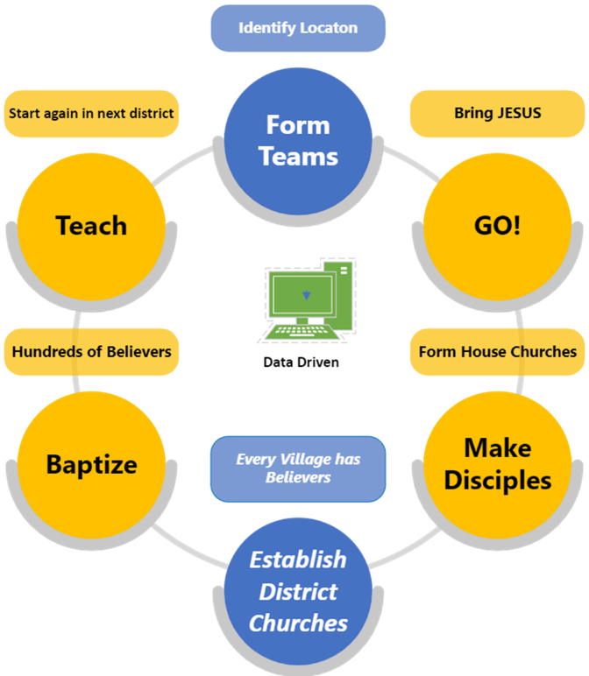
Figure 1: AFT Data-Driven Discipleship
Why This Methodology Works
The AFT mission is underpinned by a clear and universally supported vision. We in the AFT leadership are fortunate to have hundreds of dedicated volunteer church planters, driven by their passion to share the gospel with their fellow Thais. They are acutely aware that every minute, a Thai individual passes away without having heard about Jesus, and they are committed to reaching these individuals first.
The AFT approach is methodical and biblical. We systematically visit every village and road, seeking out “persons of peace.” These individuals are ubiquitous in Thailand, a country where people have been waiting for over 2,000 years to hear about Jesus. When they finally hear the gospel, it is incredibly good news.
AFT church planters maintain a comprehensive database of every new believer, recording their information. These records allow the church planters to revisit the new believers regularly for discipleship and to monitor their spiritual growth (Martin, 2024).
The AFT message is not one of legalistic religion, laden with rules and condemnation. Instead, we bring a Gospel of love, hope, and reconciliation with their creator God, a message that Thai people can readily embrace. We encourage them to immediately foster a relationship with Jesus through prayer.
The AFT recognizes that a district church can be an alien and uncomfortable environment for new believers. They may struggle with unfamiliar Christian terminology, and if they attend a church their family may object to their association with a “Christian church,” leaving them unsure of how to respond. Therefore, AFT church leaders do not compel attendance at a district church or adherence to various Christian regulations typically expected of new “converts” in the traditional sense.
AFT’s commitment is to disciple new believers with fidelity mostly in house churches, allowing the Holy Spirit to effect transformation within them. This transformation is evident over time as individuals naturally relinquish their previous beliefs. The spiritual journey is unique to each person, and we in AFT honor that individuality in our discipleship.
To address the challenges that new believers face, AFT forms house churches, providing these new believers with a spiritually safe and comfortable “home” environment in which to grow. AFT leaders return to these house churches often, discipling the people using Scriptural principles. Here, they learn what it means to be a follower of Christ and develop a “Christian vocabulary and understanding.”
Once AFT has established a house church in every village, we initiate a district church. The district church works in tandem with the house churches to facilitate their growth. When AFT inaugurates a district church, the believers from the house churches attend, filling the district church from its very first Sunday. If their family now objects to them attending a Christian church, they are equipped to “stand up” for their beliefs.
AFT leaders continue to disciple the believers with additional teaching, ensuring the continued growth of these churches. AFT does not close a house church, as it serves as the channel to guide more people to Christ.
Interactive Mapping of the Gospel’s Reach and Church Growth
The dissemination of the gospel in Thailand through the AFT can be systematically tracked through two interactive web pages that provide daily updates through the use of KapTrack. The first page is dedicated to visualizing the expansion of the gospel’s reach by mapping the geographical coordinates of individuals’ initial engagements with the gospel message. Each dot on the map below (Figure 2) corresponds to the GPS location where a person first responded to the gospel.
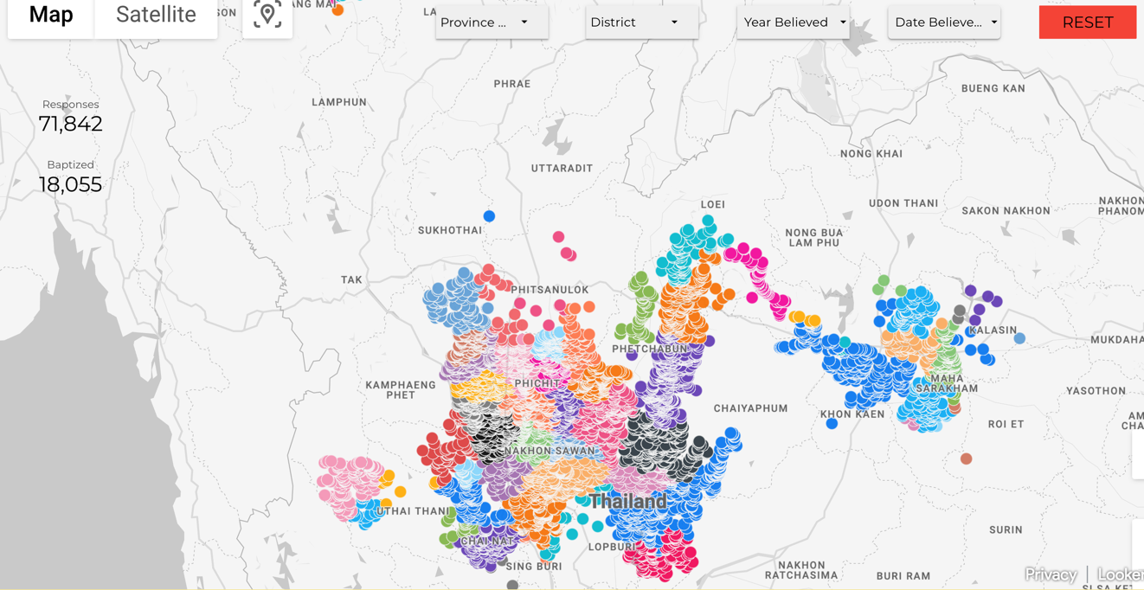
Figure 2 (eSTAR Foudation, n.d.-c)
The second page offers insights into AFT’s structural growth by charting the proliferation of house and district churches. Similar to the first web page, this second page (Figure 3) employs dots to denote the GPS locations of these establishments.
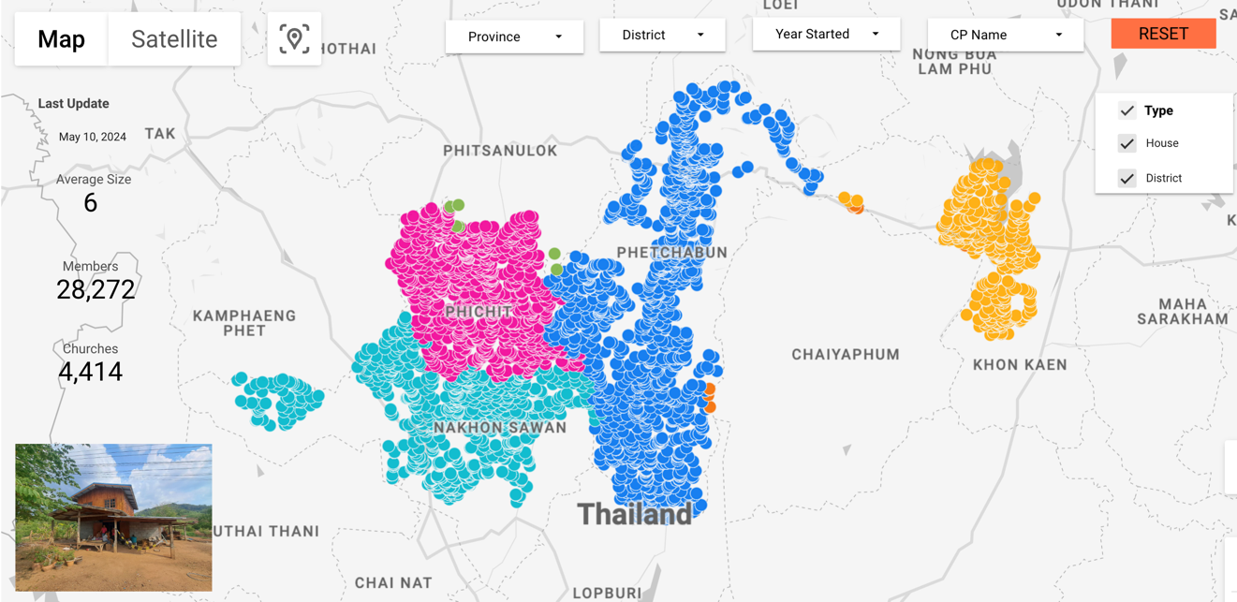
Figure 3 (eSTAR Foundation, n.d.-b)
Both web pages are dynamic, allowing users to tailor the displayed information according to their specific interests or research needs. Users can set various parameters to filter and analyze the data, thus facilitating a more personalized and in-depth examination of the gospel’s spread.
Conclusion
The AFT has had a profound influence on the lives of tens of thousands of Thai individuals who have accepted the gospel and experienced the love and power of Jesus. Remarkably, the AFT has not encountered opposition from either the government or Buddhists.
The vision of the AFT is to establish a house church in each of Thailand's 84,646 villages and district churches in all 928 districts spanning the country's 77 provinces. The AFT has already made significant strides, having reached all villages in the provinces of Phichit and Phetchabun. Their goal is to complete their mission in Nakorn Sawan by the end of 2024. By 2026, the AFT aims to reach all villages in the adjacent provinces of Khon Kaen, Chaiyaphum, and Phitsanulok. As the AFT continues to make progress in its mission, it is our aspiration that other Christian organizations in Thailand will recognize the impact of our vision and collaborate with us. With their support, we know that the transformation of Thailand can be expedited and achieved within a shorter time frame.
The AFT is reliant on the guidance of the Holy Spirit to direct their vision in disseminating the gospel across Thailand beyond 2026. This strategic and methodical approach underscores their commitment to their mission and their belief in its eventual success. We in the AFT believe that the Spirit is bringing an awakening and Kingdom expansion in Thailand, and we are deeply grateful to be participating in the Spirit’s work.
References
Barre Center for Buddhist Studies. (2005). Heaven: sagga. Access to Insight. https://accesstoinsight.org/ptf/dhamma/sagga/index.html
eSTAR Foundation. (n,d.-a). Where Churches are Needed. Data Current as of April 19, 2023. eSTAR Foundation. Retrieved May 17, 2024. https://estar.ws/
_____. (n,d.-b). AFT Churches. Data Current as of May 10, 2024. Retrieved May 20, 2024. https://estar.ws/AFT-Churches.html
_____. (n.d.-c). The power of faith in action. eStar Foundation. Retrieved May 20, 2024. https://estar.ws/AFT.html
KapTrack. (n.d.). KapTrack. Homepage. Retrieved May 20. 2014. https://kaptrack.com/
Lopez, Donald S. (n.d.). Nirvana. Britannica. Retrieved May 17, 2024. https://www.britannica.com/topic/nirvana-religion
Martin, D. (2023). Nov 10, 2023 baptism of 2,327 new disciples of Jesus Christ in Khon Kaen Thailand. YouTube video. https://www.youtube.com/watch?v=af13HzFU5uk
_____. (2024). Pioneering Precision and Transparency in Mission Work. Global Missiology, Vol. 21, No. 1 (January): 17-24.
http://ojs.globalmissiology.org/index.php/english/article/view/2838
TUTHAI. (n.d.). Find Churches by. TUTHAI. Retrieved May 17, 2024. https://thaichurches.org/directory/area/
Venerable K. Sri Dhammananda Maha Thera. (n.d.). No Sinners. What Buddhists Believe. BuddhaSasana. Retrieved May 17, 2024.
https://www.budsas.org/ebud/whatbudbeliev/182.htm

