**Multilingual Ministry: Identifying Languages and**

**Finding Bible and Other Resources**

Peter Brassington

Published in *Global Missiology*, [globalmissiology.org](http://www.globalmissiology.org), October 2025

**Abstract**

Linguistic hospitality and a multilingual approach to both integration and discipleship have many benefits. However, language difference is all too often seen purely as a barrier rather than as a bridge to deeper connection. One challenge that many local churches face in building such bridges of connection is that of finding and using Bibles and other resources in newly arrived people’s languages. This study thus seeks to help answer the following questions:

* How do you find what languages are spoken by people in your church and community?
* Why is that such a complex question?
* How can they find Bibles and other resources both online and, if desired, as printed books?

**Key Words:** multilingualism, intercultural church, Bible translation, Scripture engagement, language identification

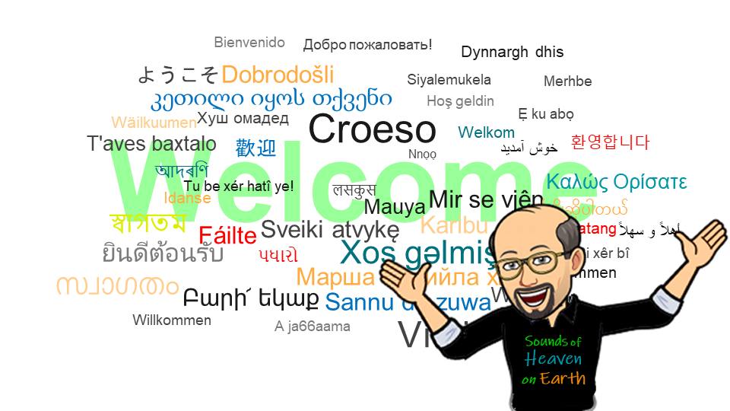

Linguistic hospitality, in which recently arrived people and their languages are made welcome, has many benefits, but language is all too often seen purely as a barrier rather than as a bridge to deeper connection. One barrier for churches is the not so simple challenge of finding materials. Another barrier is that it often does not occur to church leaders that exercising linguistic hospitality could be a good idea. This article explores the 'simple' challenge of identifying diaspora languages and finding resources ...with a bit more background on why those tasks are not so simple.

# The Complexity of Multilingualism in a World of New Neighbours

Knowledge that there are over 7000 languages in the world can mask the fact that almost 90% of the world’s population speak the top 200 of those as their first language. Even speakers of those top 200 can feel marginalised and unwelcome outside of their home country. Some develop their own diaspora maintaining their home language and familiar styles of worship, developing an oasis in which they can fully be themselves—while the next generation navigates identity in a bicultural space, not always feeling fully welcome in either space.

Although the detailed reports in past US censuses uncovered over 1,300 different named languages and dialects, smaller communities do not appear in public statistics, relegated to various categories of “other language.” Even so, these hidden languages are present and spoken in both major cities and smaller communities around the world.

When asked where I’m from, I might name the country, the region, or the precise town. My answer depends on who I am talking to. Having now lived in many places, I might mention ones that I think will provide a connection to the speaker. My place of origin is part of my identity, as is my language. I am not aware that I use many dialect words particular to my place of birth—my parents and school were keen to encourage me to use standard English—but there are a few pronunciations in my accent that give me away. There are also times when I, like many other people, change how I speak depending on who I am speaking to.

As part of an introduction to SIL’s Multilingual Assessment Tool, Sociolinguist Maik Gibson (2023) uses the image of both different tools and different types of clothes to explain how people use different languages as deemed useful and appropriate in different situations.

If talking to someone outside their local community, speakers of minority languages will switch to another language, but they may also switch within the community to show respect. A Kenyan colleague once mentioned how he (as an adult) had offended a school headmaster by speaking to him in a local language they both spoke, when the head clearly felt that his status and their location demanded they use English.

There can be prejudices about languages, dialects, and accents. These can lead people to mask their origins and opt for using what is perceived as a more prestigious language. This same tactic can also apply to the language people think is appropriate for using with God, even when they do not understand the “holier” language as clearly as the one they speak with friends and family.

Multilingualism is the norm for many people around the world, especially if their first language is not one of the most dominant ones used in government, trade, media, and education. In countries where monolingualism is considered the norm (at least by the dominant majority), the use of other languages is not significantly on the agenda of most churches—even in major cities. A British pastor I spoke to confided that his Nigerian elder spoke better English than he did. He had been surprised to learn that this elder often used another language at home and even when reading the Bible, in addition to reading in English.

How many languages are spoken by people in your church and community? There may be more than you think. How can people, if they wish, find Bibles and other resources in all the languages they use? Are there spaces where they can they pray and worship using both their heritage language and musical styles?

# Language and the Church: Embracing Diversity

When it comes to migration and multiculturalism, language can be divisive—both in terms of how issues are rhetorically framed and discussed as well as in the linguistic sense of which vernacular is used to do so.

‘Foreign’ languages are frequently used by both established communities in a country and by new migrants. The current rise in nationalism in a number of countries is often accompanied by increasing hostility towards migrants. Those migrants’ use of their own languages can be seen as a refusal to fully embrace and assimilate into their host culture. Linguistic prejudice is high, and addressing it involves more than a passing mention in a sermon.

A “more multilingual church” might start by acknowledging that there are multiple languages used by members of the church and by encouraging them to be used more in both personal and corporate settings. Where people feel marginalized, one step in validating their identity and experience can be through validating languages and cultures.

This approach does not have to be complicated. One very simple idea proposed by Josh Davis of Proskuneo ministries is simply including a word or two in another language: “You know the word holy in Spanish is Santo? Could you say that with me” (Davis, 2012).

Over the last 25 years those working with Proskuneo have also learned another truth: we each have things to learn from another! Beginning to open the door to more multilingual worship has opened the door for more conversations about culture and to fresh insights both about one another and about the God who loves us.

Does your church have a clearly articulated theology of language? Probably not, but people come with various assumptions, often including the idea that “for the sake of unity” people should all speak the same language when they come to church. But are you supposed to leave your language and culture at the door when you enter a church building?

Here is another insight from Proskuneo: “A lot of people believe that unity means that we all have to think the same way, want the same things, dress the same, talk the same, act the same. But unity and diversity are not opposites. They actually coexist beautifully in God and can also coexist beautifully in us as humans” (Davis, 2025).

Jesus did not say, “And I have other sheep that are not of this fold, and I must lead them. They shall hear my voice, and there shall be several sheepfolds….” Jesus rather speaks of one sheepfold and one shepherd (John 10:16). There are several reasons why we humans, including we Christians, like to stick in our own groups, and there are several reasons why that is sometimes helpful. However, there are also reasons why “we” need to get better at being more welcoming to “sheep from other folds.” And that is true whether you are from one of the larger groups in your town or city or whether you are part of a minoritised group.

# Theological and Historical Perspectives on Linguistic Diversity

Since the Jerusalem Council (Acts 15), the Church has struggled with how churches and their leaders recognise and reconcile differences in culture. Where Christian communities coexist, there are a range of models including segregation, assimilation, or various forms of intercultural church. Historically attitudes to other languages in both wider society and the Church have favoured segregation, sometimes under the name of homogenous units (McGavran, 1970) or assimilation (critiqued by Sanneh, 2003), seeking to maintain cultural and linguistic standards.

One often unchecked assumption is that linguistic diversity is purely the result of the fallenness of humanity and a punishment explained in the Babel story (Genesis 11:1-9). Within this view, the multiplicity of languages might be expected to be a temporary inconvenience, with restoration of a single language in heaven (or a new earth). Others see linguistic diversity as one more example of God’s love of variety, evidenced throughout creation, with an expectation that the fatal flaws present in each person and society will be addressed but that variety and a level of individual and cultural identity will be maintained without the prejudice and barriers that exist here and now.

Prior to Babel, God had told the sons of Noah to fill the earth (Genesis 9), and they did just that, as listed by “their clans and languages, in their territories and nations” (Genesis 10). However, at some point in the interim, while intending to spread out over all the earth serving and praising God, people stopped, distracted by an exciting new technology, known as the brick, and decided to make a name for themselves (Genesis 11:1-4).

God confused their language and “scattered them over the face of the earth” (Genesis 11:8), as per the original plan. Unsurprisingly there are different interpretations of Babel and different ideas about language.

Some have argued that Pentecost did not reverse Babel but instead underlines it. That view asserts that Christians have a message and a purpose, namely to go to everyone, everywhere, equal before God. That view further explains that others do not have to be like Christian groups culturally to be loved by God and that unity is not about uniformity.

In support of that viewpoint on unity-in-diversity is how Revelation 7:9 speaks of every tribe, tongue, and nation worshiping together. Language is about both communication and connection.

My own organisation, SIL, had helped translate Revelation, and the rest of at least the New Testament, into a thousand languages before embarking on a series of internal conversations on missiology leading to a symposium, and now a book, *Language and the Mission of God* (Greed, 2025). The book features chapters by over 20 authors from multiple countries, citing works from 400 other authors that had pondered aspects of this missiological topic concerning language before. It is not a light read, but it is often a gripping one.

**Welcoming the Stranger**

I am starting to ask monocultural churches the following questions:

* When you encounter people from another country, or even another part of this one, do you see them as a threat? …or as someone who might want to know about Jesus? …or as someone who might have some experience and insights that could help you?
* When you hear another language being spoken, does it spark your interest or raise your suspicions?
* When you meet someone from another church, do you see them as a brother or sister in Christ, or some distant cousin, who’s somehow part of the family but you’re not so sure about them?

When I get to preach, especially at Pentecost, I often talk about languages and different cultural expressions of church. I build on a growing list of resources (Brassington 2025) and do not always ask if my hearers know how many languages are spoken on earth today, or exactly how many, or how many they think will, or should be, spoken in heaven.

Differences can make us uncomfortable. Back in the 1970’s Donald McGavran stated that people “like to become Christians without crossing racial, linguistic, or class barriers” (McGavran, 1970, 198). This observation may be true to a certain extent, e.g., sociologically. The first Jewish Christians were certainly uncomfortable with the idea of Gentiles in the Church, and (reading in Acts 6) there were even tensions between Grecian Jews and Hebraic Jews—a situation that led to the appointment of the first deacons and structures to address inequality (Acts 6:1-6).

At a pragmatic level, there is much to be said for forming churches of groups of people who are similar to one another in many ways, especially when it comes to matters of language. This is particularly true when those people all live in the same place and form a church that looks and feels like a redeemed expression of their own culture. The challenge, however, is when the community is more diverse than “homogenous”; in such a setting, monocultural churches can also lead to segregation.

The ideas set out by McGavran and others in the “Church Growth School” in the 1960’s and 1970’s were not universally applauded and led to a consultation of different leading thinkers as part of the Lausanne Movement, resulting in the first Lausanne Occasional Paper. The paper affirmed that highlighting the importance of culture was both pragmatic (“churches grow fastest that way”) and biblical (“God desires it that way”). Whether that meant separate “homogeneous unit churches” or something else, participants were united in “celebrating the colorful mosaic of the human race that God has created,” opposing cultural imperialism, and stating that “colorless uniformity is a denial of the Creator and an affront to his creation. The preservation of cultural diversity honors God, respects man, enriches life, and promotes evangelization. Each church, if it is to be truly indigenous, should be rooted in the soil of its local culture” (Lausanne Committee for World Evangelization, 1978)

**Bible Translation, Availability, and Impact**

In the second half of 2025 a new milestone in global Bible translation was reached. There are now over 4,000 languages in which some Scripture or a Scripture-based product—including Jesus Films and story sets where there is no corresponding printed Scripture—has been made available and almost 1,700 in which translation work has begun but nothing is yet published (See Table 1 below). Initial translation of Scripture has increased at a dramatic rate in recent years, but not everything that exists is available, not everything that is available is accessible to everyone, and not everything that is available is known about or effectively used.

**Table 1: Completed Scripture and Work in Progress, Oct 2025**

|  |  |  |  |  |  |  |
| --- | --- | --- | --- | --- | --- | --- |
|  | **No**  **Scripture** | **Stories** | **Selections** | **New**  **Testament** | **Bible** | **Total** |
| Work In Progress | 1,642 | 171 | 922 | 1,204 | 508 | 4,447 |
| No Work in Progress | 1,691 | 65 | 315 | 600 | 273 | 2,944 |
| Totals | 3,333 | 236 | 1,237 | 1,804 | 781 | 7,391 |

(ProgressBible, 2025)

I work with a Bible translation organisation, and I am 100% convinced that everyone on the planet should have access to a Bible in a language and form that makes sense to them, and 100% convinced that translation alone is not enough. Bible translation is not just about *translation into languages*: it is *translation for and with people*, and the process needs to look beyond purely linguistic barriers.

For ten years I was responsible for explaining the publicly available figures on the progress of Bible translation. More recently I have been looking at availability, impact, and the challenges of finding Bibles.

The last challenge is partially addressed by apps, websites, and the search engines that trawl them. Even where the internet is not available and thus unable to bridge the whole distance, it brings Scriptures closer to those who can take it the last few miles or the last few hundred.

Two major Bible apps are YouVersion (Life.Church, 2025) and Bible.is (Faith Comes By Hearing, 2025).

YouVersion recently celebrated the incredible milestone of one billion downloads for their app which hosts over 3,500 Bible versions in over 2,300 languages. Bible.is provides access to Scripture in over 2,200 languages. Many of these Bible translations are on both platforms in text and audio. The platforms also including the Jesus Film in over 2000 languages, and one or more of the four gospels from the LUMO Project (LUMO Project Films, 2024) in over 1500 languages. LUMO has also produced a summary of the Old Testament, the Covenant, and a film of the gospel of Acts, all of which will be dubbed into hundreds of languages.

In addition to new translations, many older versions have been digitised and made available, with many more still to be added.

As mentioned, however, the internet is still not available everywhere on earth. The need for digital Scriptures that would work offline, and which could even be shared phone to phone, led to the development of Scripture App Builder by SIL, which allows for the production of customisable Bible apps (citation). Scripture apps are reported in over 1,740 languages using this software (Find.bible) but because it is available for anyone to use, there may be many unreported.

The conglomerate number of digitized Scripture available through YouVersion, Faith Comes By Hearing, and Scripture App Builder is depicted below (Table 2):

**Table 2: Number of Languages with Digitally Available Scripture, October 2025** 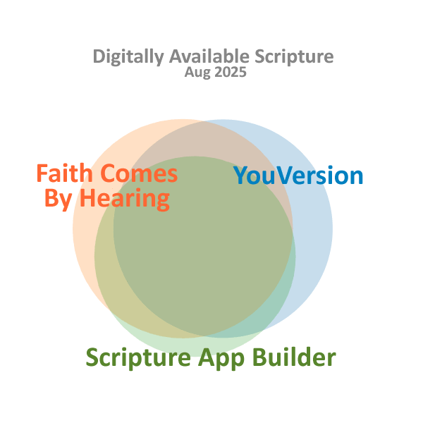

|  |  |
| --- | --- |
| YouVersion | 2,349 |
| Faith Comes By Hearing | 2,400+ |
| Scripture App Builder | 2,000+ |
| Total | 2,863 |

(Brassington, 2025)

Behind the scenes, two major platforms exist to make Scripture available to developers of apps and websites. These are The Digital Bible Library (American Bible Society, 2025) and Bible Brain (Faith Come By Hearing, 2025).

Not every product in every translation is on every platform, so it is useful to have sites that exist just to help ordinary people find Scripture in the languages they are looking for. One of the lesser-known pioneering websites in digital Scripture availability is ScriptureEarth (ScriptureEarth.org, n.d.), created in 2009 by a small team including SIL’s Bill Dyck:

I was working in the administrative office in the city of Lima, Peru. Two men from a village in a remote area of the Peruvian jungle came to my office one day. They were believers and had heard that we had made a translation of their Scriptures. They wanted their own copy of their New Testament. I felt bad that I had to tell them that there were no more copies available in Lima. We had shipped them all to their village. But they were now living in Lima and were not planning to take that long trip back to their village any time soon. The men left disappointed and empty handed. … How would you feel if Bibles in your language were no longer available? This incident gave me the vision to make Scripture available on the web.

From simple beginnings the site expanded beyond providing Scripture in the languages of the Americas to being a repository for Scriptures and linking to digitally available Scriptures on other platforms in (almost) every language known to exist  
(Doejaaren, 2017).

Another site with a similar goal and approach is Find.Bible, originally launched by the Forum of Bible Agencies International in 2006, and since 2013, managed on their behalf by the Digital Bible Society (Find.Bible, n,d.a).

While ScriptureEarth is aimed primarily at people looking for Scripture in their own language, Find.Bible is aimed slightly more at those looking for Bibles for other people. Clearly both sites are used for both purposes, and over the years the cooperation between the two enterprises has increased.

ScriptureEarth committed to keeping their website as simple as possible, aimed at users whose first language is not English and who may be in places with limited or expensive internet. Find.Bible seeks to aggregate additional information for its users by drawing in additional information about countries and languages from a variety of sources.

Both sites also include some links to sources of printed Bibles, but print availability can be harder to track globally. A newer site with a smaller scope is New Neighbour Bible (2025). This site is gradually expanding its list of print suppliers of minority language Bibles in Europe and North America and exploring new tools and techniques to aid in the identification and discovery of resources.

Each site sketched above does a difficult task well, but even in places with good internet access each faces challenges for example:

* Speakers of the languages offered (and others serving them) often do not know these sites exist.
* While on the sites, identifying the language one is looking for can be difficult.
* It can be difficult to decide which Bible version to use when there is more than one available.

In the case of the largest languages there can be a bewildering number of choices, e.g., 243 listings for Scripture on Find.Bible for English, 46 for Mandarin Chinese or French, 36 for German, 33 for Spanish (Find.Bible, n.d.b). For most minority language speakers there is often only one version in their language, or perhaps an old translation and a revision.

The first of the three challenges listed above might seem to matter less as long as search engines and now AI searches can find the information on the site (or reliable information elsewhere), but search engines can only find what someone has already carefully indexed and posted. It is still possible to find that a particular Scripture version exists without being able to get hold of it, or to not find it and conclude that it does not exist.

**Languages: Many Names, Duplicated Names**

¿Hablas español? Parlez-vous français? What a language is called by its own speakers is often different to the name(s) given to it by outsiders. There may be additional differences in how the various names are spelled, especially when using different alphabets and orthographies.

In addition to multiple names for each language there are often multiple languages that go by the same name, as well as complexities of dialects and groups of languages known as macro languages.

Keeping track of languages and their names is complicated. The Ethnologue demonstrates such complexities. Since 1951 the Ethnologue has grown from a hand-typed list of minority languages to the most comprehensive directory of all the known languages in the world and still seeks new contributors to aid with its annual updates (Eberhard, Simons, & Fennig, 2025).

ScriptureEarth includes a number of alternate names to help with searching, but it is not always easy to know from the name alone which language is which. The site also includes maps showing the main location a language is reported to be spoken in.

**Ask**

Whether one is a majority language speaker seeking to help others secure a Scripture in their own language or a minority language speaker in a new environment, the following advice is helpful: “Keep searching. It might be available under a different name or with a different spelling,” or it may not be online yet (SIL Global Diaspora Services, 2025). One can reach out to the various sites or translation agencies mentioned in this article and ask if they know more. Also, the Lord of the Harvest is ready to be asked for guidance. More Bibles, and more workers, are needed everywhere around the world, including amongst the diaspora in everyone’s neighbourhood.

**References**

American Bible Society. (2025). The Digital Bible Library. American Bible Society. <https://app.library.bible/tos>

Brassington, P. (2025). Other resources: Multilingual/Multicultural church resources. SIL Global Diaspora Services. <https://globaldiaspora.sil.org/other-resources>

Davis, J. (2012). Multilingual worship: Incorporating language into musical worship (pt 2) [Video]. Proskuneo Ministries.[youtube.com/watch?v=8xmuY5CFeRw](https://www.youtube.com/watch?v=8xmuY5CFeRw)

Davis, J., et al. (2025). Proskuneo documentary [Video]. Proskuneo Ministries.[youtube.com/watch?v=dSG98UcVxQ4](https://www.youtube.com/watch?v=dSG98UcVxQ4)

Doejaaren F. (2017). ScriptureEarth story [Unpublished internal document]. SIL International.

Eberhard, D. M., Simons, G. F., & Fennig, C. D. (Eds.). (2025). *Ethnologue: Languages of the world*. 28th ed. Dallas, Texas: SIL International. Online version: Methodology. Ethologue, SIL Global. <https://www.ethnologue.com/methodology/>

Faith Comes By Hearing. (2025). Bible.is. Faith Comes By Hearing. <https://www.faithcomesbyhearing.com/audio-bible-resources/bible-is>

Find.Bible. (n.d.a). *About*. <https://find.bible/about/>

Find.Bible. (n.d.b). *Bible Apps*. <https://find.bible/resources/collections/scripture-app-builder/>

Gibson, M. (2023). *Multilingual assessment tool: Intro video* [Video]. SIL International[sil.org/mat](http://sil.org/mat)

Greed, M. (Ed.). (2025). *Language in the mission of God*. SIL Global Publishing.

Lausanne Committee for World Evangelization. (1978). *The Pasadena consultation: Homogeneous unit principle* (Lausanne Occasional Paper No. 1). [lausanne.org/occasional-paper/lop-1](https://lausanne.org/occasional-paper/lop-1)

McGavran, D. (1970). *Understanding church growth*. Eerdmans.

Life.Church (2025). YouVersion. Life.Church. <https://www.bible.com/app>

LUMO Project Films. (2024). LUMO Project. LUMO Project Films. <https://lumoproject.com/>

New Neighbour Bible. (2025). *New-Neighbour-Bible*.[new-neighbour-bible.org](http://new-neighbour-bible.org)

ProgressBible. (2025). Home Page. Progress Bible. SIL Global. <https://progress.bible/>

Sanneh, L. (2003), *Whose Religion is Christianity: The Gospel Beyond the West*, Eerdmans.

ScriptureEarth.org (n.d.). ScriptureEarth. ScriptureEarth.org. <https://scriptureearth.org/>

SIL Global Diaspora Services. (2025). *Locating Scripture resources*.<https://globaldiaspora.sil.org/locating-scripture-resources>