PRE-PUBLICATION ANNOUNCEMENT

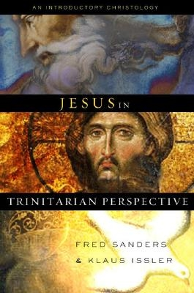

Jesus in Trinitarian Perspective
Contribution by:
Garret DeWeese Donald Fairbairn, Bruce Ware,
Scott Horrell
Editor: Fred Sanders & Klaus Issler
Product Description:
Jesus in Trinitarian Perspective features six highly respected scholars from schools such as Erskine Theological Seminary, Talbot School of Theology, Dallas Theological Seminary, and Southern Baptist Theological Seminary. These scholars address an issue that has a significant impact on the way Christians should approach everyday evangelism but is often ignored: the fundamental fact that the Savior who died on the cross and rose from the dead is the eternal second person of the Trinity.
The Christian church has confessed this truth since the early centuries, but many modern theologies have denied or ignored its implications. To clarify the complex issue, these writers approach “post-Chalcedonian” (451 AD) Christology from a variety of disciplines—historical, philosophical, systematic, and practical—thoroughly examining the importance of keeping Jesus Christ in trinitarian perspective. Major chapters include: “Introduction to Christology: Chalcedonian Categories for the Gospel Narrative,” “The Eternal Son of God in the Social Trinity,” “The One Person who is Jesus Christ: The Patristic Perspective,” “Metaphysical Models of the Incarnation: Person, Nature, Mind, and Will,” “The Atonement: A Work of the Trinity,” and “Jesus’ Example: Prototype of the Dependent, Spirit-Filled Life.”
This introductory Christology book is written for advanced undergraduates and entry-level seminary students.
Publisher: B&H Publishing Group
Pub. Date: September 2007
Type: Hardcover
ISBN 10: 080544422X
ISBN 13: 9780805444223
Product #: 005018273
Weight: 0 lbs
Trim Size: 0 X 0 X 0
Binding: Paperback
Price: $24.99

