Sample Books Helpful for Church Planting
See: http://www.northamericanmissions.org/?q=node/12

Book Reviews
Be Fruitful and Multiply
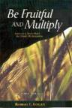 | Be Fruitful and Multiply  Author: Robert E. Logan  Binding: Paperback  List Price: $12.00 USD

Bob Logan – Book Reviews – Church Planting
read more – login or register to post comments
Indigenous Church Planting, a Practical Journey
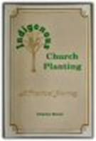 | Indigenous Church Planting, a Practical Journey  Author: Charles Brock  ASIN: 1885504276  Binding: Paperback

Book Reviews – Church Planting
read more – login or register to post comments
The Global House Church Movement
 | The Global House Church Movement  Author: Rad Zdero  ASIN: 0878083421  Binding: Paperback  List Price: $12.99 USD  Amazon Price: $10.39

Book Reviews – Church Planting – Rad Zdero
read more – login or register to post comments
The Ripple Church
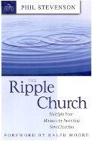 | The Ripple Church  Author: Phil Stevenson  ASIN: 0898272718  Binding: Paperback  List Price: $12.99 USD  Amazon Price: $11.04

Book Reviews – Church Planting – Leadership – Phil Stevenson
read more – login or register to post comments
Cell church planter's Guide
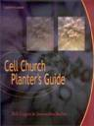 | Cell Church Planter's Guide  Author: Robert E. Logan and Jeannette Buller  ASIN: 0801026482  Binding: Hardback  List Price: $95.00 USD

Book Reviews – Cell Church – Church Planting
read more – login or register to post comments
Church Planting Movements: How God is Redeeming a Lost World
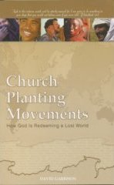 | Church Planting Movements: How God is Redeeming a Lost World  Author: David Garrison  Binding: Paperback  List Price: $29.95 USD

Book Reviews – Church Planting – David Garrison – Missions
read more – login or register to post comments
House Church and Mission: The Importance of Household Structures in Early Christianity
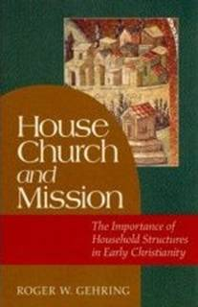 | House Church and Mission: The Importance of Household Structures in Early Christianity  Author: Roger Gehring  ASIN: 1565638123  Binding: Hardback  List Price: $29.95 USD  Amazon Price: $21.26

Book Reviews – House Church – Missions – Roger Gehring
read more – login or register to post comments
Introducing World Missions: A Biblical, Historical, and Practical Survey
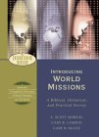 | Introducing World Missions: A Biblical, Historical, and Practical Survey  Author: A. Scott Moreau, Gary R. Corwin, Gary B. McGee  ASIN: 0801026482  Binding: Hardback  List Price: $29.99 USD  Amazon Price: $20.69

A. Scott Moreau – Book Reviews – Gary B. McGee – Gary R. Corwin – Missions
read more – login or register to post comments

http://207.200.19.180/images/10000/3000/216CI/user/306Barneysbook.pdf

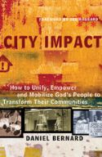 | City Impact  Daniel Bernard - (SKU#: cityimpact-4205)  Price: $12.00

