Jewish and Chinese Calendars...
A Hebrew teacher stood in front of his classroom and said, "The Jewish people have observed their 5,769th year as a people. Consider that the Chinese, for example, have only observed their 4,705th year as a people. What does that mean to you?"
After a moment of silence, one student raised his hand.
"Yes, David," the teacher said. "What does that mean?"
"It means that the Jews had to do without Chinese food for 1,064 years."

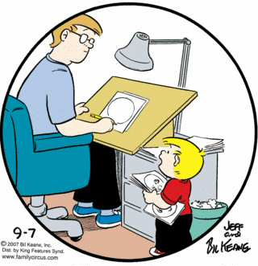

Bill Keane, creator of the Family Circus cartoon strip tells of a time when he was penciling one of his cartoons and his son Jeffy said, "Daddy, how do you know what to draw?" I said, "God tells me." Jeffy said, "Then why do you keep erasing parts of it?"

Water Anyone?
An Arab was walking through the Sahara desert, desperate for water, when he saw something, far off in the distance. Hoping to find water, he walked towards the image, only to find a little old Jewish man sitting at a card table with a bunch of neckties laid out on it.
The Arab asked "Please, I'm dying of thirst, can I have some water?"
The man replied "I don't have any water, but why don't you buy a tie? Here's one that goes nicely with your robes."
The Arab shouted, "I don't want a tie, you idiot, I need water!"
"OK, don't buy a tie. But to show you what a nice guy I am, I'll tell you that over that hill there, about 4 miles, is a nice restaurant. Walk that way, they'll perhaps give you all the water you want."
The Arab thanked him and walked away towards the hill and eventually disappeared.
Three hours later the Arab came crawling back to where the man was sitting behind his card table. He said "I told you, about 4 miles over that hill. Couldn't you find it?"
The Arab rasped "I found it alright. They wouldn't let me in without a tie."

