Review

Philip Jenkins

The Lost History of Christianity: The Thousand-Year Golden Age of the Church in the Middle East, Africa, and Asia—and How It Died

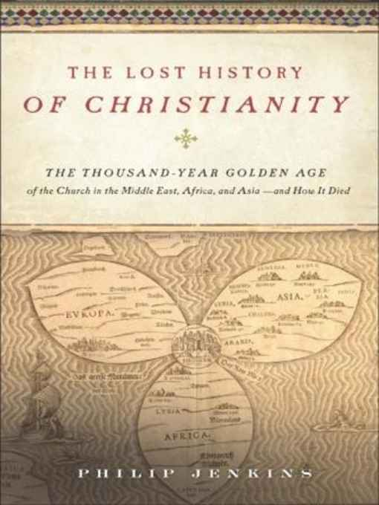

New York: HarperCollins, 2008
Reviewed By Rev. Mark R. Kreitzer, D. Miss., Ph. D.
Visiting Professor, Reformed Theological Seminary, USA.

Published, Review & Preview, in the July 2009 issue of the multi-lingual online journal www.GlobalMissiology.org

Download PDF Version
In this fascinating volume, history of religion scholar Philip Jenkins, Penn State Professor of history provides readers with what he terms as “the lost history of Christianity.” For a thousand years during the European middle age, the actual core of the Christian movement was Jerusalem with large orbs spreading out east from there toward what is now Iraq and Iran (Persia), west toward Europe, and south toward Ethiopia. The Church of the East (pejoratively called “Nestorian” by the Western Church) had large and significant communities as far as China, Tibet, and India. The Lost History of Christianity popularizes what Kenneth Scott Latourette termed “The Thousand Years of Uncertainty.” From the time of Christ to about 1400 AD and especially in the millennium from 400 to 1400 the Christian movement was huge in Africa and Asia. He shows that at least until the Muslim invasions in the Eighth Century and then for a few centuries afterwards, these two regions were very possibly the centers of the Christian movement rather than Europe.
It was from Christianized Asia and Africa, for example, that monastic mysticism, great strides in theology and even scientific knowledge came. Jenkins further demonstrates that the some of the largest Christian denominations during the much of European Middle Ages were what the Roman and Greek churches called “heretics”—Monophysites and Nestorians. Especially this last movement, better known as the Church of the East, was a far reaching web reaching as far as Tibet and China. Along with the Eastern Orthodox Church, the Asian and African members of now almost forgotten churches dominated the Middle East in the centuries before the Muslim conquest and then provided most of the architectural, administrative, and scholarly backbone for the Arabic Empire.
As the title states, Jenkins shares the story of decades of peace punctuated with years of persecution and horror for the Christians, as the Muslims gradually became the majority in the once Christian dominated lands of the Middle East. Sadly, only in the last century and especially in the last thirty to forty years is the last remnant of these once great Christian denominations being totally eradicated from Turkey, Iraq, Lebanon, and Palestine. Jenkins provides the history and background context to the present religious strife in the Middle East, South East Asia, and the band of states just south of the Sahara in Africa. As we in the West become renewed in our knowledge of how Christianity was gradually destroyed, we can understand what possibly could happen to Europe if the present demographic trends continue. Muslim Europeans are rapidly growing while Europeans of former Christian states are failing to have children. That negative growth combined with massive Muslim immigration could lead to the development of a totally Islamicized Eurabia in the next half a millennium if God does not revive and renew the Christian movement in Europe through the power of the Spirit and the Gospel.
I also particularly valued the Lessons section in the last chapter entitled: “The Mystery of Survival.” First was the penetrating insight on the reason that the very orthodox North African church, except for with in Egypt, virtually became extinct within one century after the Muslim onslaught. “Where the African church failed was in not carrying the Christianity beyo9nd the Romanized inhabitants of the cities and the great estates, and not sinking roots into the world of the native peoples” that is the barbarians (Berbers) that Paul speaks about. The “African church,” he further writes, had made next to no progress in taking the faith to the villages and the neighboring tribes, nor, critically, had they tries to evangelize in local languages” (229-230). This is a critical insight for the Korean and American churches, for example. The Koreans seem to have ceased evangelizing whole sections of the rural areas and the Americans have abandoned the now largely multi-ethnic and increasingly immigrant dominated cities. Jenkins concludes: “Christianity in this region remained a . . . colonists’ religion” (230) in contrast to that of Egypt which “did reach the hearts of their natives, and from early times” in ancient Coptic, their mother tongue (230). The Coptic Church was based on a “network of monasteries and [rural] village churches” unlike North Africa west of Egypt.
Last, Jenkins correctly points out that the Church of North Africa, like Medieval Europe, had a very visible presence in church buildings, other ecclesial real estate, and monasteries. The grave weakness was that these could be easily plundered and destroyed, and “once these were gone, so were many of the forces that kept believers attached to the faith” (235). He then makes a very relevant observation about a form of Christianity that could have withstood the onslaught of Islam in order to grow even among the conquerors. “Retroactively, we could even think of a Christianity that looked more Protestant, in the sense of placing more control and initiative in the hands of ordinary believers, whose decentralized church life would depend less on institutions than on direct access to the scriptures” (236). He tempers this ideal somewhat by noting that the monastic and episcopal forms “were so deeply engrained in Eastern tradition” and the Protestant ideal of direct access to Scripture had to await the inventing of the printing press. (236) Yet still this is powerful lesson for the evangelical movement now rapidly growing in Iran and other Muslim countries. Could the Lord God be cleaning out the old-line denominations based on monasteries, priests, salvation by faith plus works and, in my opinion, idolatrous icons and statues in order to replace it with the New Testament faith of the apostles? I believe so.
In conclusion, Jenkins interacts with many other scholars on the subject while powerfully and graciously demonstrating strong evidence for his perspective. What I especially appreciate is that this volume is written in a very readable and interesting style filled with both the broad stroke needed to give perspective and wonderful historical details that add human interest. Although he gives facts and figures such as the huge number of churches and bishoprics that the Churches in the East encompassed, yet this was done in such fascinating narrative that it carries your interest throughout. All in all this is a very important new work that updates and repopularizes K. S. Latourettes’ work. I heartily recommend it and plan to keep using it in my History of the Expansion of Christianity classes.

I took several seminal ideas for this review from other reviews especially on the Amazon.com website.

