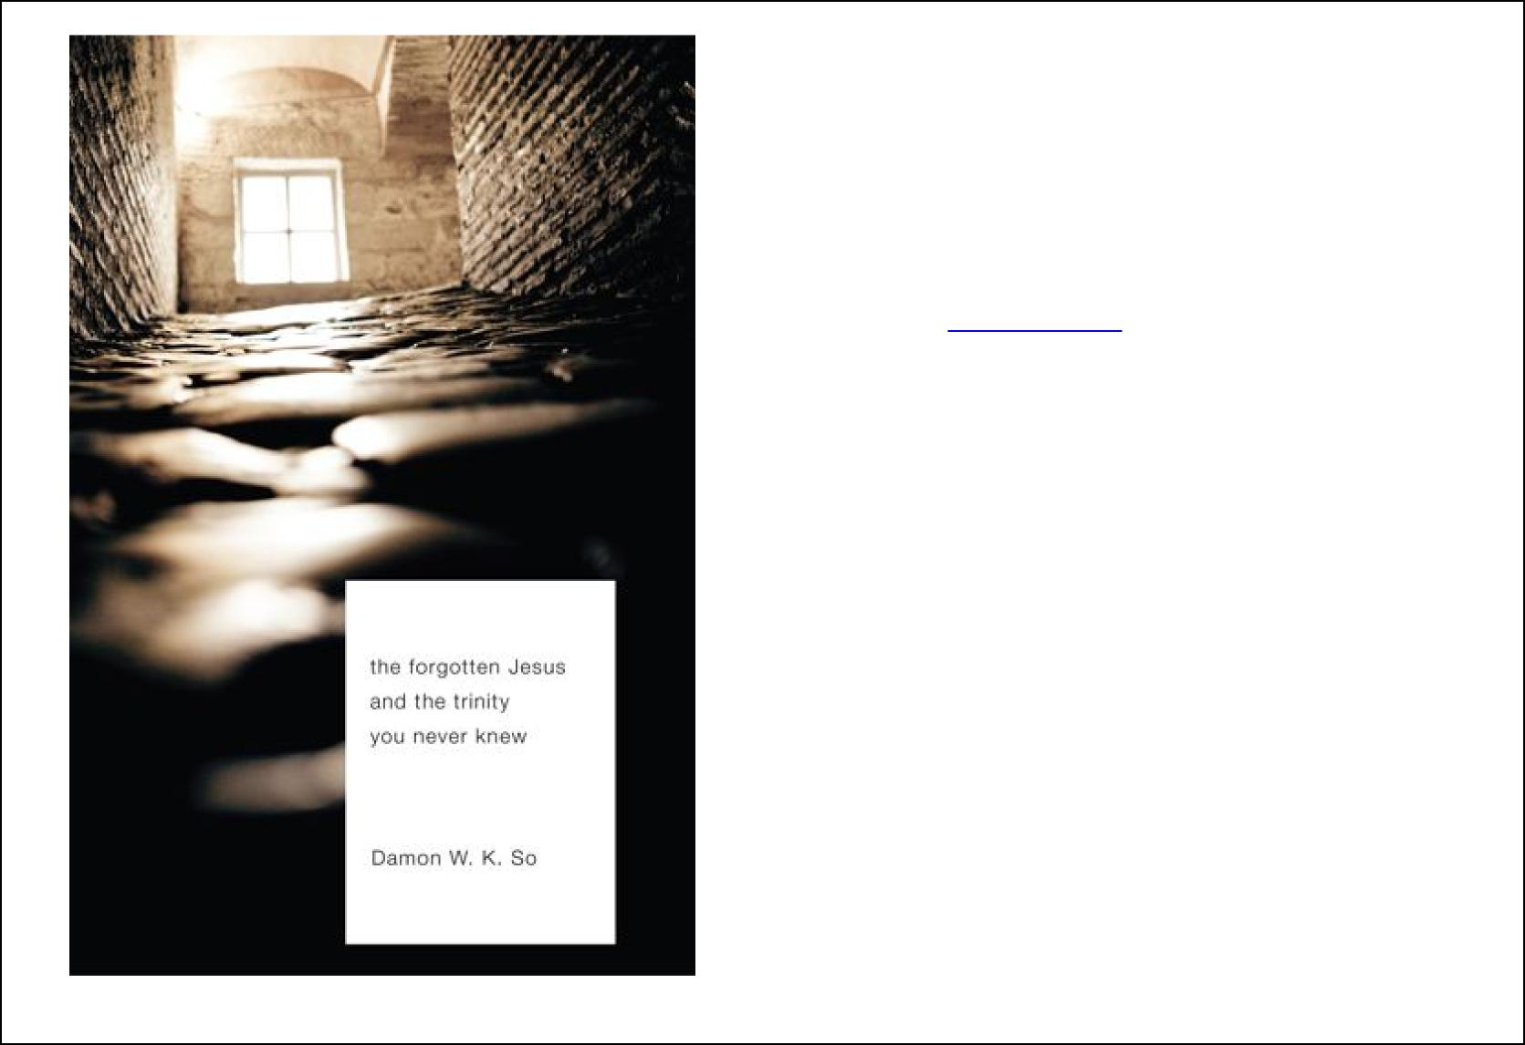
The Forgotten Jesus and the Trinity
You Never Knew
Author: Damon W. K. So
This book is suitable for university students, lay leaders, church leaders, pastors, evangelists, mission activists, seminary students, and non-believers who are more intellectually inclined and open to the gospel of Jesus.
Published by Eugene: Wipf and Stock, 2010; 254 pages;
RRP: £20; available at WipfandStock.com (with possible discount) and Amazon Discount price from author: £12.50; order by email to forgotten.jesus@gmail.com

Posted in “Trinitarian Study” section, Oct. 2010, www.GlobalMissiology.org
This book presents a dynamic picture of Jesus in his majestic Lordship and freedom, his humble servanthood and obedience, his compassion for needy humanity in his public ministry, his courageous entry into Jerusalem and his sacrificial love revealed in his death there, his resurrection from the dead and his universal reign. This dynamic picture is related closely to Jesus’ fundamental and underlying relationship with his Father through the Holy Spirit. The concrete expression of that Trinitarian relationship in Jesus’ life, ministry, death, and resurrection is presented in a unified manner, avoiding the pitfall of majoring on only one of these aspects. This holistic and dynamic picture of Jesus in intimate fellowship with his Father through the Spirit gives the readers a valuable glimpse into the mystery of the Trinity and invites them to reflect on what it means to follow Jesus as individuals and as communities in the context of the twenty-first century with its many challenges. Jesus Christ came with his cutting edge message in the first century, bringing what was new and liberating in the Kingdom of God. In the twenty-first century, Jesus Christ continues to be the one who can exercise that cutting edge to truly transform individual lives and communities, bringing freedom, healings, peace and hope of the Kingdom of God to an aching and disillusioned world.
‘Jesus É the window for us to look into the TrinityÉ’ (p. 231)
See commendations on second page, table of contents on third page, and a
meditation from the fourth page.

Uniquely among those who tell the life of Jesus, Damon So succeeds in bringing out the Trinitarian character of these relationships to be seen in Jesus' story. He does this not in a merely theoretical way but in order to bring out practical implications for the Christian believer, the whole church, and for Christian mission in the world. The last chapter itself, ‘The Trinity, The Kingdom Of God and Human Society,’ is worth the price of the whole book.
Joe W. Martin
Advisory Council Chaplain for the Oxford University Graduate Christian Union, honourary staff member in St Ebbe's Church, Oxford, former L'Abri worker
Dr. Damon So´s work is a very timely reminder of the need to recover the New Testament view of Jesus in intimate relationship with his Father through the Holy Spirit. All too often Christology has ignored this Trinitarian approach. As a result, it has failed to give proper account of the spiritual basis for Jesus' life and ministry as well as for his death and resurrection. This book provides a necessary corrective for this failure and shows the relevance of a Trinitarian Christology to the life and mission of the church in today's world. I wholeheartedly recommend this work by one of the most capable theologians from the Majority World.
C. Rene Padilla, President Emeritus, Kairos Foundation, Buenos Aires, Argentina.

The Forgotten Jesus is perfect for undergraduate theology and religious majors including postgraduates in this area of study and especially useful for the contemporary mission field in which the church strives to make Christ known.
Joseph Galgalo, Academic Dean and Professor of Theology, St. Paul's University, Limuru, Kenya.

A unique feature of this fascinating presentation of Jesus is its Trinitarian emphasis—the intimate relationship of Jesus with his Father in the
Holy Spirit. This biblical presentation of Jesus in vivid images of interpersonal love is inspiring and relevant for the life of the church in the contemporary world. This book will greatly benefit church leaders and those engaged in Christian ministry who are looking for resources to enable them to present more effectively the Trinitarian Christ and the Christian message of forgiveness, reconciliation and liberation to a needy world. I wholeheartedly recommend this book.
Corneliu Constantineanu, Executive Director, Areopagus Center for Christian Studies and Contemporary Culture, Romania
This excellent refreshing look at the Trinitarian engagement in mission provides a comprehensive tool for holistic involvement in society... He has shown us that insightful and scholarly reflection can be both accessible to the community of disciples as well as faithful and deeply reverential to the Trinitarian revelation of God. The book will be a welcome resource for those who seek a holistic understanding of Christian faith and mission.
C.B. Samuel, Chairman, Micah Challenge India

About the author: Damon W. K. So studied theology at Oxford University and Wales University. His first doctorate was in Atmospheric Dynamics at Imperial College, London. He is Research Tutor in theology at the Oxford Centre for Mission Studies, and the author of Jesus’ Revelation of His Father: A Narrative-Conceptual Study of the Trinity with Special Reference to Karl Barth (2006).

Chapter 5: The Journey With Needy Humanity To The End
The Forgotten Jesus and the Trinity
You Never Knew
Table Of Contents
Chapter 1: Introduction
Chapter 2: Manifesto Of Liberation At Nazareth
Chapter 3: Revolutionary Liberating Teaching
1 Introduction
2 The First Antithesis: Murder and Personal Dignity
3 The Second Antithesis: Respect for the Opposite Sex
4 The Third Antithesis: Respect for Marriage
5 The Fourth Antithesis: Respect for Truth
6 The Fifth Antithesis: Non-retaliation but Compliance
7 The Sixth Antithesis: Loving Your Enemies
8 The Characteristics of Jesus' Teachings
9 Jesus' Relationship with his Father and His Divine Lordship
Chapter 4: Radical Unconditional Love In Action To Liberate
1 Introduction
2 Healing of the Leper
3 Healing of the Centurion's Servant
4 Jesus and the Sinners
5 Jesus and the Sabbath
6 Jesus and the Adulterous Woman
7 Jesus and the Children
8 Conclusions about Jesus' Radical Liberating Actions
3
1 Introduction
2 The Birth of Jesus
3 The Childhood of Jesus
4 The Baptism of Jesus
5 The Temptations of Jesus
6 Jesus' Identification with Needy Humanity in his Compassionate Ministry
7 The End of the Journey
8 The Resurrection of Jesus and a New Beginning
Chapter 6: The Trinity, The Kingdom Of God And Human Society
1 Jesus' Own Rest in His Father and His Revelation of His Father
2 Jesus and the Holy Spirit
3 The Mystery of the Trinity
4 The Divinity and Humanity of Jesus Christ
5 Meditation on the Lord Jesus Christ
6 The Trinity, the Church and Human Society 6.1 Freedom and Moral Reference
6.2 Freedom from Self-Interest 6.3 Freedom for the Poor
6.4 Freedom from Structural Evils
6.5 Freedom from Conflicts: Reconciliation
6.6 Trinity and Human Society
6.7 Trinity, Church and Mission in the World
7 Conclusions
Appendix A: Meditation on Jesus' Lordship and Servanthood Appendix B: Jesus Suffers With Us
Appendix C: Holiness and Love
Appendix D: He Did Not Turn Back
Appendix E: He Lives-He Rose from the Dead
The Forgotten Jesus and the Trinity You Never Knew
(Eugene: Wipf and Stock, 2010), 254 pages
by Damon W.K. So, Research Tutor, Oxford Centre for Mission Studies
Excerpt and roadmap of the book:
Meditation on the Lord Jesus Christ
He is the unique Jesus Christ, the one who is at once authoritative and yet humble, powerful and at once gentle, demanding perfect righteousness yet gracious and forgiving, patient yet overturning tables in the temple, one before whom we stand in awe and yet one who is approachable, calm and yet with deep feelings and emotions, apparently concealing and yet in truth revealing himself to us, drawing people’s attention to himself and yet totally non-egocentric, condemning sin and yet willing to die for sinners, died and yet has risen, having all things and yet giving up all, one who is rich and yet standing alongside the poor, one who fully understands us but is himself not understood.
He was not of the world but he looked on the lost and broken world with compassion and sympathy. He understood their pains, he understands our struggles. His heart goes out to the needy, his hand reaches out to the poor. Though he was not of the world, he was in the world and in his love and compassion he committed himself totally to the world to save it. He was born not in a palace but a stable and a manger were sufficient for him. He was not protected by an army of royal palace guards but he was persecuted and exiled as an infant refugee (to Egypt). He chose not to grow up in a wealthy and well-known family but in a carpenter’s home he was raised. He could have been rich and famous, but he chose to stand in solidarity with the humble and the needy. Indeed he came to preach good news to the poor, he came to comfort those who mourned. He came to heal the broken-hearted and bind up their bodily wounds. He reached out his hand to those crying, imprisoned, and set the captives free. He gave sight to the blind that their eyes could see the light. He drew close to the rejected and despised that they might know his love. He touched those who were afflicted so that they might be restored. He spoke tenderly to the downcast that they might have hope in him. He was gentle with the weak that they might gain strength from him. He came to those who faced death that they might live again. A bruised reed he will not break, and a smoldering wick he will not snuff out. He wept with those who wept and cried with those who cried that they might know that their Lord is by their side.
4
He treasured each and every human life; for each he came to live and die. He came to heal and to preach, that we may know God’s Kingdom had arrived. He came to teach God’s Kingdom and righteousness that we may repent and do God’s perfect will. He spoke not as one with borrowed authority, but he spoke with full conviction and the very authority of God. His words pierced our hearts, his teaching awakened our spirit, his righteousness exposed our darkness and vain conceit. He came not to condemn, he came not to judge, he came to show the way of eternal life to us. He had no home to stay, he had nowhere to lay his head, but he came to bring us to our eternal home of rest. He longed for us to come under his wing, but there were many who were not willing. He grieved at their stubborn will, but for one sinner who repented, with the angels in heaven he rejoiced. He was the one doing the greatest things in the history of the world and yet he remained humble and unassuming. He could have enjoyed the admiration and the praises from the people (or even from himself), but he retreated from these so that no vain conceit was found in him. He sought not his own glory but the glory of the one who sent him. He was the one not doing the things that the crowd expected or desired but he was the one who resolutely did the will of God and fulfilled his Father’s mission for him.
He was born under the law but he was not bound by the law, but rather fulfilling it. He saw that the letter kills but the spirit gives life, and freedom. He was living in a world plagued by barriers to relationship (religious/ritualistic, ethnic or otherwise) but he was daring to challenge and overcome these barriers. He boldly taught the unconditional love of his Father and practiced this revolutionary love in his own life—courageously, radically confronting and transcending these barriers to set the people free. His radical teaching and his revolutionary action liberated the people to experience the unconditional love of his Father, but he aroused the anger of the religious leaders who eventually put him to death. He was veiled to those who rejected and persecuted him but he opened wide his heart and offered his friendship to those who trusted in him. He was not aloof from the people, but was found approachable by those who drew near to him. He was not ascetic, but with his friends and disciples he enjoyed and gave thanks for all that his Father had provided. He was not indulgent or enslaved by anything, but he was free to abstain for his Father’s will (e.g., the temptations in the desert). Indeed he was free from bondage, fear and guilt; in his freedom he shared his love and his life with those around him and fulfilled the very will of God. He did not look at the outside of a person or the outside of
things but he looked into the heart of the matter and people’s hearts. He was never lost for words but in every situation he always knew and spoke his words of wisdom and his words of grace; with authority and decisiveness he showed himself to be the Lord. He was not merely teaching the greatest truth in the history of the world, but he was practicing what he preached. He was never divided, but his inner and outer were always integrated in truth. He is truly the way, the truth and the life of God and he is the Lord.
He had the power to make himself king in this world, but he chose to be a servant of all. He was indeed King but his Kingdom was not of this world. He was living a lifestyle of poverty, but was making many people rich. He sought first his Father’s Kingdom and righteousness, trusting that his Father would provide for him. He was faced with many threats and persecutions, but he trusted in his Father to work through all things to accomplish his sovereign will. He knew that he was not alone, but that his Father was always with him. His yoke was easy and his burden was light as he found rest in his loving heavenly Father (Matt 11:30). He knew that his Father always heard his prayer and answered him. He knew that his Father loved him and had entrusted all things to him. He loved his Father and obeyed his will in all things. He lived in a world of sin but he remained pure to the end. The world was laden with guilt but he knew no guilt in himself. As the Father was holy and perfect, he himself was holy and perfect. The Father was in him and he was in the Father. As the Father had life, he had the same life in himself and was one with the Father. Living in the personal presence of his Father, sharing the same spirit with his Father through the Holy Spirit, he breathes in the atmosphere of the Spirit and thinks, sees, hears, speaks, teaches, preaches, acts, heals and lives, all in the unity with his Father through the Spirit. He is one with his Father through the Spirit and those who see him in faith see the Father through him.
He was conceived by the Spirit and he lives in the natural atmosphere of the Spirit from birth; there is nothing alien or external to him about the Spirit, the Spirit is inherently in him. Yet, he is not identical with the Spirit; he is in a mysterious sense distinct from the Spirit. When he heals, exorcises, and does mighty works in the power of the Spirit, he does all these with the power which he experiences as his very own, which he exerts and wields at his own authority and will. He is the subject, the Lord, who possesses the Spirit. He is one in unison with the Spirit and yet somehow is mysteriously distinct from the Spirit, being the Lord and yet giving the Spirit the highest honor, exercising the Spirit’s power as his own and yet acknowledging the Spirit’s power in him. It has always been in his nature and existence to move and live in the Spirit. And it has always been in the Spirit that he experiences his Father’s holy and loving presence; it has always been in the Spirit that he lives and moves in holy communion and loving unity with his Father (Mt. 11:27–30).
5
In all respects he was fully human and yet in the fullest sense he was truly divine, revealing the glory of his Father. He was himself the life-giver but he gave himself unto death, even death on the cross. He had committed no sin, yet he was condemned as a criminal and a blasphemer. He endured gross injustice, but did not indulge in self-pity. He could have denied his true self to save himself, but he made no compromise with the truth. He could have argued vehemently with those who unjustly accused him, but in dignity he briefly stated his case. He was meek in person and yet he was firm with the truth. Indeed he was meek as a lamb, but through his meekness he revealed the greatness of God. He had failed and lost in the eyes of the world, but he had triumphed with the greatest victory. He was broken and weak but through his brokenness, he demonstrated the strength of God. He was foolish to those of the world, but in truth he revealed the wisdom of God. He was apparently shamed in his death, but in truth revealed the glory of life. He suffered the pain of the cross, but for the joy before him resolutely endured it to the end. He was crucified by his enemies, but he prayed and interceded for them.
He who was innocent received the taunts and ugly violence of sinful men so that the sinfulness of sin might be exposed. He endured the sins of sinful men but through it he overcomes sin and sets men free from their sins. He was God’s beloved Son and yet for the will of his Father was forsaken by him. He who knew no sin was made sin for us so that we sinners might become the righteousness of God. He was condemned for the sins of sinful men that we might be freed from our guilty conscience and the fear of condemnation by God. He was alienated by God so that we may be reconciled to God and have peace with him. He knew his suffering was God’s salvation to the world and he voluntarily gave himself on the cross, not wishing it to be otherwise nor bearing any bitterness or resentment. By his suffering and death he showed us what is love: he loves us who are sinners to the extent that he laid down his life for us, that he suffered the agony of the cross for us—the nails of the cross, the sneers and taunts of sinful men, being forsaken by his friends, and finally being forsaken by his Father. His heart was pierced, his spirit was drowned with sorrow and grief; no words could be his consolation, no answer could soothe his pain; in desolation and dereliction, he cried out to his Father, “O God, O God, why have you forsaken me?” There was no one to help him; there was no one to abate his sorrow. He alone bore it to the end, and cried, “It is finished” as he
breathed his last. He was forsaken by men and he was forsaken by God, but in his resurrection he has been vindicated by his Father. He tasted humiliation and death on the cross, but was raised to life to the glory of his Father. He had gone to the lowest and darkest place, but now is exalted to the glorious and highest throne, seated on the right hand of his Father. He was mocked, insulted, and beaten, but now is given a name which is above every name, that at the name of Jesus every knee should bow and every tongue confess that Jesus is Lord.
6
Now he is not seen on earth but is reigning in heaven with his Father, and living in our hearts by his Spirit. He was judged by men while he was on earth but he will come back to this earth to judge the living and the dead. The world will not see the like of him again as he towers over history. He was in history for a short time but he gave the ultimate meaning and reference to history. He had no army, fought no war, conquered no country, but he has had the greatest impact on the history of the world. He did not count equality with God something to be grasped, but humbled himself to come into the world, a world broken, lost, and starved of love, justice and truth. He so loved the world that he gave all of himself for the world. His heart for us in the world is still the same. He is reaching out to us and saying to us that he loves us. He was and is and will be the same, the same uniquely glorious Jesus Christ. He was the Word with God, the Word became flesh and the Word was and is God. To him be praise, glory, honor, and power forever and ever. Amen.
He now asks all of us to open wide our hearts to him, to receive his grace and unconditional love, to receive the forgiveness through his cross, to acknowledge and confess him as Lord, to take up our cross everyday and follow him. He tells us that he understands us—that he sympathizes with us in all our sorrows and struggles, that he sees all our hurts and pains, he knows all our fears and worries, our hopes and our dreams. He asks us to trust him and his Father who fathers us with his everlasting unfailing love, the perfect love that the Father has for him from eternity to eternity—as the Father has loved him, so he has loved us. He promises to be with us by his Spirit that we may know him and his Father, that we may be drawn into the Trinitarian life of communion and love. He asks us to turn from our old self, live in his spirit, according to his Spirit, and fulfill the righteousness of God. He asks us to stand up and be counted, to commit ourselves to him and to the world as he had committed himself to the world; not only to receive and enjoy his love for ourselves, but also to be his channels and instruments to bring his Kingdom and himself—his healing, restoration, his truth, his life and his love—to this lost, aching and broken world. He promised to be with us to the end.
His Kingdom has come and will fully come. The King has come and he will come. He will come on the clouds of heaven to bring an end to evil, darkness, pride, injustice, rebellion, hypocrisy, lies ... all that are opposed to the will and the Kingdom of God. The King will come, gather his people, consummate his Kingdom and transform us to his likeness. He will bring us to the city of light, the New Jerusalem where we shall see him face to face, where our Father will wipe away every tear from our eyes, take us into his eternal glorious presence, fill us with his peace, love, joy, and truth and bestow on us the gift of eternal life in the Kingdom of his Son, so that we may praise him for his Son, for his power and majesty, for his authority and humility, for his righteousness and his grace, for his truth, his life, and his love, that the Father is truly glorified through his Son Jesus Christ.

