Do as I Say, Not as I Do

Children are natural mimics. They act like us in spite of all our attempts to teach them good manners.

=======
Solomon-like Wisdom

Several older women, each trying to one-up the other, appeared in court, each accusing the others of causing the trouble they were having in the apartment building where they lived.

The judge, with Solomon-like wisdom, announced: "Okay, I'm ready to hear the evidence. I'll hear from the oldest person first."

The case was dismissed for lack of testimony.

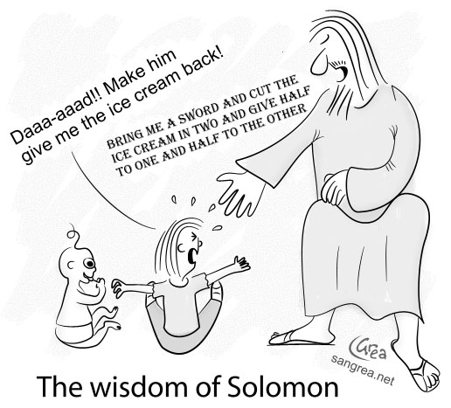
=====
The Mechanic and the Surgeon

A mechanic was removing a cylinder head from the motor of a Harley motorcycle when he spotted a well-known heart surgeon in his shop.

The surgeon was there, waiting for the service manager to come and take a look at his bike.

The mechanic shouted across the garage, "Hey, Doc, can I ask you a question?"

The surgeon, a bit surprised, walked over to the mechanic working on the motorcycle. The mechanic straightened up, wiped his hands on a rag and asked, "So Doc, look at this engine. I open its heart, take the valves out, fix 'em, put 'em back in, and when I finish, it works just like new. So how come I get such a small salary and you get the really big bucks, when you and I are doing basically the same work?"

The surgeon paused, smiled, leaned over, and whispered to the mechanic...

"Try doing it with the engine running."

