Exploring Sino-Spirituality

Enoch Wan
Professor, Western Seminary

Published in Global Missiology, Spiritual Dynamics, Oct. 2003, www.globalmissiology.net

Abstract
Chinese ministers from different backgrounds tend to hold different views on the spirituality of a servant. The paper offers perspectives on seven dimensions of true spirituality of a servant of the Lord. It contrasts viewpoints of Western trained versus traditional Chinese background and proposes biblical, cross-cultural qualities of spiritual leaders.

First published in January 1998 in the First Evangelical Church Association Bulletin, Alhambra, CA, USA. Republished February 20, 2003 in China Contours at www.christianityinchina.org, a website managed by the Christian Leadership Exchange (CLE) and designed to promote better understanding of the development of the Church in China.

Send comments to: ewan@westernseminary.edu
Dichotomized Views: Western and Chinese Cultural Influence
Chinese ministers from different backgrounds tend to hold different views on the spirituality of a servant. Generally speaking, those who receive Western theological training insist that the spirituality of a servant should include: having been called by God and ordained by the church, blessed with spiritual gifts and employed by a congregation, authorized by the government to officiate wedding, baptism, funeral, etc., competent in administration, and efficient in his profession. However, ministers from a more traditional Chinese background see these qualities as secularized and Westernized. They believe that the spiritual qualities of God's servants should be: saved and called by God's grace, pious in. orientation, humble in attitude, and faithful in service.
Both views are correct and incorrect at the same time. They are both correct in that each identifies one dimension of the true spirituality of a servant of the Lord. They are both wrong because they insist on only one dimension of spirituality, operating on the "either-or" assumption and orientation. According to the Bible, the characteristics listed in these two views should be in a "both and" relationship (Gen. 1-2; Matt. 3:16-17, 28:19; Jn. 1:14, 18, 15:26, 17:24; 2Cor. 13:14; Gal. 4:6; Heb. 1:5-6).
Rethinking Spirituality from the Chinese Cultural Viewpoint
The "Western Cognitive Pattern," inherited from Europe and represented in current American culture, is dualistic. Take English as an example. There is a distinction between subject and predicate in any sentence, e.g. "He (subject) + is a boy (predicate)." Names of people and places begin from the parts to the whole, e.g. James Smith; 7 Main St.; Paradise, PA, USA. As shown in Figure 1, the circle is partitioned into two halves, A & B. According to Aristotelian logic and the law of non-contradiction, A is not B, and B is not A, each half being either A or B.
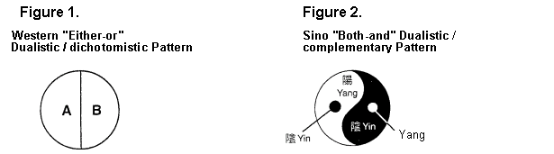
Chinese have a very different cognitive pattern. For instance, since Chinese is monosyllabic and ideographic, the formation of words and sentences has to do with the complementary parts. forming the whole. Names for people and places begin with the clan, and then move to family, and onto the individual. Formation of phrasal words is the combination of opposite pairs. Figure 2 illustrates the complementary parts of "yin-yang" in an equilibrium, forming the whole. It is holistic (the whole circle) with complementary parts of yin and yang. It is integrationistic but not dichotomistic, for there is "yang in yin" and "yin in yang." The two are neither dialectic nor mutually exclusive; but are both-and, and holistic.
Similarly, we learn from the doctrine of the Trinity that there is only one God who is supreme above all and yet the Father, the Son and the Holy Spirit sharing in honor, power and glory. As shown in Figure 3, the three are distinct in identity, one in essence but three in existence, unity with diversity, union in fellowship and holistic in harmony. This is the Trinitarian model, complementary to the Chinese pattern (both-and).
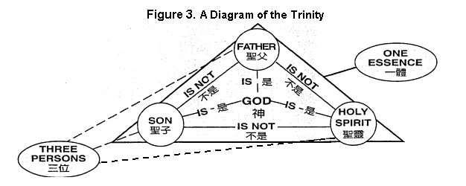
Figure 4 illustrates the formation of various theological issues from the perspectives of church history and systematic theology. Chinese ministers, in receiving Western theological training, often find the following debates boring: the christological controversies of the early years in church history, the conflict (Calvinism vs. Arminianism) on the doctrine of salvation in the Reformation, the debate on the inerrancy of the Scriptures, the search and study of the "historical Jesus," and the phenomenon of the "Jesus seminar" in recent years, etc. This is because they operate from a Sino "both-and" mindset whereas the root of the contentions and conflicts, and contrast sprang from the Western "either-or" cognitive pattern. Figure 5 compares and contrasts the strengths and weaknesses of the Western and Sino-cognitive patterns.
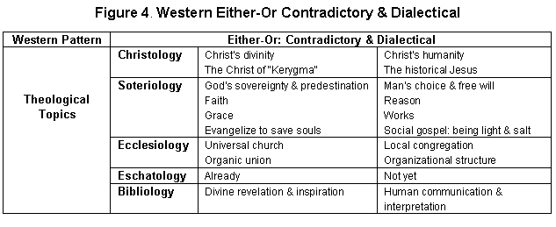
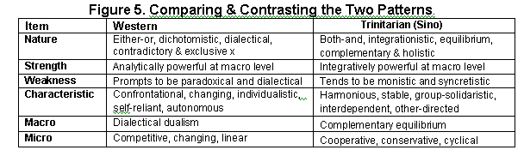
The Spiritual Qualities of a Servant
In responding to the issue of "spirituality of a servant," ministers with a strong Chinese background and the pietistic heritage of traditional Chinese Christians would list the characteristics in the left-hand column of Figure 6. On the contrary, those ministers who are raised and educated in the West and trained under the "either-or" style of theological tradition would emphasize the characteristics in the middle column of the diagram. However, spirituality that is biblically based and compatible with the Sino type cognitive "both-and" pattern should be the "Trinitarian" model on the right-hand column of Figure 6.
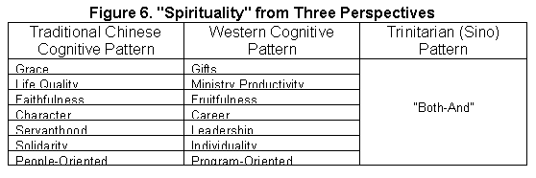
Figure 7 summarizes the principle and practice of spirituality, which fits the Sino-type cognitive thinking on the quality of spirituality. Basically, the "both-and" pattern encompasses the two columns under the heading "Principle," emphasizing the order of priority.
The "spirituality" that adheres to biblical truth and that is compatible with Chinese culture should have 7 aspects. Each aspect has two levels. It is very important to keep the proper order of the components in each level. Mixing the order will distort the truth about spirituality.
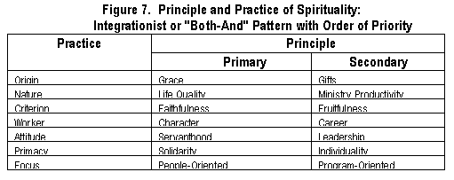
1. Grace --> Gifts
A spiritual man should be a recipient of God's grace of redemption and regeneration with calling to serve and be a saint (set apart). Experience of God's life-changing grace should precede the ministry/service gifts (Le. the manifestation of grace in the form of gifts for service: evangelism, teaching, healing, etc.). Claiming to have received God's grace but not serving others is hypocritical and selfish. Merely demonstrating gifts without the grace of bearing the fruit of the Spirit (love, joy, peace, humility, etc.) renders the presumed gifts questionable, suggesting them to be no more than counterfeits. Grace precedes gifts but not without gifts to serve.
2. Life Quality --> Ministry Productivity
Before showing any ministry productivity, Le., "God working through him," a servant of the Lord should have experienced the transformation of life by "God working in him." Without the Spirit indwelling reality, the Spirit endowment of gifts for service is impossible. Otherwise, those who are prone to the busybody, "Martha-like" service will lose that blessing which Mary secured (Lk. 10:42). Those who boast of having high qualities and supreme spirituality but without productive ministry are unwise stewards or lazy workers, lacking strong desire to serve effectively with Spirit empowerment. Life quality precedes ministry productivity but not without the latter.
3. Faithfulness --> Effectiveness
Contemporary Christian workers place too much emphasis on efficiency and often forget that ministry opportunities and results are given by God, not man-made, methodology-induced or efficiency-driven. On the other hand, those who talk of being faithful, focusing on minutiae, missing the Kingdom perspective, and losing the vision for worldwide evangelization are not exercising their spiritual gifts in ministry and cannot claim to be faithful at all. Faithfulness precedes effectiveness but not without the latter.
4. Character --> Career
Whether serving God vocationally (full-time) or not, no godly servant should think of himself as having a career or a profession alone. Neglecting the primacy of godly character over career is "ministerial professionalism," and not "ministerial spiritualism." Many servants of God are conscious of the godly character required for Christian ministry at the early stage of their service. Unfortunately, when Christian organizations grow bigger, institutional organizations become more complex, quantity gradually replaces the quality and the preoccupation of getting things done professionally then crowd out matters of character. True spirituality requires both character and career in their proper order.
5. Servanthood --> Leadership
A true servant of the Lord is a humble servant of all, as Christ was (Lk. 22; Jn. 13; 1Cor. 9). Leadership, according to the world, is occupying a high position above others. Self-appointed leaders of the world are not Christ's way of servanthood. Only those who serve others with God-fearing, self-abasing humility are leaders of true spirituality. Christ's exaltation by God the Father as Lord/ leader above all came only after his lowly service, painful crucifixion, and humiliating death. Moses made many excuses for himself when called by God. This was not a sign of true spirituality. He only sounded humble and seemed spiritual when resisting God's calling and refusing God's commission. Servanthood is a prerequisite attitude/orientation of humility for godly leadership and genuine spirituality.
6. Solidarity --> Individuality
He who seeks self-fulfillment above the Kingdom of God or focuses on self-interest before the collective good of the group cannot be really spiritual. Individualism is one of the primary features of Western culture with preoccupation of individual rights, self-actualization, self-autonomy, self-reliance, etc. The emphasis of group (e.g. family, clan, etc.) in Eastern cultures is closer to the teaching on group solidarity of the Bible (e.g. solidarity in Christ, the Church, the Kingdom of God, etc.). Salvation begins with the universal atonement of Christ before an individual's decision for Christ but not without the latter. The doctrine of the Church gives primacy to the solidarity of the body of Christ, the household of God, etc. over individual members but not without the latter. True spirituality gives priority to collective solidarity over individual persons but not without the latter.
7. People-Oriented -->Program-Oriented
Contemporary Christians, living in a technological society, are prompt to place much emphasis on ministry techniques, method of spiritual formation, program-oriented ministry plans, and accomplishment of designated tasks. God takes time to prepare His messengers before He can use them, yet Christians are preoccupied with the "how" or "how to." Spiritual ministry should first and foremost be people-oriented rather than program-oriented. There is the priority of people/personnel over program, but not without the latter.
Spirituality in accordance with Scripture and within the context of Chinese culture as shown in Figure 7 is to integrate the two dimensions in each of the above seven aspects (primary & secondary principles) and yet maintain the proper order. Otherwise it is fragmented, faulty, contradictory to Scriptural teachings and consequently unchristian. The compartmentalization of the two dimensions and the dialectical/ dichotomistic orientation of the Western perspective of spirituality can be misleading.
Editor’s note: This article is used by permission of the author and the First Evangelical Church Association Bulletin, Alhambra, CA, which published it January 1998.

