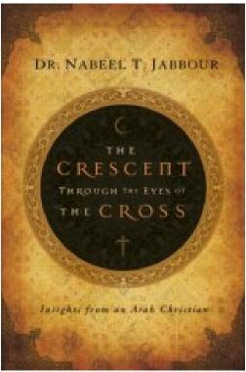
The Crescent through the Eyes of the Cross
Nabeel Jabbour, Th.D.
Colorado Springs: NavPress, 2008.
Paperback, 272 pp.
Published under “Review and Preview” at www.globalmissiology.org, April 2008
In this most relevant book Dr. Jabbour, an Arab Christian who served as a missionary in Egypt for many years before being expelled, introduces us to “Ahmad” and his family. Ahmad in turn shares with the reader 15 aspects of the Muslim worldview that bear directly on the effectiveness of Christian mission to Muslims but which most Western Christians badly misunderstand. He does this under three categories: Your Christian Message; You, the Christian Messenger; and Me, the Muslim Receiver. The result is disturbing yet challenging. As missiologist Ralph Winter has said, “Page after page will take your breath away!”
Here in North American we are bombarded by Christian sermons, magazine articles, radio and TV programs, not to mention internet blogs, frantically declaiming the imminent clash of civilizations and the fearsome threat of “Islamo-fascism.” In the
atmosphere thus generated the average layperson comes to look upon Arab Muslims and other Muslims – Iranian, Pakistani, Bangladeshi, Indonesian – as the enemy, and finds it difficult to embrace Jesus’ command to “love your enemy; bless them who curse you.” Yet that is precisely what we are called to do. The Crescent through the Eyes of the Cross, by dismantling stereotypes and building genuine bridges of understanding, creates the possibility of truly effective Christian witness.
The Crescent through the Eyes of the Cross is invaluable. The book is well edited, easy to read. Beginning with Chapter 5, the author provides a set of questions for reflection and discussion which makes the book especially useful for group study. The author’s numerous graphic illustrations enhance the book’s value. It has no index, but does include a list of recommended reading.
Waldron Scott
former General Secretary World Evangelical Alliance Author: Bring Forth Justice; What About the Cross?

