Evangelist has unprecedented entrance in China
Published under “Spiritual Dynamics” at
www.globalmissiology.org, April 2008 with permission.
In an intense historic tour of three major Chinese cities in five days, world evangelist Luis Palau recently took the word of God directly to Chinese people in Beijing, Hangzhou and Shanghai. In a special Saturday night service in Hangzhou, more than 8,000 people jammed the massive building that is designed for just 5,000. Palau's ministry recorded almost 1,000 decisions to follow Christ.
Palau concluded his trip in Shanghai with a visit with Zhao Qizheng, Dean of the Renmin University School of Journalism and Communication and China's former Minister of Information, who co-wrote with Palau the book 'A Friendly Dialogue between an Atheist and a Christian'. The Chinese translation of the book is a bestseller in China. Also see this video clip produced by Palau's ministry:
http://www.youtube.com/watch?v=IXxwrE0dkzQ.
Source: Luis Palau Association.
Luis Palau's Book Launches in New York
http://www.palau.org/news/story/luispalauand8217sbooklaunchesinnewyork308
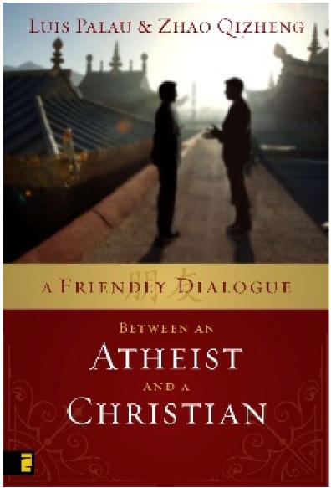 | Luis’ latest book,  A Friendly Dialogue Between an Atheist and a Christian  (Zondervan, 2008),  is the first-ever book written  between a Chinese diplomat and a Christian evangelist openly  discussing Christianity and its role in society. Originally published in China in 2006, this book was written in partnership with Zhao Qizheng, an influential government leader for the People’s Republic of China and self-proclaimed atheist.

New York, NY) February 22, 2008 – An historic book got an historic sendoff this week in New York as leaders of the publishing, media, and diplomatic worlds gathered to celebrate the release of A Friendly Dialogue Between an Atheist and a Christian by coauthors Luis Palau and Zhao Qizheng.
The first collaboration between a preeminent American Christian evangelist with a global ministry (Palau) and a Chinese scientist, scholar, and atheist (Zhao), A Friendly Dialogue is an open and frank exchange on issues of faith, culture, history, and politics. It has been a bestseller in China since its release in August of 2006; the much-anticipated English
and Spanish versions, published by Zondervan (a division of HarperCollins Publishers) arrived in American bookstores this week.
At a unique launch event hosted by News Corporation CEO Rupert Murdoch, HarperCollins CEO Jane Friedman, and Zondervan CEO Moe Girkins, Palau and Zhao shared the story of creating the book’s unique content through recorded conversations that were later transcribed. Minister Zhao was accompanied at the event by representatives of China’s publishing industry, the Chinese Consulate, and Ye Xiaowen, director-general of the State Administration for Religious Affairs.
In introductory remarks, Ms. Friedman said, “The world we live in is becoming increasingly global and new technologies are removing barriers that once separated countries and cultures. As this happens, it is important for us to be able to understand, respect, and discuss our ideas and cultures. Dr. Palau and Minister Zhao have done just that, and I believe we all have something to learn from them.”
“Minister Zhao and I learned so much about each other and our cultures during our dialogues,” said Palau. “That two men could be so dramatically different in our beliefs and backgrounds and yet find so many areas of agreement should be a great encouragement to those who will interact with the Chinese people in the century ahead.”
“I am a physicist and an architect by training,” said Zhao through a translator, “but I have read the Bible several times, as well as the writings of Martin Luther, Calvin, and others, so I welcomed and enjoyed the dialogue on issues of religion and faith with Dr. Palau.”
Palau and Zhao also participated in a series of interviews with national and international media during their New York visit. Palau travels next to Buenos Aires, Argentina, where a major launch of the Spanish edition of A Friendly Dialogue will coincide with one of the evangelist’s largest outdoor festivals in the history of his global ministry.
(From http://www.palau.org/media/ posted with permission)

