For Those Who Thought They Knew Everything
(Fun Trivia)

The liquid inside young coconuts can be used as a substitute for...

Blood plasma.

No piece of paper can be folded in half more than seven (7) times. Oh go ahead...I'll wait...

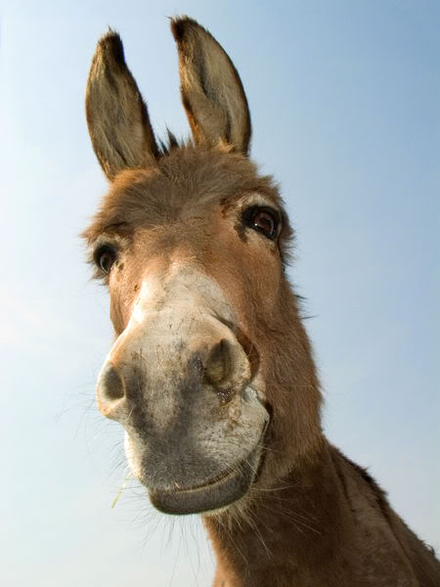

Donkeys kill more people annually than plane crashes or shark attacks.

You burn more calories sleeping than you do watching television.

Oak trees do not produce acorns until they are fifty (50) years of age or older.

The first product to have a bar code was Wrigley's gum.

The King of Hearts is the only king WITHOUT A MOUSTACHE
American Airlines saved $40,000 in 1987 by eliminating one (1) olive from each salad served in first-class.



Venus is the only planet that rotates clockwise. (Since Venus is normally associated with women, what does this tell you ?) (That women are going the 'right' direction... ?)



Apples, not caffeine, are more efficient at waking you up in the morning .

Most dust particles in your house are made from DEAD SKIN !

The first owner of the Marlboro Company died of lung cancer...So did the first 'Marlboro Man'.

Walt Disney was afraid ...OF MICE!

PEARLS DISSOLVE IN VINEGAR !

The three most valuable brand names on earth: Marlboro, Coca Cola, and Budweiser, in that order.

It is possible to lead a cow upstairs... but, not downstairs.

A duck's quack doesn't echo, and no one knows why.

